Cold War Source Analysis Exercise

Name:
Criteria | Excellent | Satisfactory | Poor
Interpretation of Sources (7.5)  1. interprets & explains each  source to identify an  ideological perspective  2. discusses links b/w  principles of liberalism and  each source  Expected to address all 3 sources. May present interpretations and discussion of links of liberalism in linear or holistic fashion. | Interpretation and explanation of the source is sophisticated, insightful, and precise. The discussion of the links to liberalism is accurate, perceptive, and comprehensively developed. | Interpretation and explanation of the source is adequate, straightforward, and conventional. The discussion of the links to liberalism is relevant and developed in a generalized fashion. | Interpretation and explanation of the source is minimal, inaccurate, and/or simple copied from the source. The discussion of the links to liberalism is disjointed, irrelevant, and demonstrates little or no understanding of the assigned task
Identification of relationships (5)  1. Identifies the relationship(s)  that exist among the 3  sources  2. Explains the relationship(s)  that exist among the 3  sources  May identify & explain the relationship(s) in one part of response or the identification & explanation of relationship(s) may be embedded throughout the response | Relationship(s) are accurately & perceptively identified. The explanation is thorough and comprehensive. | Relationship(s) are generally and adequately identified. The explanation is straightforward and conventional. | The identification of relationship(s) is minimal. The explanation is tangential and/or incomplete.
Communication (2.5)  1. Vocabulary  2. Sentence structure &  organization  3. mechanics & grammar  Expected to use paragraph form for response. Consider the proportion of error in terms of complexity and length of response. | Vocab is precise and deliberately chosen. Sentence structure is controlled and sophisticated; ideas are judiciously organized. The writing demonstrates skillful control of mechanics and grammar. | Vocab is conventional and generalized. Sentence structure is controlled and straight-forward; ideas are adequately organized. The writing demonstrates a faltering control of mechanics and grammar. | Vocab is overgeneralized and/or inaccurate. Sentence structure is uncontrolled; organization of ideas is haphazard and/or lacking. The writing demonstrates a profound lack of control of mechanics and grammar.

- For each of the source, brainstorm around the source (key events, people that might be connected
- Analyze and write the main perspective of the quote
- Connect to any key thinker (economists, classical/modern liberalism thinkers)
- Identify the relationship between the sources (name at least 3)
- Explain the relationship between the sources (explain those 3 that you identified)

Source 1:
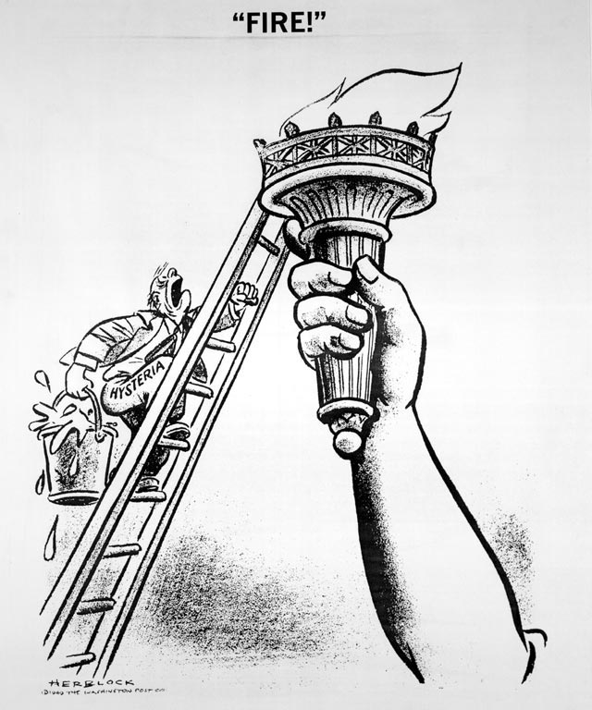
____________________________________________________________________________________________________________________________________________________________________________________________________________________________________________________________________________________________________________________________________________________________________________________________________________________________________________________________________________________

Source 2:
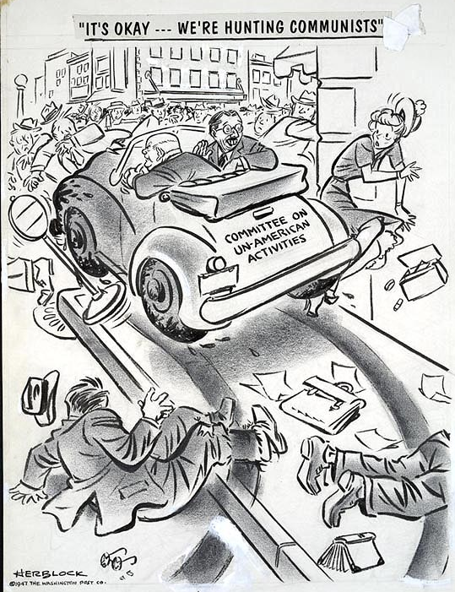
________________________________________________________________________________________________________________________
________________________________________________________________________________________________________________________________________________________________________________________________________________________________________________________________________________________________________________________________________________________________________________________________________________________________________________________________________________________________

Source 3:

I couldn't help but say to [Mr. Gorbachev], just think how easy his task
and mine might be in these meetings that we held if suddenly there was a
threat to this world from another planet. [We'd] find out once and for
all that we really are all human beings here on this earth together.
~Ronald Reagan, 1985
____________________________________________________________________________________________________________________________________________________________________________________________________________________________________________________________________________________________________________________________________________________________________________________________________________________________________________________________________________________

Source 4:
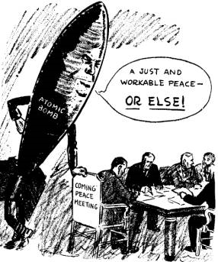
____________________________________________________________________________________________________________________________________________________________________________________________________________________________________________________________________________________________________________________________________________________________________________________________________________________________________________________________________________________

Source 5:
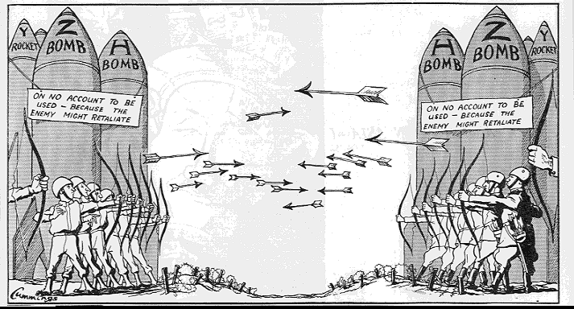
________________________________________________________________________________________________________________________________________________________________________________________________________________________________________________________________________________________________________________________

Source 6:

Where is the indignation about the fact that the United States and Soviet
Union have accumulated thirty thousand pounds of destructive force for
every human being in the world?
~Norman Cousins
________________________________________________________________________________________________________________________________________________________________________________________________________________________________________________________________________________________________________________________
__________________________________________________________________________________________________________________________________________________________________________________________________________________________________________

Source 7:
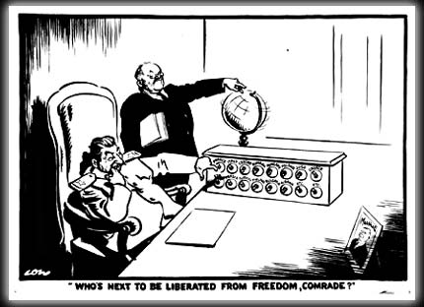
________________________________________________________________________________________________________________________________________________________________________________________________________________________________________________________________________________________________________________________

Source 8:

Every gun that is made, every warship launched, every rocket fired signifies in the final sense, a theft from those who hunger and are not fed, those who are cold and are not clothed. This world in arms is not spending money alone. It is spending the sweat of its laborers, the genius of its scientists, the hopes of its children. This is not a way of life at all in any true sense. Under the clouds of war, it is humanity hanging on a cross of iron.
~Dwight D. Eisenhower, speech, American Society of
Newspaper Editors, 16 April 1953

________________________________________________________________________________________________________________________________________________________________________________________________________________________________________________________________________________________________________________________
__________________________________________________________________________________________________________________________________________________________________________________________________________________________________________

Source 9:
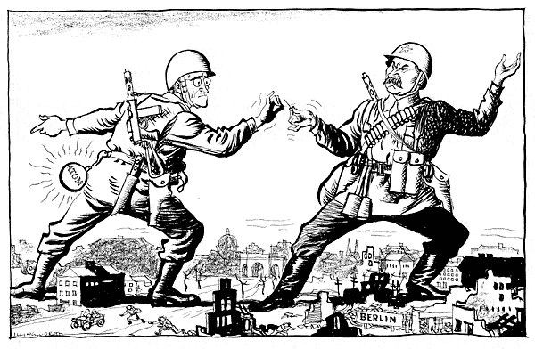
______________________________________________________________________________________________________________________________________________________________________________________________________________________________________________________________________________________________________________________________________________________________________________________________________
Source 10:



