Social 20 – Contending Loyalties – Region – 2014 (Updated 2019)

The Alberta Oil Sands

NAME: ________________________________________________________________________

DATE: _________________________________________________________________________

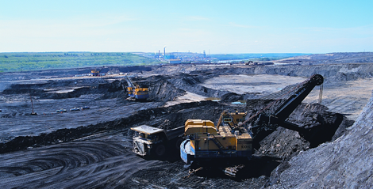
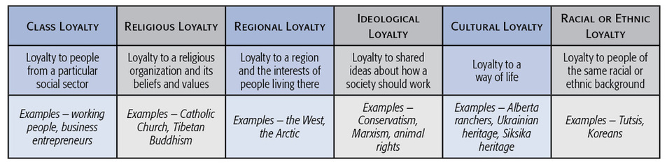
A region may be an area within a country (e.g. the West), an area with a province (e.g..
Northern Alberta), or even an area that crosses provincial and national boundaries (e.g.. the
Prairies). People often express their regional loyalty by actively promoting the interests of
their region. But this loyalty can sometimes clash with their national loyalties. This is what
happened in Alberta in the 1970s.

Step 1: As a class, discuss the following scenarios. Identify how nationalist and non-nationalist loyalties might conflict:
- You have just received a “prosperity cheque” from the Alberta government, which is distributing the cheques so Alberta citizens can share in the revenues generated by the oil industry.
- Your best friend gets a summer job delivering pizza in Fort McMurray and wants you to join the team. He says it’s “easy money”.

Step 2: Read the following scenario and respond to it in a half page response.
“For as many years as you can remember, your family has worked for oil companies. Both your mother and grandfather have worked and supported the development of the oil sands. Your mother has been a geologist, and your grandfather was the CEO of a major western Canadian oil firm. You share their beliefs on the development of the oil sands, but you are concerned with environmental stewardship.
You recently joined Greenpeace.
In a heated discussion around the supper table last night, your mother and grandfather try to talk some “sense” into you.”
Your task is to identify your loyalties to both Greenpeace and the development of the oil sands and to explain how these loyalties might be in conflict. Can these loyalties be reconciled? How?
Step 2: Complete the following chart to enhance your understanding of when regional and national loyalties compete.
Oil, Gas, & Regional Loyalty | The Oil Sands & Loyalty | The Oil Sands & Ideological Loyalty | The Oil Sands & Cultural Loyalty

Step 3: Examine the following political cartoon (from Graeme MacKay) and the accompanying text from CTV News and answer the questions below.
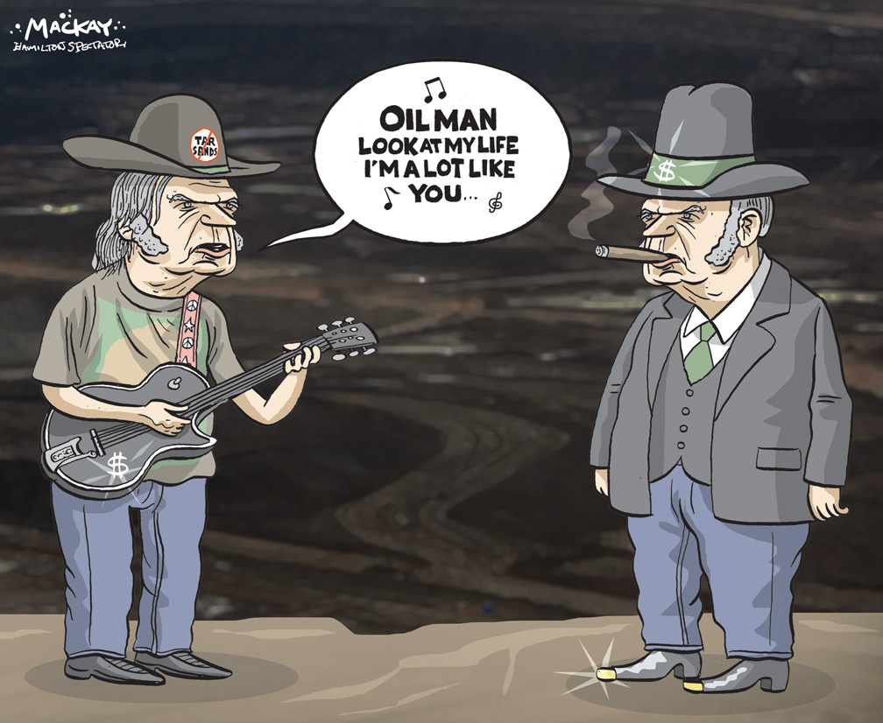
January 14, 2014

Neil Young blasts Harper government for allowing development of Alberta oilsands
Neil Young is accusing the Canadian government of “trading integrity for money” when it comes to Alberta’s oilsands.
Speaking at a news conference Sunday, the rock legend suggested the Canadian government is “killing” First Nations people by pushing forward with rapid development of the oilsands.
“The blood of these people will be on modern Canada’s hands,” he said.
Young was speaking in Toronto ahead of the first of four benefit concerts aimed at raising money and awareness for the Athabasca Chipewyan First Nation’s legal fight against Shell Canada’s Jackpine oilsands mine expansion plan.
The federal government approved the project last month despite a review panel’s conclusion that the project would result in severe and irreversible environmental damage.
Shell has said it will double its bitumen production in the region to 300,000 barrels a day and the project will create 750 jobs.
Young, who said he recently visited one of the oilsands sites, was joined at his press conference by a panel of anti-oilsands activists. The panel was moderated by environmentalist David Suzuki.
The “Honour the Treaties” concert will take place Toronto’s Massey Hall Sunday night, and moves to Winnipeg, Regina and Calgary later this week.
“I want my grandchildren to grow up and look up and see a blue sky,” Young said, noting he instead only sees a government “out of control.”
“Money is number one, integrity isn’t even on the map,” he said.
Jason MacDonald, a spokesman for Prime Minister Stephen Harper, countered that “projects are approved only when they are deemed safe for Canadians and (the) environment.” He added that the resource sector creates “economic opportunities” and “high-wage jobs” for thousands of Canadians

Questions:
What contending loyalties is Neil Young trying to evoke with his “Honour the Treaties” tour?

What loyalties are the Prime Minister’s spokesman, Jason MacDonald, appealing to?

Who is the cartoonist critical of…”Big Oil”, or Neil Young? Defend your answer.

