School Name: Bashaw School
School District: Battle River School Division #31

Permission to View Film/Video

Dear Families,

Occasionally, film/videos are used in the classroom in order to illustrate a particular curricular-related concept.

I am notifying you that we will be watching a film/video in class with a rating above the G rating, in this case PG-13, that features graphic images.

I will be showing a film/video in the classroom on MAY 29 until its completion. This form must be returned before then.

Film/Video Title: Sicko
Canadian Rating: PG

Topic under discussion to which movie is relevant: Numerous repeated themes from throughout the course, including, but not limited to: Comparison of United States and Canada; how values, beliefs, and attitudes shape government decisions; taxation and health care; political and economic systems. Themes in this film will re-emerge in Social 10 and Social 30 and it is suitable for end of course study.

Instructional objectives: Students will utilize media thinking skills and connect their learning to “real world” cases. Ultimately, students will be responsible for comparing the health care systems of the United States and Canada and evaluating the effectiveness of both in relation to one another, as well as the systems found in the UK and France.

Additional information provided on back of form.

Teacher: Kyle McIntosh Class: Social 9

-------------------------------------------------------------------------------------------------------

Child’s Name ______________________________________________________________

____ Yes, I give my son/daughter permission to view curriculum and school appropriate film/videos related to classroom content and subjects.

____ No, I do not give my son/daughter permission to view curriculum and school appropriate film/videos mentioned in this letter. I understand alternate learning experiences will be provided for my child while the movie is being watched.

Signature of Parent or Guardian: ______________________________________________

Date: _______________________________________
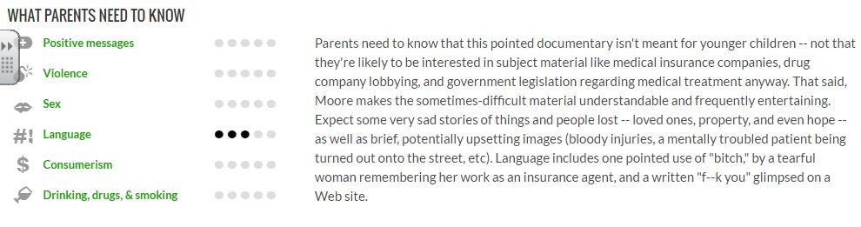

Other considerations (IMDB):

Sex & Nudity
The film begins with a portion of a George W. Bush speech in which Bush says that "too many OB-GYNs aren't able to practice their love with women all across this country."
There is a brief instance where a man lowers his trousers to receive an injection from a doctor, and his buttocks can be seen.

Violence & Gore
The opening credits are interspersed with brief scenes of a man stitching his own open wound closed. It is mildly graphic.

Profanity
The only profane language in the film is a shot of the [f-word] written in an e-mail message.

Alcohol/Drugs/Smoking
Numerous interview subjects in France are shown drinking wine. Additionally, shots of people on French streets drinking wine and smoking cigarettes are shown to illustrate alcohol and tobacco consumption in France.

Frightening/Intense Scenes
A man does a cartwheel on a busy street and dislocates his shoulder. 9/11 rescue workers discuss searching for people who are still alive but finding only bodies and parts of bodies.
Recommended for 13 and up.

