Quebec Project Rubric 2017
Content Focus x2
Excellent - 4
Connections to nationalism are thoroughly discussed.
Appreciation of Quebecois nationhood intentional.
Evaluation of national unity is comprehensive.
Good – 3
Connections to nationalism are discussed.
Appreciation of Quebecois nationhood is evident.
Evaluation of national unity is actively discussed.
Basic – 2
Connections to nationalism are barely evident.
Appreciation of Quebecois nationhood is incidental.
Evaluation of national unity is incidental.
Not Meeting – 1
Above criteria is surface level if at all present.

Research and Analysis x2
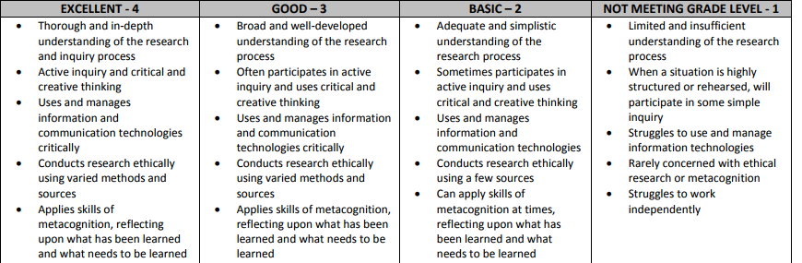
Communication
