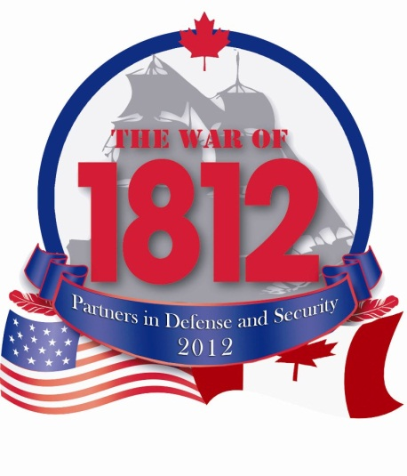
Becoming Canada – Ch 6: War of 1812 Poster Project
In 2012 we celebrated the 200th anniversary of the War of 1812, an important chapter in our country’s history. In Upper and Lower Canada (Ontario and Quebec), the British with the help of the First Nations allies and Canadians, succeeded in protecting their territory against the American Invasion. These historic events led to the establishment of our country and 200 years of peace between Canada and the United States.
Draw a poster that tells the important stories of our past.
- Illustrate how those stories shaped the Canada of today.
- Celebrate the significant people, important sites and history of Canada in your work of art.
- Explore and show the wealth of our heritage by including scenes from daily life: music, dance, architecture, fashion traditions of the period.
- Combine your imagination and talents to draw a poster that highlights the theme. Your artwork will be completed on standard paper.
- All artworks must be original designs that have been created by the student.

- Theme – Artwork must reflect the theme of War and Peace – The Fight for Canada. Think about how the British, American, and Canadian soldiers and their First Nations allies would have been dressed at the time. You may choose any event from the War of 1812. Consider the 5W + H!

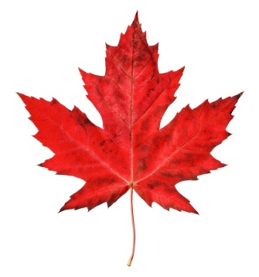
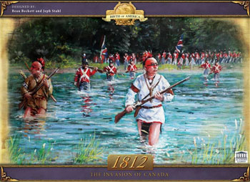
- Symbols – The use of Canadian Symbols is encouraged. Show what Canada means to you. Canada has many symbols that are recognized here at home and around the world. Our symbols are just as diverse as our history and citizens.

- Colours – All artwork must be in full colour. Black and white posters will not be accepted. The use of vibrant “eye catching” colour will achieve the best results for your poster.

- Minimal Words – A picture is worth a thousand words, so let your artwork do the talking. Keep the number of words to a minimum. You should not have more than three or four words on your poster.

You will be evaluated on the following criteria:
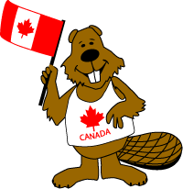
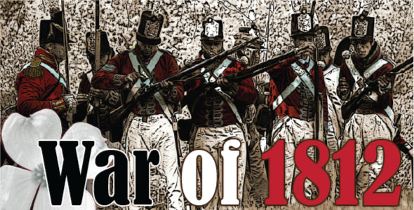

 | 4 | 3 | 2 | 1
Historical Content & Explanation  (x2) | Paragraph includes an extensive amount of historical content. All of the required questions are answered. Reasoning and historical significance of event is made clear. | Paragraph includes a good amount of historical content. Most of the required questions are answered. There is a good amount of reasoning and historical significance of the chosen event. | Paragraph included some historical content. Less than half of the required questions are answered. There is some reasoning and historical significance of the chosen event. | Paragraph included little or no historical content. Little to no required questions answered. Little or no historical significance of chosen event.
Design | Creatively commemorates an event from the War of 1812.  Symbolism within the design is well utilized as is space and colour. | Commemorates an event from the War of 1812.  Symbolism within the design is utilized and colour/space are appropriately used. | Commemorates an event from the War of 1812.  No symbolism is used. Colour/space are ineffective. | Doesn’t adequately commemorate a person the War of 1812.  Symbolism, colour, space, and all design components are poorly used, if at all.
Total |  |  |  | /12

