Related Issue 1 Performance Task

Background:

As we have discussed in class, nationalism is the shared aspirations and beliefs that develop within a nation as its members begin to identify strongly with one another and develop shared goals. As this nationalism grows within a nation it is common that a system of symbols is developed that members rally behind and use to identify one another. These can include things such as flags, shared slang or language, the wearing of certain types of clothing or colours, and, as is related to this assignment, the development of a coat of arms.

As the Roman army spread across the world during its rise to power the practice of placing a symbol on a soldier’s shield to identify which unit they belonged to became common practice. As warfare and time progressed medieval knights came to use these symbols to not only identify friend and foe during battle but as a way to display their social honour and standing.

Today, coats of arms are used by a variety of individuals and institutions to represent not only themselves but the ideals and beliefs they stand behind.

Alberta’s Coat of Arms

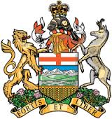

Performance Task:

*** You must complete each step to fully complete this task ***

1.) Use the attached graphic organizer to brainstorm and develop your thoughts. Remember a coat of arms needs the following elements: a motto, a crest, shield elements, and supporters.

*** Please note you will need to have your graphic organizer handed in and approved in order to receive a mark on the task ***

2.) After having your planning approved choose which elements you feel should be included on your coat of arms. Remember because of the limited space available on a coat of arms your challenge becomes choosing which elements you feel best represent Canadian nationalism.

3.) Create your coat of arms. Feel free to use the template provided or to create your own. Images can be hand drawn, composites, or computer generated. A final version must have all of the elements mentioned in step 1 and included in the image below, titled a Diagram of a Coat of Arms:

4.) Once your coat of arms is complete create a paragraph for each of the four elements explaining why you chose it and how you think it represents Canada as a nation.

5.) Explain, in an additional paragraph, the various loyalties Canadians have that you chose to EXCLUDE…why did you choose not to represent various groups? Maybe you didn’t represent the oilfield because you’re an environmentalist; maybe you used an Eagle feather to represent all Indigenous peoples lumping in Metis etc. Exclusion is as important as inclusion.

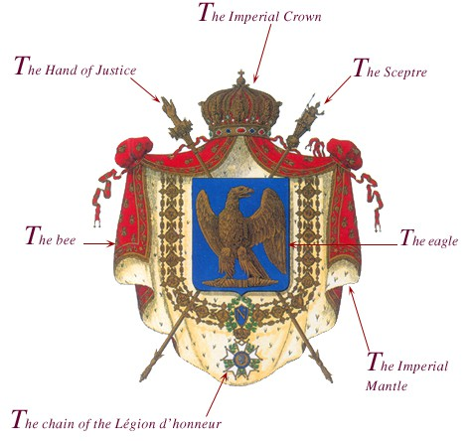

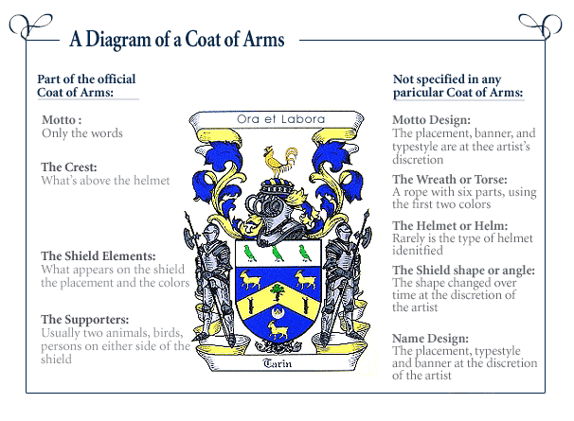

Check-in Deadline: April 1st, 2019 Summative Deadline: April 8, 2019

Where to Start?

1.) Begin by defining and listing what beliefs, values, occupations, special interests, cultural backgrounds, regions, and even colours you identify as being “Canadian.” How might you represent these in your Canadian coat of arms?

2.) Think about what symbols you might identify as being specifically Canadian and where and how could these be incorporated into your design?

3.) When thinking about what colours to use remember that they can be combined and have special meanings. Here is a partial list below.

Gold (Or): Generosity; elevation of the mind
Silver or White (argent): Peace, sincerity
Red (gules): Warrior or martyr; Military strength and magnanimity
Blue (azure): Truth, loyalty
Green (vert): Hope, joy, and loyalty in love
Black (sable): Constancy or grief
Purple (purpure): Royal majesty, sovereignty, and justice
Orange (tawny or tenne): Worthy ambition
Maroon (sanguine or murray): Patient in battle, yet victorious

What elements of life in Canada do I believe are part of the Nation’s identity?

Select five elements listed above and describe and explain how you see these as part of your vision of Canada.

1.) Element: _________________________________________________________________________

Why this is Canadian: _________________________________________________________________________________________________

_________________________________________________________________________________________________

_________________________________________________________________________________________________

_________________________________________________________________________________________________

How would you symbolize this on a coat of arms?

_________________________________________________________________________________________________

_________________________________________________________________________________________________

2.) Element: _________________________________________________________________________

Why this is Canadian: _________________________________________________________________________________________________

_________________________________________________________________________________________________

_________________________________________________________________________________________________

_________________________________________________________________________________________________

How would you symbolize this on a coat of arms?

_________________________________________________________________________________________________

_________________________________________________________________________________________________

3.) Element: _________________________________________________________________________

Why this is Canadian: _________________________________________________________________________________________________

_________________________________________________________________________________________________

_________________________________________________________________________________________________

_________________________________________________________________________________________________

How would you symbolize this on a coat of arms?

_________________________________________________________________________________________________

_________________________________________________________________________________________________

4.) Element: _________________________________________________________________________

Why this is Canadian: _________________________________________________________________________________________________

_________________________________________________________________________________________________

_________________________________________________________________________________________________

_________________________________________________________________________________________________

How would you symbolize this on a coat of arms?

_________________________________________________________________________________________________

_________________________________________________________________________________________________

5.) Element: _________________________________________________________________________

Why this is Canadian: _________________________________________________________________________________________________

_________________________________________________________________________________________________

_________________________________________________________________________________________________

_________________________________________________________________________________________________

How would you symbolize this on a coat of arms?

_________________________________________________________________________________________________

_________________________________________________________________________________________________

What are some ideas for your coat of arms’ motto?

*** Hand in when completed for marks ****

