Chapter 10 Project: Expanding Confederation - Timeline
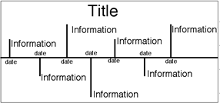
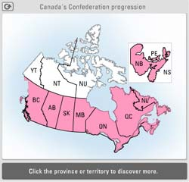
Your task is to make a timeline that shows the important dates of the Canadian Confederation and a brief summary of each!.
You must include the following:
- A timeline title
- Your name
- In colour, has put clear effort into the timeline
- Labeled in evenly spaced 10 year increments
- 1867- Confederation of Quebec, Ontario, New Brunswick, and Nova Scotia
- 1870- Manitoba
- 1871- British Columbia
- 1873- Prince Edward Island
- 1898- Yukon becomes a territory
- 1905- Alberta, Saskatchewan
- 1949- Newfoundland, Labrador become a province
- 1965- Maple Leaf is adopted
- 1999- Nunavut becomes a territory
- You have clearly marked a date for each historical event
- At least 5 other important historical events of your choice that have occurred between 1860-2000
- A graphic or symbol for at least half (7 or more) of each of your events

- Using your textbook as a reference (page 166-167), you must include a minimum of 14 important events (this includes the 9 dates listed for you), and a maximum of 20 events.
Steps:
- Put your name on the back of your timeline
- With a ruler draw 1 straight vertical line along your timeline paper
- Mark 1 inch sections along your timeline (you can choose your own spacing, this is an example)
- Label these 1 inch sections as your 10 year increments starting at 1860
- Add in each of your events approximating where they would have occurred along your timeline, ½ an inch is 5 years
- Add your events and graphics
- Colour your timeline and add a title

You will be marked using the following rubric:
Criteria | 4 - Excellent | 3 - Proficient | 2 - Basic | 1 - Limited
Historical Thinking- marks historical events | Detailed, Broad and insightful timeline of Confederation  Includes all the required items and events | Detailed and credible timeline of Confederation  Includes most of the required items and events | General and cursory timeline of Confederation  Includes some of the required items and events | Vague, partial or incorrect timeline of Confederation  Includes very few of the required items and events
Visual Literacy- communicates clearly and purposefully | Timeline enhances communication and purpose, clear effort has gone into its creation | Timeline is clear and purposeful, effort has gone into its creation | Timeline is partly logical and somewhat evident purpose, moderate effort has gone into its creation | Timeline is confusing or may contain errors,  Little to no effort has gone into its creation
Total

/8
Comments:
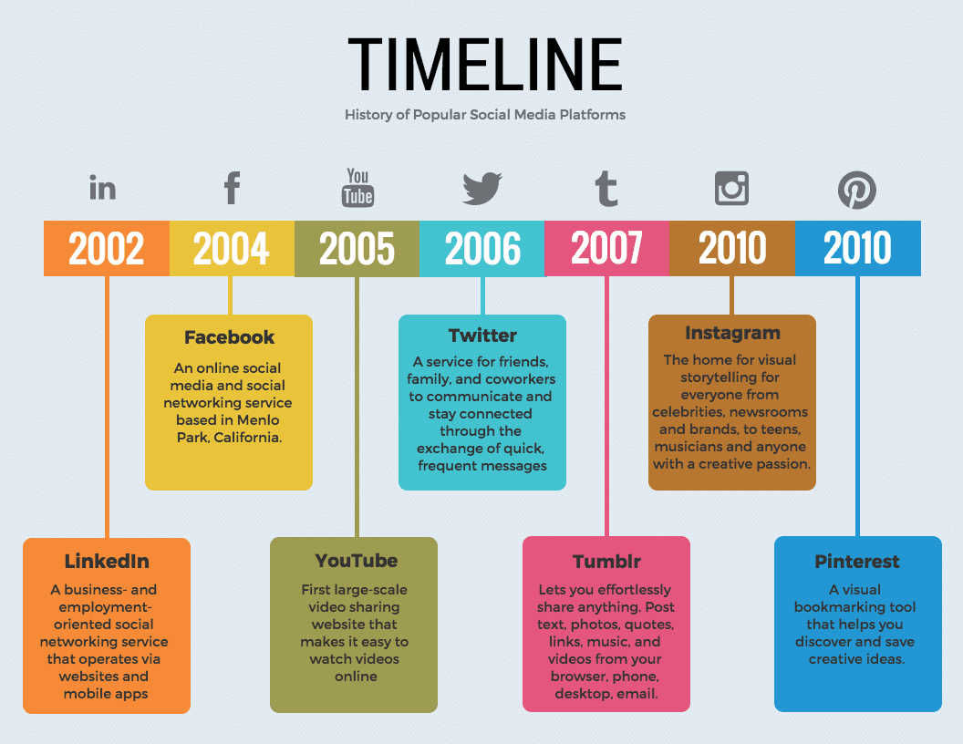
SAMPLE

