By the numbers: 7 charts that explain hate groups in the United States
By Ryan Struyk, CNN with graphics by Will Mullery, CNN
Updated 12:26 PM ET, Tue August 15, 2017
http://www.cnn.com/2017/08/14/politics/charts-explain-us-hate-groups/index.html
Washington (CNN)
White nationalist and neo-Nazi hate groups have made headlines over the last two days for the violent clashes in Virginia on Saturday, but what does their influence look like outside of Charlottesville?
President Donald Trump denounced violence "on many sides" on Saturday after protesters and counterprotesters clashed. But the President faced bipartisan criticism for failing to call out the racist and white supremacist views of those who had traveled from across the country for the event; he finally did so Monday afternoon, a full 48 hours after his first tweet on the topic.
"Racism is evil and those who cause violence in its name are criminal and thugs," Trump said on Monday, "including the KKK, neo-Nazis, white supremacists and other hate groups that are repugnant to everything we hold dear as Americans."
The number of hate groups in the United States has ticked up since the 2016 presidential campaign began, according to classifications of groups from the Southern Poverty Law Center, an Alabama-based nonprofit activist group that tracks civil rights and hate crimes.
Meanwhile, the number anti-Muslim groups skyrocketed and other types of white nationalist, neo-Nazi and neo-Confederate groups reversed their pattern of decline to tick upward.
The SPLC defines a hate group as an organization with "beliefs or practices that attack or malign an entire class of people, typically for their immutable characteristics." Some critics of the SPLC say the group's activism biases how it categorizes certain groups.
Here's a deeper look at how the number of hate groups and hate crimes has evolved over the last year and the last two decades, according to SPLC.

1. Overall hate group numbers rose over election season
Over the course of the 2016 presidential campaign, the number of hate groups in the United States grew after falling off following former President Barack Obama's re-election. The number of total hate groups has risen 17% since 2014, to 917 organizations, according to data from the Southern Poverty Law Center. The SPLC specifically pointed to a "presidential campaign that flirted heavily with extremist ideas" for the recent uptick in these groups. However, though the current number is double the number of hate groups that existed in 1999, it falls short of the high of 1,018 hate groups recognized by the organization in 2011.
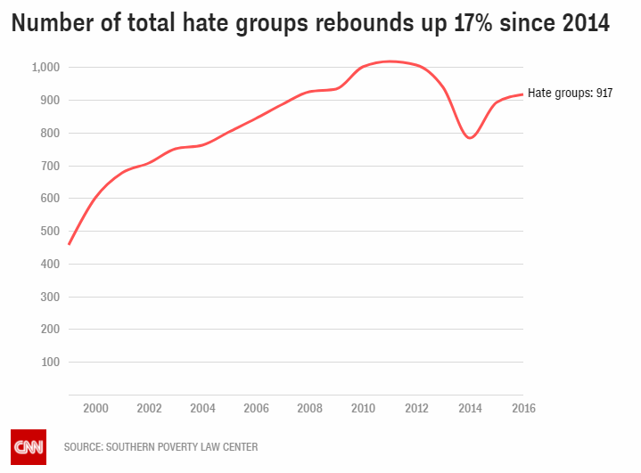

2. Breaking down types of hate groups in the United States
Black separatists, anti-white groups who support separate institutions for blacks, make up one in five hate groups in the United States, according to the Southern Poverty Law Center. One in six is linked to the Ku Klux Klan, while another one in 10 are white nationalist and one in 10 are neo-Nazi. One in 10 hate groups are anti-Muslim. Smaller categories include neo-Confederates, anti-LGBT groups and racist "skinheads," according to the organization.

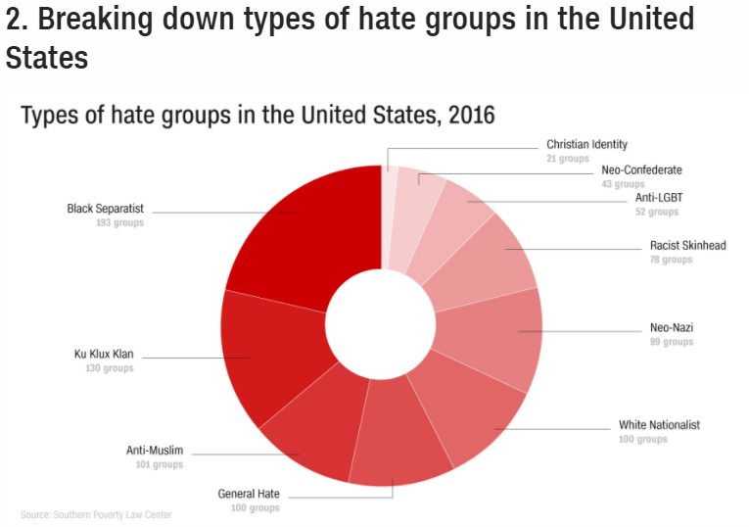

3. Anti-Muslim groups tripled in last year
The number of hate groups focused on Muslims increased dramatically over the last half-decade, jumping after the GOP electoral wave in 2010 and then tripling over the last year. Only five groups focused on anti-Islamic beliefs in 2010. But now 101 hate groups focus mainly on Muslims, marking the third-largest category of hate group behind only black separatists and Ku Klux Klan organizations. "Muslims are depicted as irrational, intolerant and violent, and their faith is frequently depicted as sanctioning pedophilia, coupled with intolerance for homosexuals and women," the Southern Poverty Law Center said.
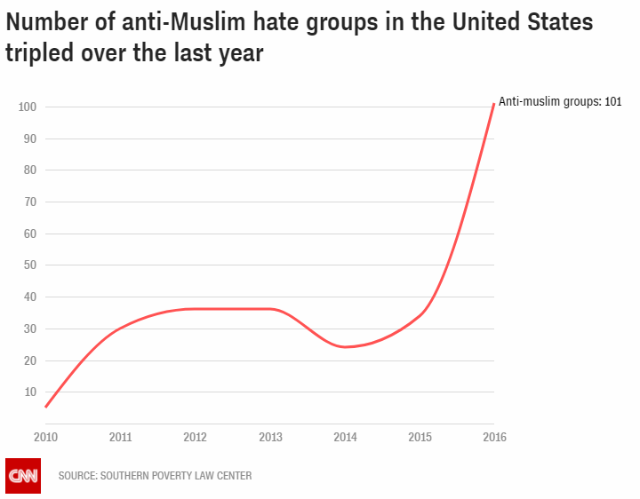

4. Anti-Islamic hate crimes spiked in 2015 in FBI data
Hate crimes against Muslims spiked in 2015, according to FBI data, reaching their highest point since the immediate aftermath of the September 11, 2001, terrorist attacks. The FBI recognized 257 anti-Islamic hate crimes in 2015 -- up sharply from the 154 incidents reported the previous year. Then-candidate Trump made immigration from the Muslim-majority world a core issue of his campaign, proposing a "complete and total shutdown" of Muslims entering the United States. Again, experts say these numbers are actually higher because some localities do not report hate statistics.
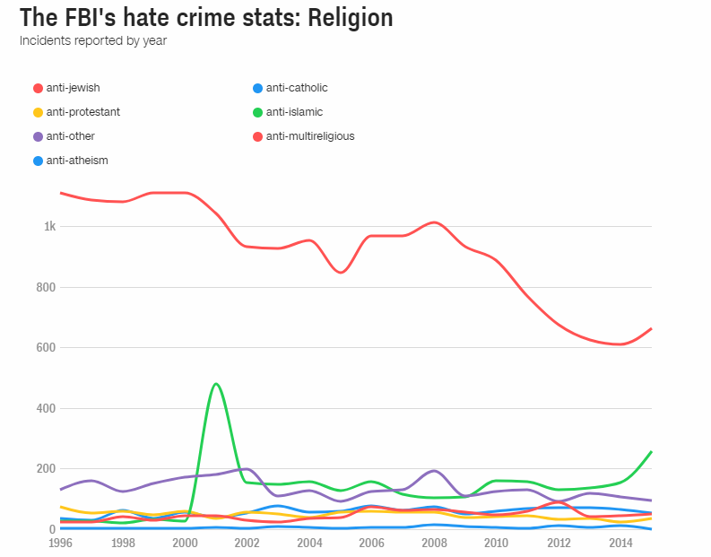

5. Racially motivated hate crimes against blacks ticked up last year
FBI data tracking hate crimes show racially motivated crimes against blacks in the United States declining steadily since Obama took office in 2009. But in the last year, those numbers slightly increased by 8% to 1,621 hate crimes nationwide in 2015. Still, experts say these numbers are largely underreported because the FBI relies on local governments to report their data -- and many don't.
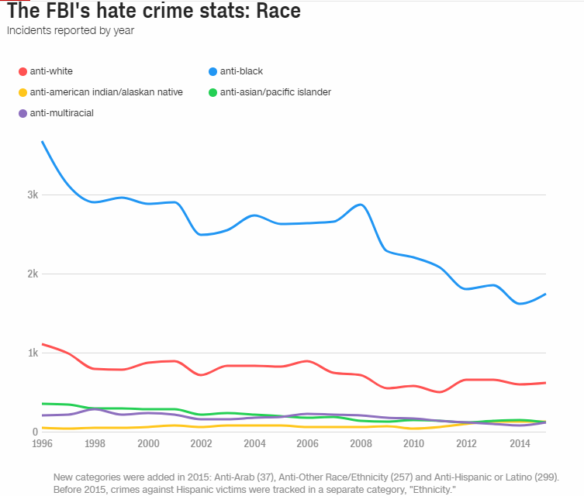

6. Some racially focused hate group numbers declined over last several years
Some racist hate groups -- including neo-Nazis, white nationalists and their more violent counterparts, a group dubbed racist "skinheads" -- have seen declining numbers over the last half-decade. The number of white nationalists fell from 146 groups in 2011 to just 100 groups today, according to data from the Southern Poverty Law Center. The number of neo-Nazi groups fell from 170 to 99, and racist "skinheads" fell from 133 to 78 over the same time span. Still, the overall number of hate groups has increased, largely due to increases in anti-Muslim groups and black separatist groups.
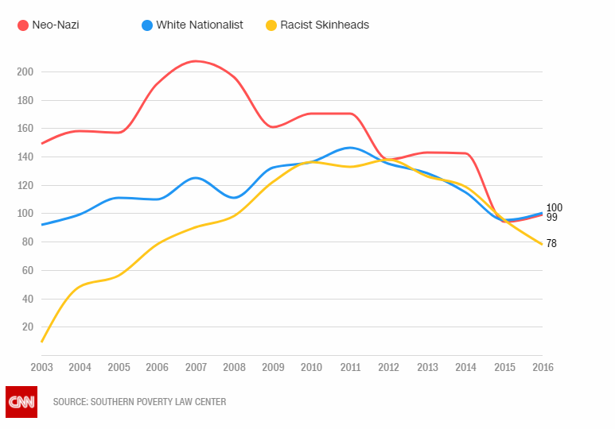

7. Other racially focused group numbers ticking upward in 2016
But neo-Confederate and black separatists have seen their numbers increase over the last few years. The number of neo-Confederate groups inched up to 43 -- the highest figure since early in Obama's presidency but still far from its 21st century high of 124 groups in 2001. Meanwhile, the number of black separatists has rocketed from 81 groups a decade ago to 193 groups now -- the largest subgroup of hate group, according to the Southern Poverty Law Center. Also, it should be noted that neo-Nazis and white nationalists, both mentioned in the previous section, bucked their yearslong trend and saw their numbers tick up just slightly in 2016.
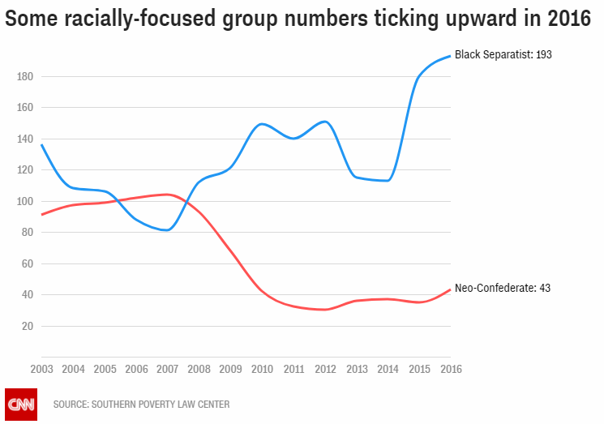
CORRECTION: This story has been updated to reflect the highest number of neo-Confederate groups in the 21st century. Neo-Confederate groups reached a 21st century high of 124 groups in 2001.

