Part I: Matching
1. Directions: Match each of the characteristics on the right to the persuasive technique it best describes to the left. Persuasive techniques can be used more than once.
____ Using a catchy phrase or statement a. Name calling
____ Using a person whose lifestyle resembles the audience b. Bandwagon
____ Telling only one part of the truth about a product c. Appeal to plain folks
____ Connecting with the audience’s feelings and thoughts d. Testimonial
____ Using loaded, emotional or slanted language e. Appeal to emotion
____ Comparing and contrasting two objects or people f. Slogan
____ Using everyday situations or images g. Glittering Generalities
____ Using a well-known person to support a product or service
____ Creating a negative attitude about an opponent
____ Using undefined terms, such as freedom and peace, to gain the audience’s attention
____ Creating the desire to join a large group
____ Generalizing a large amount of information about a product
____ Using a celebrity’s signature on a product to add legitimacy to a product
____ Creating the idea that everyone is doing it and you should join them

Part II: Multiple Choice
Directions: For each of the following questions, circle the best answer.
2. Which of the following is an opinion about persuasion?
a. Persuasion tries to convince people that one product is better than another product
b. Persuasion tries to convince people to agree with a specific point of view or idea
c. Persuasion tries to convince people that celebrities know everything
d. Persuasion tries to convince people to act in a specific way

3. Which persuasive technique is being used?
a. Bandwagon
b. Appeal to Emotion
c. Testimonial
d. Name Calling

4. A McDonald print ad states that McDonalds has the “world’s most famous hamburger.” Which persuasive technique is demonstrated in this ad?
a. Testimonial
b. Glittering generalities
c. Bandwagon
d. Appeal to emotion

5. Which of the following advertisements would be the most effective way to sell flowers to males between the age of 22-30.
a. An ad illustrating winter coming and showing how the flowers will die if they are not bought
b. An ad illustrating flowers being delivered to Angelina Jolie at a restaurant
c. An ad illustrating a laughing couple eating dinner together with flowers on the table
d. An ad illustrating children picking flowers beside a playground
6. Which of the following is an opinion about Colgate toothpaste?
a. It fights germs for up to twelve hours
b. It can brighten your smile by three shades
c. It fights plaque and gingivitis
d. It comes in fun and tasty flavors
7. “Every parent in this town” uses the bandwagon technique. Which word is the most effective in demonstrating this technique?
a. Every
b. Parent
c. This
d. Town
Part III: Analyzing Ads
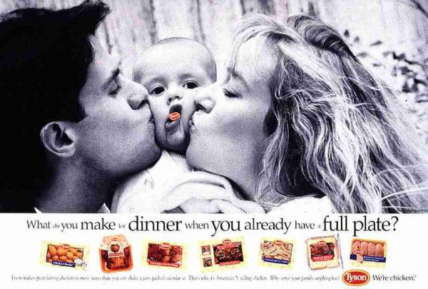
Directions: Use the following Tyson’s Chicken print ad to answer questions 8& 9.

8. What is Tyson’s slogan? ________________________________________________________
9. Identify the target audience and one persuasive technique in this advertisement.

10. What is the message this ad is hoping to relay to its audience?

11. Is the ad effective in relaying its desired message? Explain your answer using supporting information from the advertisement.

12. Why do you think Tyson’s chicken chose to put a baby in this ad? Use at least two complete sentences to justify your answer.
Directions: Use the following Verizon FiOS print ad to answer questions 10& 11.

13. List 2 facts about Verizon FiOS that are found in this print ad.
a. ________________________________________________________________
b. ________________________________________________________________
14. List three words or phrases that demonstrate how Verizon FiOs is faster than ‘the average internet.’ Explain how these words or phrases help illustrate the meaning of this print ad.
1.
2.
3.
Directions: Use the following Geico advertisements to answer question 12.
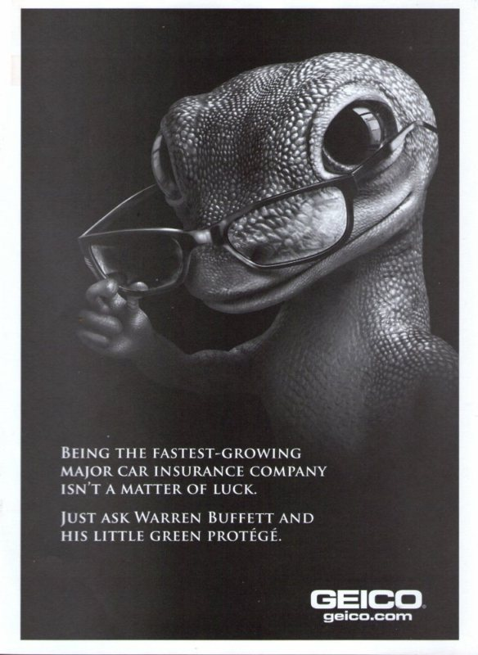
15. Inspect the two print ads above. In a well-written paragraph, explain in what types of magazines you might find these two different Geico ads.
When giving proof for your magazine selection, explain the following for each:
- the type of persuasive techniques being used
- the targeted audience the ad aims at attracting

