Social 20: RI2 Quiz
SECTION 1: Road to war, World War, Interwar
1. | In the Interwar era, national interests overrode internationalism when
 |  | A. | a wave of pacifism swept over the western democracies.
 |  | B. | nations failed to provide collective security against aggression.
 |  | C. | the League of Nations was created at the Paris Peace Conference.
 |  | D. | nations agreed to follow international rules for war established in the Geneva Convention.

2. | Nazi Germany’s pursuit of Lebensraum aimed at
 |  | A. | unification of Austria and Germany.
 |  | B. | defeating Britain and France in a war of revenge.
 |  | C. | recovering German territories in Poland and Czechoslovakia.
 |  | D. | the conquest, ethnic cleansing and resettlement of Poland, Ukraine, Belarus and Russia.

3. | During the Interwar era, German and Japanese ultranationalists believed that the “ultimate geographical realization of nationalism” was
 |  | A. | a large empire.
 |  | B. | an independent nation-state.
 |  | C. | an extremely patriotic culture.
 |  | D. | a world of interdependent nation-states.

Use the following chart to answer questions 4-5

 | Nationalism  in the Western World | Nationalism in  the Non-Western World
Conception of Society | Western nationalism was the product of the Age of Reason—the Enlightenment. This meant the ideas of liberty, equality, and fraternity, as well as those of constitutionalism, parliamentarianism, liberalism, democracy, tolerance, and free speech. This type of nationalism favored a pluralistic or open society. | Non-Western nationalism arose later than Western nationalism. Moreover, it arose in areas that were at a more backward stage of socio-economic development. In nations of the non-Western World, enlightenment ideas of individual freedom and human rights were rejected as unreasonable, even foolish. For non-Western nationalists, nationalism meant not freedom but the duty to serve the state. This type of nationalism favored an authoritarian or closed society.
Approach to Nation-Building | Nationalism in the West emphasized political reality. It responded to the challenge of building nations without too much regard for the past. The nation itself was regarded as a real, vital, existing thing. Political integration was sought around a rational goal. | The non-Western mind was absorbed not by reality but by an eternal search for the ideal fatherland. This form of nationalism was characterized by myths and dreams of the future, and not by any immediate connection with the present. The newborn nation always looked to the past and to non-political and history-conditioned factors.
Nature of Collective Consciousness | Western nationalists saw nations as unions of citizens joined by a common will expressed in the social contract and other covenants and plebiscites. The people were to work together for a common future. | Non-Western nationalists regarded the nation as a political unit centering on the irrational, pre-civilized folk concept. The rallying point was not a free and rational order but the folk community. Emphasis was placed on the diversity and self-sufficiency of nations.
Views on Rights and Citizenship | Western nationalists approved a legal and rational concept of citizenship. Individual rights were regarded as sacred. All men were to be regarded as fundamentally alike as individuals, no matter what their social class or historic nationality. | In the non-Western world the decisive appeal was not to individual but to collective rights, to peculiarities of race or class. The idea of citizenship was left purposely vague, thereby lending itself more easily to exaggerations of imagination and to the excitation of emotions.
Nature of National Pride | Western nationalism, reflecting the confidence and optimism of the philosophers of the Age of Reason, was self-assured and positive about its virtues. | Non-Western nationalism, without any real roots in socio-political reality, lacked self-assurance. Often enough its sense of insecurity was overcompensated by overconfidence and aggressiveness.
Base of Support | Western nationalism was originally supported by the politically and economically powerful bourgeoisie. | Non-Western nationalism originally received its main support from a combination of aristocracy and the masses, both conservative minded.

4. | The above chart suggests all of the following except
 |  | A. | nationalists in the non-Western world have an inferiority complex.
 |  | B. | citizens in the non-Western world are encouraged to be obedient to national leaders.
 |  | C. | nationalism is more emotional in the Western world than in the non-Western world.
 |  | D. | the middle class was the original base of support for nationalists in the Western world.

5. | Based on the information provided in the chart, which of the following categorizations is correct?
 |  | A. | On the eve of World War II, Western nationalism was dominant in Japan.
 |  | B. | On the eve of World War II, non-Western nationalism was dominant in Britain.
 |  | C. | On the eve of World War II, Western nationalism was dominant in Soviet Russia.
 |  | D. | On the eve of World War II, non-Western nationalism was dominant in Germany.

Use the following drawing to answer the next question.
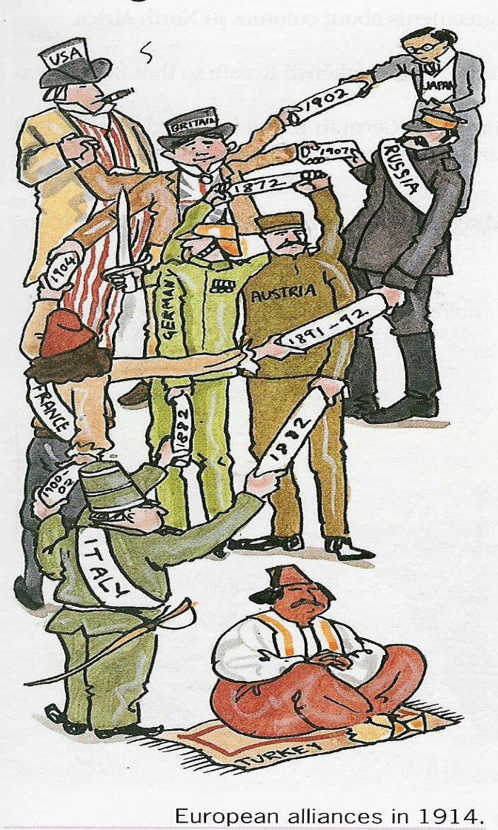

Austria
France
Italy
USA
Britain

Russia

Germany

Turkey

- The concept that is being conveyed through this cartoon is the idea of pursuing national interest through:

  - spheres of influence
  - imperialist policies
  - arms stockpiling
  - alliance systems

Use the following source to answer questions 7 & 8.
Article 231

The Allied and Associated Governments affirm and Germany accepts the responsibility of Germany and her allies far causing all the loss and damage to which the Allied and Associated Governments and their nationals have been subjected as a consequence of the war imposed upon them by the aggression of Germany and her allies.

- Article 231 is better known as the_______________, and was part of the __________________.

  - War Guilt Clause: Berlin Peace Accord
  - War Guilt Clause: Treaty of Versailles
  - Reparations Clause: Treaty of Versailles
  - German Aggression Clause: Allied Manifesto

- Article 231 most likely reflects the input of which of the “Big Four”?

  - Clemenceau of France
  - Wilson of the USA
  - Orlando of Italy
  - Both A and B

- The best rationale for why levels of bloodshed were so high during WWI compared to past wars is:

A. the use of new technology and old military strategies

B. the involvement of multiple European countries

C. the use of new war machines in the sky and sea

- due to the high world population at the time

- Which of the following is NOT an indicator of Canada’s new national prominence that was established during the WWI era?

  - Canadian war hero (Billy Bishop) was celebrated internationally
B. Canadian troops are led by Canadian Generals by the end of the war
C. Canada gets a seat at the table during the ‘Treaty of Versailles’ meetings
D. Canadians arrive in Europe as Canadian soldiers, not as a British Imperial soldiers

SECTION 2: Genocide, Crimes Against Humanity
Use the following list to answer the next two questions.
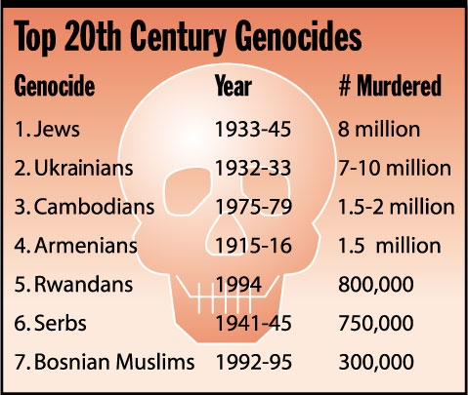

11. | Two of the genocides found on the list occurred in
 |  | A. | Sudan
 |  | B. | Turkey
 |  | C. | Yugoslavia
 |  | D. | the Soviet Union (USSR)

12. | All of the following belong on the above list except
 |  | A. | the Holocaust.
 |  | B. | the Holodomor.
 |  | C. | the massacre of the Tutsis by the Hutus.
 |  | D. | the internment of Ukrainians during the First World War.

Use the following list to answer the next five questions.
- The organization of militias or paramilitary groups
- The use of identity cards to identify specific groups
- The segregation of specific groups
- The use of the media to demonize or dehumanize specific groups

13. | What is shown on the above list?
 |  | A. | Main objectives of total warfare
 |  | B. | Warning signs of a coming genocide
 |  | C. | Strategies for discouraging and punishing draft dodging
 |  | D. | Ways of democratically preventing the rise of fascism and terrorism

14. | Which of the following could be correctly added to the above list?
 |  | A. | The enforcement of compulsory military service
 |  | B. | The passing of hate laws to punish extremist groups
 |  | C. | The exclusion of targeted groups from positions of power
 |  | D. | The imprisonment of enemy agents and spies during wartime

15. | Which item on the above list is most closely associated with the practice of “scapegoating”?
 |  | A. | Item 1 (Organization of militias and paramilitaries)
 |  | B. | Item 2 (The use of identity cards)
 |  | C. | Item 3 (Segregation)
 |  | D. | Item 4 (Use of the media to demonize or dehumanize)

16. | Which item on the above list is most closely associated with the practice of “ghettoization”?
 |  | A. | Item 1 (Organization of militias and paramilitaries)
 |  | B. | Item 2 (The use of identity cards)
 |  | C. | Item 3 (Segregation)
 |  | D. | Item 4 (Use of the media to demonize or dehumanize)

17. | Which of the following are examples of militias or paramilitaries?
 |  | A. | Auschwitz, Sobibor and Treblinka
 |  | B. | The Interahamwe and the Janjaweed
 |  | C. | Internment operations in Canada during World War I and World War II
 |  | D. | Japanese kamizake units and Allied bomber squadrons during World War II

18. | Most of the genocides of the twentieth century were planned and carried out by
 |  | A. | states.
 |  | B. | stateless nations.
 |  | C. | moderate nationalists.
 |  | D. | German ultranationalists.

Use the following statement to answer question 19
The nationalist not only does not disapprove of atrocities committed by his own side, but he has a remarkable capacity for not even hearing about them.

--George Orwell

19. | More than anything else, the above statement is a criticism of
 |  | A. | uniformed public opinion.
 |  | B. | nationalist bias and denial.
 |  | C. | nationalist acts of shocking cruelty and inhumanity.
 |  | D. | the act of binding oneself intellectually or emotionally to a nation.

20. | Ultranationalism is often associated with a belief that
 |  | A. | one country is superior to all others.
 |  | B. | the nation is a poor foundation for identity.
 |  | C. | national interests should be pursued only to a limited extent.
 |  | D. | international laws and organizations are needed in an interdependent world.

SECTION 3: Self-determination
Use the following information to answer questions 21 and 22
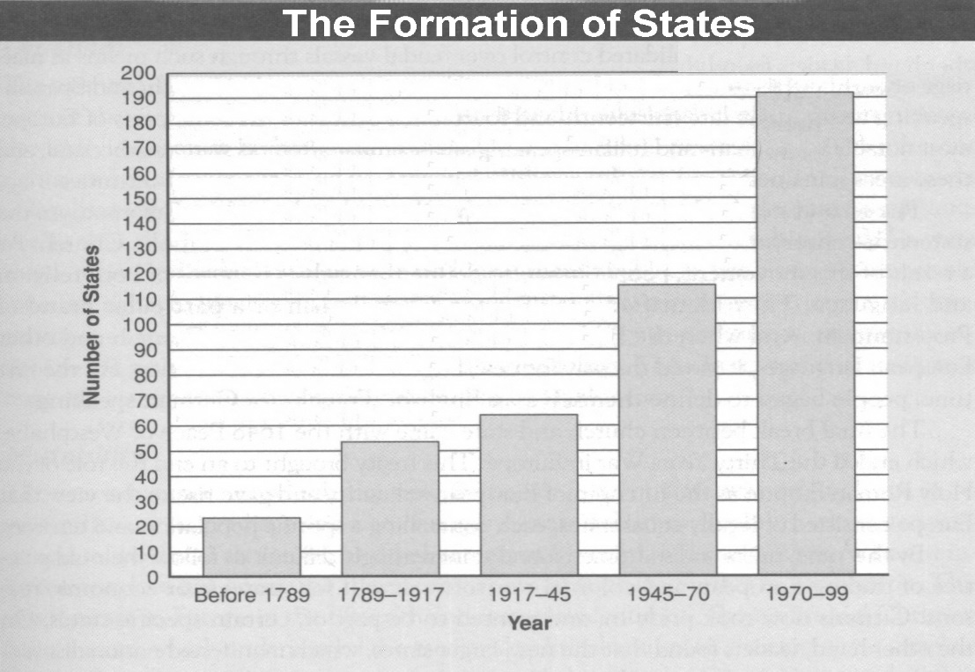

21. | The increase in the number of states over the 1789-1999 era was mainly the result of
 |  | A. | imperialism.
 |  | B. | total warfare.
 |  | C. | self-determination movements.
 |  | D. | national unification movements.

22. | The creation of new states during the 1945-1970 period was largely the result of
 |  | A. | the mandate system of the League of Nations.
 |  | B. | the trusteeship program of the United Nations Organization.
 |  | C. | the process of decolonization in Asia and Africa after World War II.
 |  | D. | the disintegration of multinational states in eastern Europe, such as the Soviet Union.

Use the following graphs to answer questions 23-25
 | Source I
Number of nation-states created
Annual rate of nation-state creation | Source II

23. | In Source I, the “most-active” year of nation-state creation was largely the result of
 |  | A. | the Paris Peace Conference.
 |  | B. | the decolonization of Africa.
 |  | C. | the break-up of the Soviet Union.
 |  | D. | the creation of the League of Nations.

24. | Source II shows that the most common means of achieving national statehood during the 1986-2000 period was through
 |  | A. | civil wars or guerilla warfare.
 |  | B. | national unification movements.
 |  | C. | the withdrawal of dissatisfied peoples from existing states.
 |  | D. | pan movements that integrated sovereign nations into federations.

25. | Both sources indicate that the most productive period of nation-state creation was
 |  | A. | the Interwar Era.
 |  | B. | the Second World War.
 |  | C. | the last quarter of the nineteenth century.
 |  | D. | the second-last quarter of the twentieth century.

