How Hitler’s Rise to Power Explains Why Republicans Accept Donald Trump
By Jonathan Chait for NYMag (fair use – academic study) July 7, 2016 (prior to US presidential election)
http://nymag.com/daily/intelligencer/2016/07/donald-trump-and-hitlers-rise-to-power.html
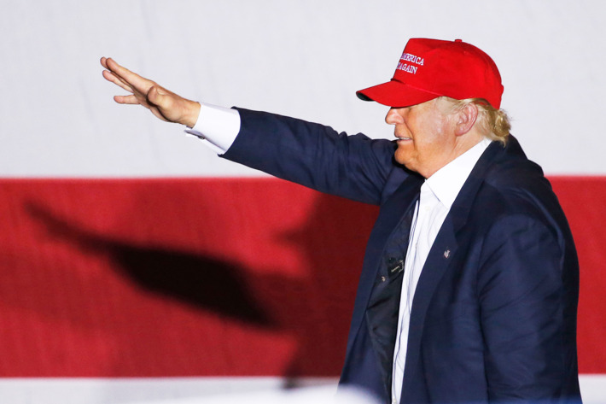
A possibly unfair image of Donald Trump. Photo: Rhona Wise/AFP/Getty Images
To watch Donald Trump rant and rave uncontrollably on the stump and on Twitter — praising Saddam Hussein for his disregard for civil liberties, insisting the anti-Semitic propaganda he inadvertently borrowed from neo-Nazis is as innocent as a Disney poster — is to ponder the psychology of a party that would entrust supreme executive authority to a racist, nationalistic, power-worshiping demagogue.
Like Hitler, Trump is a radical, authoritarian figure who lies outside the normal parameters of his country’s conservative governing class. Thus, there is a parallel between the two men’s unexpected rise to power that is worth considering: Why would traditional conservatives willingly hand power to a figure so dangerous that he threatened their own political and economic interests? Why, having failed in their halfhearted efforts to nominate an alternative candidate during the primaries, don’t they throw themselves behind a convention coup, a third-party candidacy, or defect outright to Hillary Clinton? Why do so many of them consider Trump the lesser rather than the greater evil?
Hitler’s Thirty Days to Power, by the historian Henry Ashby Turner, describes the political machinations that allowed Hitler to seize the chancellorship of Germany. (I stole the idea to read it from Matthew Yglesias, via Twitter.) In January 1933, the Nazi party’s vote share had begun to decline, and its party was undergoing a serious internal crisis, with dues falling, members drifting off, and other leaders questioning Hitler’s direction. A widely shared belief across the political spectrum at the time held that Hitler would not and could not win the chancellorship, because Germany’s revered conservative president, Paul von Hindenburg, had long vowed to deny such a position to Hitler.
Hindenburg and the German right viewed Hitler in strikingly similar terms to how Republican elites view Trump. Yes, they badly underestimated his fanaticism, which Hitler had downplayed in public. While they failed to anticipate that Hitler would launch a total war and industrial-scale genocide, they did consider him a buffoon. Alfred Hugenberg, leader of the German-Nationals, deemed the Nazis “little better than a rabble, with dangerously radical social and economic notions,” writes Turner. Hindenburg considered Hitler qualified to head the postal ministry at best. Hitler, in their eyes, was not a serious man, unfit to govern, a classless buffoon. His appeal, the German elite believed, came from his outsider status, which allowed him to posture against the political system and make extravagant promises to his followers that would never be tested against reality. What’s more, Hitler’s explicit contempt for democracy made even the authoritarian German right nervous about entrusting him with power.
All this is to say that German conservatives did not see Hitler as Hitler — they saw Hitler as Trump. And the reasons they devised to overcome their qualms and accept him as the head of the government would ring familiar to followers of the 2016 campaign. They believed the responsibility of governing would tame Hitler, and that his beliefs were amorphous and could be shaped by advisers once in office. They respected his populist appeal and believed it could serve their own ends. (Hugenberg, writes Turner, “recognized that [the Nazis] were far more successful than his party in mobilizing mass support and hoped to harness their movement to destroy the republic and establish a rightist authoritarian regime.”) Their myopic concern with specifics of their policy agenda overcame their general sense of unease. (One right-wing landowner was “hopeful of relief measures by a Hitler cabinet for the depressed agriculture of the east,” and thus concluded “the army and the forces of conservatism would suffice to prevent a one-party Nazi dictatorship.”) Think of the supply-siderssupporting Trump in the hope he can enact major tax cuts, or the social conservatives enthused about his list of potential judges, and you’ll have a picture of the thought process.
There is one more parallel between the events of 1933 and the events of 2016: Most of the complicit parties (the main exception being the scheming Franz von Papen) did not fully apprehend the extent of their actions until it was too late. In Germany, Hitler’s ascent required complicated intrigue, the upshot of which was that conservatives believed they had parliamentary leverage that would restrain Hitler. They placed enormous faith in the power of this leverage, until the final two days, when the rumor of an impending military coup rushed their timetable, and the once-crucial terms of Hitler’s chancellorship became forgotten details, discarded in a mad rush.
The Republican Party’s timetable for ushering Trump into the Oval Office appears at first glance to be much more leisurely. Republicans may feel like they can endorse Trump now, avoiding the consequence of alienating their pro-Trump constituents, secure in the knowledge that he is likely to lose. It probably does not feel to Trump’s queasy endorsers that they are actually helping to make him president. But appearances are deceiving. Betting markets give Trump better than a one-in-four chance to prevail. FiveThirtyEight, a more reliable forecaster, gives him better than a one-in-five chance. That is not negligible. If Trump’s polls improve, the pressure for Republicans to support him will only grow. There is, realistically, little opportunity for Republicans to stop Trump once they have jumped aboard. Through Election Day, a Trump presidency will be a mere hypothetical. Afterward, if it happens, the reality will descend all at once.
That reality is stark. Trump’s admiration for ironfisted dictators, not only in Ba’athist Iraq but Russia, China, and North Korea, is the ideological lodestar of his long history of political musings. Over the years, Trump has weaved left and right on health care, abortion, taxes, and even the issues currently central to his campaign, like immigration and trade, but has never wavered from his foundational belief that strong leaders are those who crush their enemies without restraint. Whatever norms or bounds that we think limit the damage a president could inflict are likely to be exceeded if that president is Trump. Those Republicans who publicly endorse Trump because he probably won’t win may be making an error on a historic scale.

