Recounting a day of rage, hate, violence and death
How a rally of white nationalists and supremacists at the University of Virginia turned into a “tragic, tragic weekend.”
https://www.washingtonpost.com/graphics/2017/local/charlottesville-timeline/?utm_term=.040a023e0352
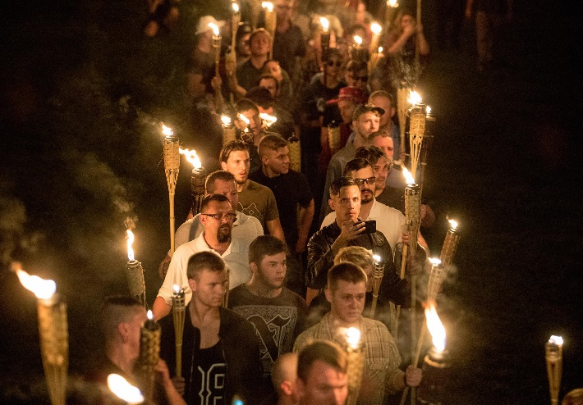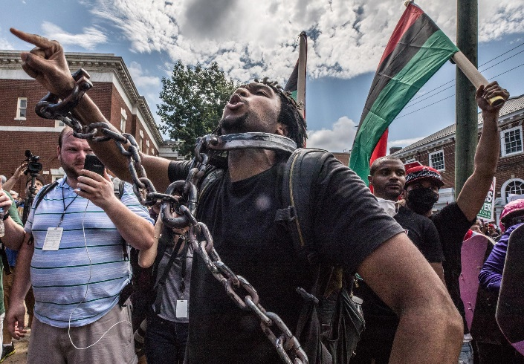
LEFT: Chanting, “White lives matter!” “You will not replace us!” and “Jews will not replace us!” several hundred white nationalists and white supremacists marched Friday as part of a Unite the Right rally at the University of Virginia that resulted in violence and three deaths the next day. RIGHT: Members of the Black Lives Matter movement stage a counter-protest at the rally on Saturday. (Photos by Evelyn Hockstein for The Washington Post)
By Joe Heim
Aug. 14, 2017
CHARLOTTESVILLE — Rumors circulated all week. Details were scant. No time or place was certain, but the word was that white nationalists and supremacists coming to town for Saturday’s Unite the Right rally had a Friday night surprise. They were going to march in a torchlight procession — a symbolic gathering meant to evoke similar marches of Hitler Youth and other ultraright nationalist organizations of the past century.
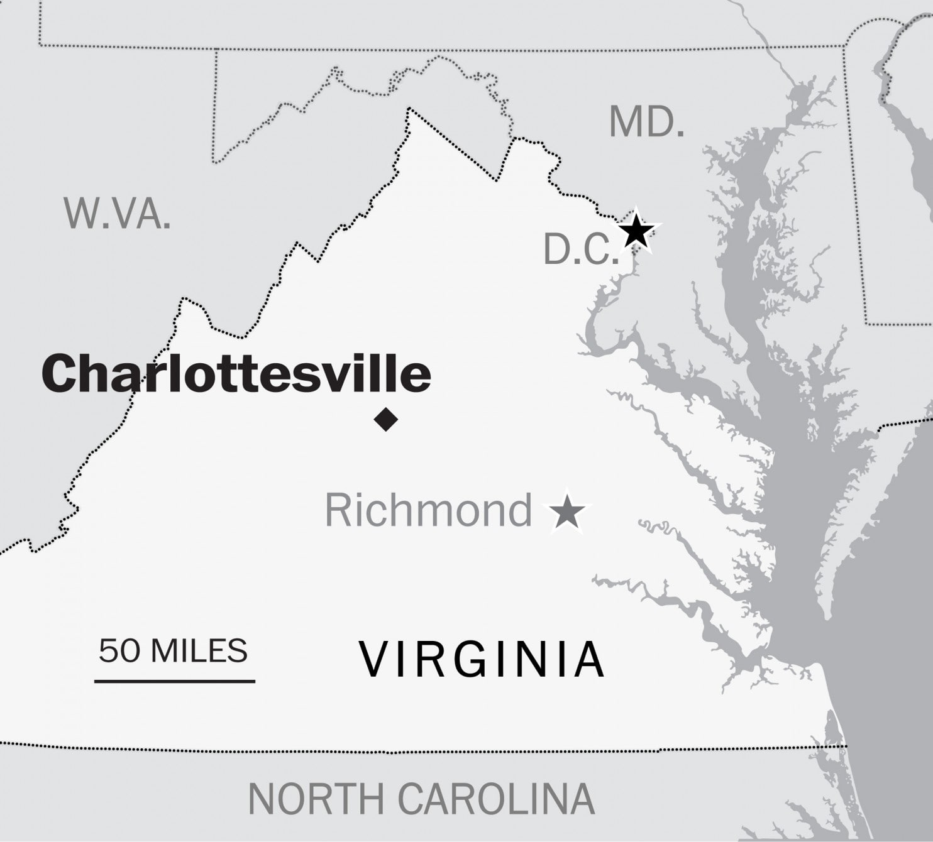
A little after 8 p.m., Richard Spencer, a leader of far-right white nationalists and a scheduled headline speaker at the Saturday rally, texted a reporter.
“I’d be near campus tonight, if I were you,” he wrote. “After 9 p.m. Nameless field.”
The rumor was true. The torchlight parade was on. It would prove to be the catalyst for a horrific 24 hours in this usually quiet college town that would come to be seen by the nation and world as a day of racial rage, hate, violence and death.
When it was over, questions about how this could happen centered on three groups: a meticulously organized, well coordinated and heavily armed company of white nationalists; a fiercely resistant and determined group of counterprotesters prepared to stop the Saturday rally; and state and local authorities who seemed caught off guard by the boldness and persistence of both groups.
By 8:45 p.m. Friday, a column of about 250 mostly young white males, many wearing khaki pants and white polo shirts, began to stretch across the shadowy Nameless Field, a large expanse of grass behind Memorial Gymnasium at the University of Virginia. Their torches, filled with kerosene by workers at a nearby table, were still dark.
“Stay in formation!” barked an organizer carrying a bullhorn. “Two by two! Two by two!”
Within minutes, marchers lit their torches. Additional organizers, wearing earpieces and carrying radios, ran up and down the line shouting directions.
“Now! Now! Go!”
The marchers took off at a brisk pace and immediately began yelling slogans: “Blood and soil!” “You will not replace us!” “Jews will not replace us!”
The chants echoed as the group marched past the iconic halls of the university founded by Thomas Jefferson, paraded down the middle of the hallowed Lawn, climbed to the rotunda and converged on a statue of Jefferson himself.
There they met their enemy. A group of about 30 U-Va. students — students of color and white students — had locked arms around the base of the statue to face down the hundreds of torchbearers. The marchers circled the statue. Some made monkey noises at the black counterprotesters. Then they began chanting, “White lives matter!”
Within moments, there was chaos. Shoves. Punches. Both groups sprayed chemical irritants. Many marchers threw their torches toward the statue and the students.
Other than one university police officer, there was no sign of law enforcement along the march, and it was several minutes before police intervened. Both sides suffered injuries. They relied mostly on their cohorts for treatment until emergency personnel arrived.

Swinging, punching, spraying
Robert E. Lee
The next day would be much worse.
The rally on Saturday was scheduled to go from noon to 5 p.m., but by 8 a.m., the park was already beginning to fill. Rallygoers arrived in contingents, waving nationalist banners and chanting slogans. Many carried shields and clubs. A large number also carried pistols or long guns.
Counterprotesters had also gathered early. Members of anti-fascist groups yelled at the rallygoers. Many of them also carried sticks and shields. They were joined by local residents, members of church groups, civil rights leaders and onlookers.
In downtown Charlottesville, most stores and restaurants closed for the day.
At 9:30 a.m., about 30 clergy members clasped arms and began singing “This Little Light of Mine.” Twenty feet away, the white nationalists roared back, “Our blood, our soil!”
In the midst of the two groups, another force arrived. Dressed in full camouflage and outfitted with semiautomatic rifles and pistols, three dozen members of a self-styled militia walked onto the sidewalk. Christian Yingling, who described himself as the commander of the unit, said they were there to keep the peace. He said members of the Charlottesville Police Department welcomed their presence. Although Virginia is an open-carry state, the presence of the militia was unnerving to law enforcement officials on the scene.
“The militia showed up with long rifles, and we were concerned to have that in the mix,” said Virginia Secretary of Public Safety and Homeland Security Brian Moran, who worried that the rallygoers and counterprotesters would mistake the militia for National Guard forces. “They seemed like they weren’t there to cause trouble, but it was a concern to have rifles in that kind of environment.”
Although Virginia State Police and Charlottesville police were stationed along the sides and the rear of Emancipation Park, the Market Street side was unattended. As it filled with rallygoers and counterprotesters, the mix quickly became volatile. The two sides screamed at each other. “F--- you, Nazis!” the counterprotesters chanted.
“F--- you, f-----s!” was the response from the park where the rallygoers stood behind metal barricades.
A lone figure stood inside Emancipation Park, offering water and holding a sign that said, “Free Hugs.” Tyler Lloyd said he came hoping for a peaceful solution. The rallygoers accepted his water but declined the hugs.
By 10:30 a.m., there had been a few small skirmishes, but the fury was building, and it became obvious that a brawl would be stopped only if police stepped in.
They did not.
Charlottesville Police Chief Al S. Thomas Jr. said the rallygoers went back on a plan that would have kept them separated from the counterprotesters. Instead of coming in at one entrance, he said, they came in from all sides. Headlong into the counterprotesters.
A few minutes before 11 a.m., a swelling group of white nationalists carrying large shields and long wooden clubs approached the park on Market Street. About two dozen counterprotesters formed a line across the street, blocking their path. With a roar, the marchers charged through the line, swinging sticks, punching and spraying chemicals.
Counterprotesters fought back, also swinging sticks, punching and spraying chemicals. Others threw balloons filled with paint or ink at the white nationalists. Everywhere, it seemed violence was exploding. The police did not move to break up the fights.
Thomas said his officers were in their regular uniforms and needed to hurry into their armor.
“The concern was that the fighting was in the middle of the crowd and that if we went in there, we would lose formation, lose contact,” Moran said. “We would be putting the public and law enforcement in jeopardy.”
Bottles and rocks continued to fly back and forth between rallygoers and counterprotesters. Smaller fights broke out and then settled. As the sporadic violence worsened, law enforcement leaders decided they had seen enough.
“At 11:22, we declared an unlawful assembly,” Moran said. “We quelled the disturbance at that point.”
He rejected the idea that law enforcement had mishandled events by not acting sooner and with greater force.
“To say we were unprepared or inexperienced is absolutely wrong,” he said. “We unequivocally acted at the right time and with the appropriate response.”
Thomas, though, acknowledged a “tragic, tragic weekend.”

Three fatalities
Within minutes of the dispersal order, the right-wing groups began leaving the park, still exchanging taunts and insults with counterprotesters as they made their way toward McIntire Park, a mile from downtown. Citing public safety concerns, the city had tried to move the rally to McIntire earlier in the week. But rally organizer Jason Kessler, a Charlottesville resident, sued the city, saying his First Amendment rights were being violated. A federal judge ruled in Kessler’s favor Friday.
Within minutes of the dispersal order, the right-wing groups began leaving the park, still exchanging taunts and insults with counterprotesters as they made their way toward McIntire Park, a mile from downtown. Citing public safety concerns, the city had tried to move the rally to McIntire earlier in the week. But rally organizer Jason Kessler, a Charlottesville resident, sued the city, saying his First Amendment rights were being violated. A federal judge ruled in Kessler’s favor Friday.
“Go the f--- home!” a black woman yelled at the passing group.
“Go the f--- back to Africa,” one yelled back. “F--- you, n-----!” many also screamed. “Dylann Roof was a hero!” another yelled, referring to the white supremacist who killed nine African Americans in a church in Charleston, S.C., in 2015. Another lit a flare and threw it at a Washington Post videographer. She jumped out of the way.
As the mass of white nationalists marched from the center of town in the midday heat, it felt like a major disaster had been averted. Several people were injured and some arrested, but nothing serious. The counterprotesters had not followed the group from downtown, and things appeared to be calming down, despite sporadic fighting around town.
There was wound-licking to be done on both sides. The rally had been stopped before it was supposed to begin. Both sides thought the police should have intervened earlier to keep the peace. But both sides were claiming victory.
At McIntire, rallygoers were informed that a state of emergency had been declared. The rally would not go forward. Cars and vans with license plates from all over the country began to arrive and pick up the marchers.
But a long and bleak day was about to get much worse.
At 1:14 p.m., the Charlottesville city Twitter account tweeted: “CPD & VSP respond to 3-vehicle crash at Water & 4th Streets. Several pedestrians struck. Multiple injuries.”
For those at McIntire, far from the scene, there wasn’t an immediate connection between the rally and what was at that point being called a crash.
Witnesses, though, had no doubt. It was “absolutely intentional,” Matthew Korbon said as he watched victims being loaded into ambulances. He had been standing on the sidewalk when rallygoer James Alex Fields Jr. allegedly roared his Dodge Challenger at a crowd of pedestrians. Heather Heyer, 32, of Charlottesville was killed, and 19 others were injured. Korbon said he saw the driver plow into one group and reverse into another.
[One dead as car strikes crowds amid protests of white nationalist gathering in Charlottesville; two police die in helicopter crash]
A state police helicopter filmed the incident, Moran said in an interview. At his arraignment Monday morning, Fields was asked by a Charlottesville judge whether he understood the five felony charges against him.
“Yes, sir,” he replied.
Late Saturday afternoon, onlookers began placing flowers on 4th Street. They held hands and prayed. They cried.
On Twitter, another report arrived: A helicopter had crashed in Albemarle County, just a few miles from downtown Charlottesville. A little after 7 p.m., officials said, one of the state police helicopters monitoring the rally had crashed. Two state troopers, Lt. H. Jay Cullen, 48, and Berke M.M. Bates, who would have turned 41 on Sunday, were dead. There had been no distress call, the National Transportation Safety Board said Monday.
It had been less than 24 hours since the torchlight march at the University of Virginia began.

