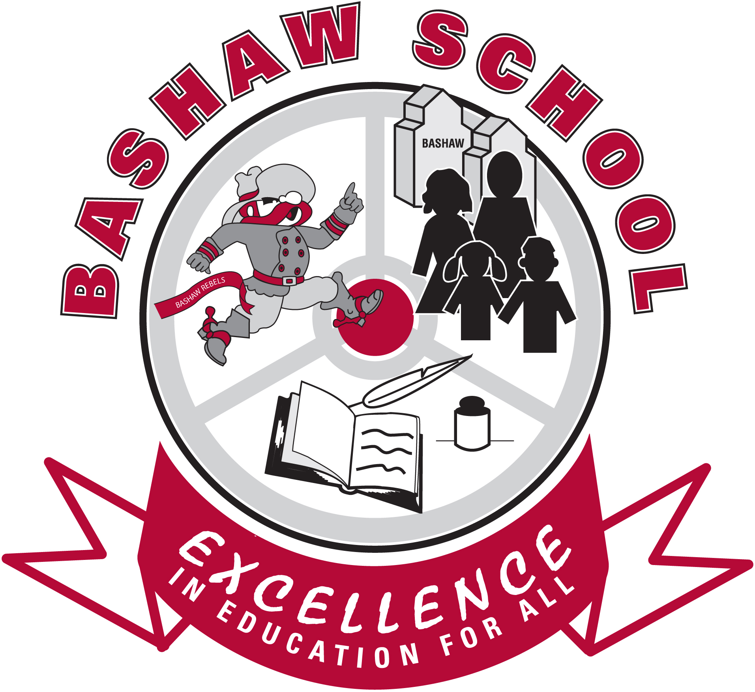
Bashaw School
Orange Shirt Day Toolkit – Version 2
2
2019 – Mr. Kyle McIntosh

Staff—

Orange Shirt Day is TODAY. I have gathered and collected resources that may assist you in bringing this event into your classroom. As a reminder, the TQS mandates that FNMI education touches every subject area and every grade level, with this joining the Knowledge, Skills, and Attributes of an Alberta teacher. Furthermore, we have been engaged in Orange Shirt Day activities for as long as the province has been an active participant in the process.

Thank you for taking part and furthering awareness in your classrooms.

K

Contents:

- Overview of Event / Event History
- A note about students who identify as FNMI
- Does it have to be a shirt?
- Letter to send home
- Div I Resources
- Div II Resources
- Div III/IV Resources
- Other Links/Ideas
- Contact and Revisions

Ka-ki-kiskêyihtêtan ôma, namoya kinwês maka aciyowês pohko ôma ôta ka-hayayak wasêtam askihk, êkwa ka-kakwêy miskêtan kiskêyihtamowin, iyinîsiwin, kistêyitowin, mina nânisitotatowin kakiya ayisiniwak, êkosi ôma kakiya ka-wahkotowak.

Realize that we as human beings, have been put on this earth for only a short time and that we must use this time to gain wisdom, knowledge, respect and understanding for all human beings, since we are all relatives. Cree Proverb

(NEHIYAWEWIN: CREE LANGUAGE AND CULTURE GUIDE TO IMPLEMENTATION: Grade Seven to Grade Nine Government of Alberta)

SURVIVOR CRISIS LINE: 1-866-925-4419.

Overview of Event / Event History

The Orange Shirt Campaign – Every Child Matters remembers the experiences of former students of Indian Residential Schools and is a commitment to ongoing reconciliation in Canada. Originating in British Columbia, this is the third year the campaign will be running in BC and other parts of Canada, and the first coordinated effort to celebrate the campaign in Alberta.

Orange Shirt Day is a legacy of the St. Joseph Mission (SJM) residential school commemoration event held in Williams Lake, BC, Canada, in the spring of 2013. It grew out of a residential school survivor’s, Phyllis, account of having her shiny new orange shirt taken away on her first day of school at the Mission. Orange Shirt Day has become an opportunity to keep the discussion on all aspects of residential schools happening annually. The date was chosen because it is the
time of year in which children were taken from their homes to residential schools, and because it is an opportunity to set the stage for anti-racism and anti-bullying policies for the coming school year. Orange Shirt Day is also an opportunity for First Nations, local governments, schools and communities to come together in the spirit of reconciliation and hope for generations of children to come.

This link has a great write-up on the story and related videos: orangeshirtday.org

In Bashaw School, no formal event is planned for this year though we will be working to build our medicine wheel in Sr High.

A note about students who identify as FNMI

Very few students on the whole identify as First Nations, Metis, or Inuit in our school. However, we must still be sensitive, as students and their relatives may have a history with residential schools we do not know about.

In particular, we need to be aware that we may cause intergenerational trauma if we do not handle such discussions with the appropriate tact. While study can and should happen, please monitor your students (as you always do!) for changes in emotion and modify your plans as necessary.

BE AWARE: This is one topic, in particular, where the teacher may not always be the expert. Our community may surprise us with insights.

Does it have to be a shirt?

No! Any orange attire on Orange Shirt Day is suitable for joining the celebration. Scarves and other simple accessories fit quite nicely and can serve as a prompt for students to engage with the topic. And, of course, invite students to participate as well…

Please note this was sent home school wide for the 2019 school year.

Letter to Send Home

September

Dear Parents,

Orange Shirt Day is a nation-wide event aimed at recognizing Truth and Reconciliation, particularly bringing awareness to the history of Residential Schools in Canada.

Orange Shirt Day is a legacy of the St. Joseph Mission residential school commemoration event held in Williams Lake, BC, Canada, in 2013.

It grew out of one woman’s account of having her shiny new orange shirt taken away on her first day of school at the Mission, and it has become an opportunity to keep the discussion on all aspects of residential schools happening annually.

Orange Shirt Day now takes place on September 30th each year. The date was chosen because it is the time of year in which children were taken from their homes to residential schools, and because it is an opportunity to set the stage for anti-racism and anti-bullying policies for the coming school year.

At Bashaw School students have the opportunity to participate in Orange Shirt Day.

Participation is voluntary.

Students may wear an orange shirt that they currently own or appropriate orange accessories such as scarves. Some informal events will be taking place around the school, depending on grade, to connect with our curricular outcomes.

For more information, please see the website below. http://orangeshirtday.org

You may also see the full text of the Government of Alberta’s commitment to increased FNMI learning opportunities here http://www.alberta.ca/release.cfm?xID=3611635CEB7FF-D766-841D-E7FC49FCADDD80B5

Should you have any questions or concerns, please do not hesitate to contact myself, Mr. McIntosh (kmcintosh@brsd.ab.ca), or Mrs. Shepherd (mshepherd@brsd.ab.ca )

Signed,

Div I Resources

NOTE: At this age range, discussion of residential schools is cautioned, at best.

The message “Every Child Matters” is more important, though some residential school connections can be made.

- “When I Was Eight”
Live reading found here: https://www.youtube.com/watch?v=LSBrkJn3NeI

Olemaun is eight and knows a lot of things. But she does not know how to read. Ignoring her father’s warnings, she travels far from her Arctic home to the outsiders’ school to learn. Based on the true story of Margaret Pokiak-Fenton, whose name was given to her by Inuit Agents, and complemented by stunning illustrations, allows students to meet this remarkable girl who reminds us what power we hold when we can read.

Have students colour orange hearts and write messages for Olemaun. These messages may be words of understanding, or you could complete a KWL chart with students.

- The First Day of School
Read a book that talks about the first day of school:
- Jessica by Kevin Henkes
- Scaredy Squirrel by Melanie Watt
- The Kissing Hand by Audrey Penn.

Have students talk about their feelings about the first day of school or when they were courageous/brave.

Read Phyllis’s story from orangeshirtday.org or watch it in the featured video.

Create a class book illustrating Phyllis’ story with promotes and student illustrations.

- Rupertsland Institute – K – 4 Presentation *NEW*
Focusing on the Metis experience in the 5-12 presentation, the K-4 online presentation is more general, asking students to engage in activities: There is a story reading, a chance to write an acrostic poem, and the hand cut out activity, along with extensions should you deem them appropriate. “When We Were Alone” is the book that is read.

Div II Resources
NOTE: At this age range, discussion of residential schools is cautioned, at best.
The message “Every Child Matters” is more important, though some residential school connections can be made, and additional connections to FNMI history and culture should be made.

- The Blanket Exercise (HIGHLY RECOMMENDED)

The KAIROS Blanket Exercise is a teaching tool that uses participatory popular education to raise awareness of the nation-to-nation relationship between Indigenous and non-Indigenous peoples in Canada. It teaches a history of Canada that most people never learn.

As the name suggests, the Blanket Exercise begins with blankets arranged on the floor to represent Canada before the arrival of European explorers and settlers. The participants, who represent Indigenous peoples, begin by moving around on the blankets. While a narrator reads from a script, other participants – representing the Europeans or newcomers - join and begin to interact with those on the blankets. As the script traces the history of the relationship between Europeans and Indigenous nations in Canada, the participants respond to various cues and interact by reading prepared scrolls. At the end of the exercise only a few people remain on the blankets, which have been folded into small bundles and cover only a fraction of their original area.

You can get a full facilitating guide from me via Google Docs.

- “I Remember” – First Nations Rap Song *UPDATED*

This music video—filmed in Saskatchewan—is really well done and was written and performed by Indigenous Canadians. The rap is appropriate for classes. You could have students pull out key ideas, descriptive language, or other related bits while connecting to the musician’s work.

Here is an accompanying article from CBC.

- The Eyes of Children – Christmas At A Residential School
Archival footage from the CBC. http://www.cbc.ca/archives/entry/the-eyes-of-children-life-at-a-residential-school Students could compare schooling from now and in the past and talk about Every Child Mattering.

Older kids: 11:45 or so is very powerful as the teacher effectively bashes the parents for not providing a “proper” Christmas.

Supplemental videos are available from CBC below the video.

A word of caution: This is a very ‘rosy’ perspective on Residential Schools. All the same, a real glimpse into a school is rare in film. As well, not all residential school experiences were “bad”…some certainly enjoyed and benefited from their time. Most did not.

- Tebatchomowin – Gr 5 Up

This resource has six full lessons within it. A strong arts and crafts theme is present throughout the activities. As well, an emphasis on real depictions of Aboriginal peoples is present throughout. These activities could be spaced throughout the year, using Orange Shirt Day as a kickoff of sorts.

Project of Heart: Students create art on symbolic tiles to commemorate survivors and their experiences.

Giving Voice to the Brick: Using photographs of an Indian Residential School students will engage in a creative writing project that will allow them to explore their feeling and reactions to what life was like for Indian Residential School students.

The Apology Revisited: Students use the federal governments apology as an introduction to the Residential School system.

Bearing Witness: Students listen to testimony of survivors and intergenerational survivors. The intent of this activity is to bear witness to real experiences and learn from their stories, express compassion and become advocates for change and reconciliation.

Sacred medicines: Students will learn about the four sacred medicines and how they are used.

Nunali: Art and Identity: Students will use Inuit art to create their own works to reflect their own identity.

- Shi-shi-etko (film adaptation – 6 minutes)

Watch the video – again, actual Indigenous people in the roles! Choose a related English activity, such as one of these two (shamelessly poached from the Manitoba Teachers organization):

- Inferring (to create personal meaning from the text, we use what the author tells us ,combine with what we already know to infer how the people are feeling in the story. We use details to infer the time of year and location) This story requires a great deal of inferring in the place of that character

Doing a Step Into the Book activity is a great way to get students to infer. Have a backdrop of nature prepared. Ask students to stand in front of the backdrop and take on the role of one of the characters-tell the class how they are feeling. Have two students simulate a conversation between Shi-shi-etko and another person from the story. Discuss the reasoning they used to portray the characters in the way they did. “I am Shi-shi-etko-I know I have to go but….” How did Shi-shi-etko feel?-readers have to use their prior knowledge to imagine how they might feel. How did her mother feel ? Her Father? Her Yaya?

- Determining Importance (Looking for the Big idea-what did the author want you to know about this little girl. How did you decide what was most important? Children need to be able to say why they think that was the most important part)

Ask students to draw one picture to explain the big idea of the story. Older students can do a fast write-everything I know about Shi-shi-etko and then choose-what is the most important thing of all the things I listed?

- NHL Goaltender Carey Price Shares Inspiring Message With Aboriginal Youth

http://www.cbc.ca/news/canada/montreal/carey-price-s-nhl-awards-speech-encourages-aboriginal-youth-1.3127244

At awards ceremony, the goalie shared a very powerful message. Discussion could involve the role and importance of heroes to a culture or a group.

- Rupertsland Institute – K – 4 Presentation *NEW*
Focusing on the Metis experience in the 5-12 presentation, the K-4 online presentation is more general, asking students to engage in activities: There is a story reading, a chance to write an acrostic poem, and the hand cut out activity, along with extensions should you deem them appropriate.

- A mother shares with her daughter her fears about school *NEW*
This powerful set of videos features Noela-Crowe Salazar speaking with her daughter about the Indian Residential School system. She first recounts the experience her father relayed to her about his time in IRS; then, she shares her fears and hopes with her daughter. Four videos in all from CBC.
<https://www.cbc.ca/player/play/1594068035672>.

Div III/IV Resources

Many of the resources in Div II may be upscaled here. (Indeed, #1 on my list, below, is just that.) The hard realities of life in a residential school is appropriate discussion starting in Grade 7. However, an emotional barometer is still needed with opt-outs an essential tool.

- The Eyes of Children – Christmas At A Residential School
Archival footage from the CBC. http://www.cbc.ca/archives/entry/the-eyes-of-children-life-at-a-residential-school Students could compare schooling from now and in the past and talk about Every Child Mattering.

11:45 or so is very powerful as the teacher effectively bashes the parents for not providing a “proper” Christmas. This is absolutely a point worth discussion and connects to many Social and Health outcomes.

Newspaper clipping: https://news.google.com/newspapers?nid=2194&dat=19621222&id=DDE0AAAAIBAJ&sjid=QvUIAAAAIBAJ&pg=3691,1862105&hl=en The Ottawa Citizen wrote about this back ahead of the film’s release. A talk on the ignorance that existed in Canada at the time is very valuable, and rooted to a primary source the connection should be made even more apparent.

A word of caution: This is a very ‘rosy’ perspective on Residential Schools. All the same, a real glimpse into a school is rare in film. As well, not all residential school experiences were “bad”…some certainly enjoyed and benefited from their time. Most did not.

- Red Deer Industrial Institute – web page

Something a little closer to home, this description of the RDII is interesting. The story it tells isn’t all bad—which we know to be the case about residential schools—but it can certainly be bleak at times. Choosing selected excerpts, read aloud to the class and initiate a discussion. The “Conditions and Student Health” section always generates gasps, but the workload, the removal from home communities, and other themes are crucial. http://thechildrenremembered.ca/school-locations/red-deer/

- Calls To Action

The Truth and Reconciliation Commission issued 94 calls to action (http://www.trc.ca/websites/trcinstitution/File/2015/Findings/Calls_to_Action_English2.pdf )

Discussion on select calls to action may be appropriate. Students could also create art inspired by select calls to action.

- “I Lost My Talk” – poem

Lesson plan, assessment, poem, bio, and obit all included here. Very powerful, short poem to be connected with English outcomes. http://www.mbteach.org/pdfs/pd/osd/OSD-RitaJoe.pdf

- “Diamonds in the Snow” and other songs

Outspoken MP Charlie Angus composed this song in response to the high youth suicide rates in Aboriginal communities. https://www.youtube.com/watch?v=OC4vrdMUaRI Tie in with health and English outcomes. I can provide transcribed lyrics, as well.
Students could be tasked to writing their MP, the responsible minister, or the Prime Minister (postage is free!) in response to this or other related issues.

“Je suis un témoin” is a French song with similar themes that could be studied while translating or otherwise. “Témoin” means witness. (English audio)

- We Are The Children – Videos (HIGHLY RECOMMENDED)
http://wherearethechildren.ca/en/stories/

These powerful videos offer up testimony of survivors in their own words. Very powerful.

Pair with The Truth and Reconciliation report “The Survivors Speak” found here http://www.trc.ca/websites/trcinstitution/File/2015/Findings/Survivors_Speak_2015_05_30_web_o.pdf

This massive document contains too many sections of note across its 200+ pages. If read aloud, DO NOT CORRECT GRAMMAR AS YOU READ.

Note: These stories can be graphic in nature. Please provide advance notice to students when employing these two resources.

- Historica Resources *NEW*
Need something that is ready to go for Jr or Sr Social/ELA? This guide includes a timeline, a link to a Heritage Minute, and varied activities such as completing a KWL (modified) chart / analyzing photos / think pair shares / and creating a museum exhibit.

http://education.historicacanada.ca/en/tools/261?c=17

- Rupertsland Institute – Grades 5-12 Presentation *NEW*
This presentation (Google Slides) features a Metis angle to the Residential School experience and includes a T/F interactive quiz.

- Health care and Jordan’s Principle *NEW*
When thinking of Canada’s history with First Nations, Metis, and Inuit people, it’s important to not just reflect on the Indian Residential Schools. Health care, in particular, has been particularly abusive to Indigenous Canadians over the years. Expanding our students’ understanding of the history of racism and government bureaucracy surrounding Indigenous peoples goes beyond just Indian Residential Schools.

Jordan’s Principle is in place after a young child named Jordan River Anderson—with complex medical needs—died after an unnecessarily long (2 years!) visit to a hospital while the provincial and federal governments squabbled. “Jordan's Principle calls on the government of first contact to pay for the services and seek reimbursement later so the child does not get tragically caught in the middle of government red tape.”

TB was often used as an excuse to abuse Indigenous peoples in Canada. Nanaimo and Edmonton have particularly deplorable histories, including using these people as test subjects for experiments without consent.

Dr. Maureen Lux shares her findings researching a “separate” health care system for Indigenous Canadians.

BC and Alberta have each implemented specific Indigenous Health branches to their systems in light of these histories.

Other Links/Ideas

- Full text of Premier Hancock’s announcement of incorporating more FNMI elements into AbEd as part of TRC.
- Journey to Reconciliation – Video for Educators
- Forgotten Metis – virtual tour of real life exhibition. Yes, Metis people were also included in residential schooling.
- Book: The Inconvenient Indian – Thomas King – This book (available in my classroom) is humorous yet scathing. It’s a history, of sorts…the type that isn’t taught in most social studies classrooms. King lived in Alberta for many years (his take on Lethbridge disappoints me) but it is essential reading.
- Book: Niitsitapiisinni: The Story of the Blackfoot People – a great resource coming from the Blackfoot Gallery Committee teaching about Blackfoot tradition in their own words. Residential schooling takes up a few pages – very powerful. Also available in my classroom.
- We Were Children – This film (by the NFB) is VERY powerful. If you’d like to use it in your mature classroom please contact me so I can ensure we have licensing available.
- Finding Heart – GREAT video on Youtube. Children—not just indigenous children—weigh in. Powerful. This becomes a brief documentary on one individual who chose not to stand by and watch.
- Factsheet: Misconceptions of Canada’s Residential School Systems – tells it like it is.
- Photographic Collections of Alberta’s Residential Schools – from the Government of Canada
- The Anglican Church of Canada Apology (and response)
- PM Harper Apologizes on Behalf of All Canadians (video)
- APTN (and others) contest PM’s motivation for the apology here.
- Blue Quills Residential School was used to inform this report on Intergenerational Trauma—a common topic when dealing with IRS. (Short summary)
- Gord Downie’s Secret Path is perhaps the most broadly known resource about Residential Schools (telling Chanie Wenjack’s tragic story). CBC, eOne, Gord Downie, Jeff Lemire and others have come together to create the music and animation. Lesson Plans are available from the Comox Valley School District and Manitoba Teachers Society (all grades).
- Indomitable by DJ Shub ft Northern Cree Singers is useful for both showing that there is hope for Indigenous Canadians and discussing what it means to live between two (or more) worlds. Images of a major pow wow show the fusion between modern and traditional cultures.

Contact and Revisions

The author of this document is Mr. Kyle McIntosh, B.A., B.Ed, adapting material from the Edmonton Public School Board and the Manitoba Teachers’ Society.

Permission is granted for educators to reproduce and distribute this material while keeping credits in place.

Support for this document can be reached by contacting me: kmcintosh@brsd.ab.ca

Date of Original Publication: September 26, 2016

Revision Log:

- September 27, 2019 – links updated (dead links removed or repaired); general additions from Historica & Rupertsland Institute; a section dedicated to Jordan’s Principle and health care; Gord Downie’s Secret Path.

