Social 30-2: Chapter 8 Part 1: Name: _______________

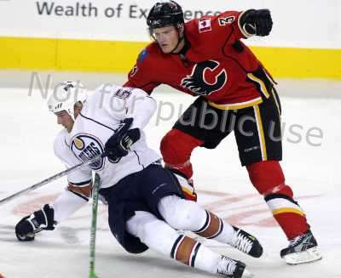**End of the Second World War: Agreements and Ideologies**

1. How is a hockey game like a war? _______________________

__________________________________________________

2. What is a hot war? _________________________________

___________________________________________________

3. What nations opposed each other in the Cold War? ________________________and ______________________

4. What ideologies conflict with one another? ___________________and ___________________

5. What did the two emerging superpowers try to acquire at the end of WWII?

_____________________________________________________________________

**Chapter Issue: To what extent does ideological conflict influence international relations?**

**Setting the Stage for ending the War (or for creating the Cold War) - Yalta Conference**

6. Explain the purpose of the Yalta Conference. ________________________________________

_____________________________________________________________________________

7. Identify the two outcomes of Yalta that would help redraw the map of Europe. __________________________________________________________________________________________________________________________________________________________

8. Who were the big three? ______________________, ____________________, and___________________________



9. What were the 5 outcomes of the Potsdam conference?

______________________________________________________________________________________________________________________________________________________

In order to understand how ideologies come into conflict we first must understand the language of the Cold War.

**Define the following words** read all of page 189 to get the definitions before you ask for help ☺

10. Spheres of Influence _____________________________________________________________________________

_____________________________________________________________________________

11. Expansionism ________________________________________________________________

_____________________________________________________________________________  
12. Explain why Stalin wanted to control Germany (try to use the words above to answer your question) ___________

__________________________________________________________________________________________________________________________________________________________

The Soviet Union was adamant that they would never be invaded again!

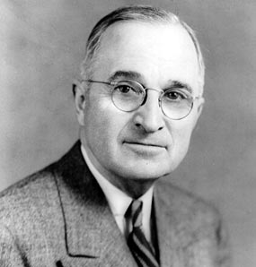

To combat Soviet expansion the USA created a political and an economic policy to stop the spread of communism. **KNOWN AS CONTAINMENT!**

13. Read the quote on page 190 and find 2 statements that reflect President Harry Truman’s belief in defending democratic liberalism.

a)______________________________________________________

b)______________________________________________________

**Terminology Time… yet again, define each of the words below? Starts on page 190**

14. What is the Truman Doctrine and explain how Truman planned to stop Communism from spreading?

__________________________________________________________________________________________________________________________________________________________

15. What is the Marshall Plan and how did the Soviet Union react to this plan?

_____________________________________________________________________________

_____________________________________________________________________________

16. What is the Molotov Plan and what was the purpose of the plan? _____________________________________________________________________________

_____________________________________________________________________________

17. Why would the US offer money to all nations, Democratic or Communistic?

__________________ __________________________________________________________

18. Were there any ‘conditions’ if your nation accepted the Marshall plan? __________ what were these conditions? _______________________________________________________________

____________________________________________________________________________

These plans did not really prevented Soviet expansionism; it divided the world into spheres of influences and military alliances.

19. During the Cold War nations HAD to choose sides:

________________________ and the Soviet sphere of influence, or capitalist ________________

____________________ the US sphere of influence

20. Define the tem alliance – use your memory from grade 11 or use a dictionary – it is not in the book.

Alliance: ______________________________________________________________________

21. List three reasons for joining alliances.





22. Who is reaching for control of countries? What part of the world is he grabbing?

_______________________________________________

23. Why did the USSR desire a sphere of influence? Read the Voices section on page 192.

________________________________________________________________________________________________

26. Explain the importance of each date or military/economic alliance and which nations are involved.

March 17, 1948:

1949:

Warsaw Pact:

COMECON: