What The Media Won’t Tell You About The Oka Crisis
Posted on July 15, 2010 | 3 Comments

I assume you are familiar with the background and chronology of what is
today known as “The Oka Crisis.” A list of suggested materials for further study is provided after this essay. In my estimation, all of them are worthy of your time. My purpose in this short piece is not to rehearse the already amply-stated; it is instead to provide you some remarks concerning the events of 1990 which I am confident you have not encountered in Canada’s media.

In August 1990 I moved from Niagara to Kingston. Four days earlier, the Canadian Army had occupied the community. I contemplated a show of support for Kanesatake — now a half-day’s drive away — but quickly came to the conclusion there was nothing I could do that wasn’t useless and indeed reckless. The main problem, it seemed to me, was that there were too many outsiders in Kanesatake and Kahnawake already.

Most Canadians misapprehend the Kanesatake conflict. The media coverage is to a degree responsible, but it should also be allowed that historical conflicts are by their nature highly complex. Consider the bloody dissolution of Yugoslavia, which was near unintelligible to most Westerners. Slobodan Milošević instigated Serbian nationalist attacks of Albanians in the 1990s by invoking the 1389 Battle of Kosovo with the Ottomans. In this one sentence there is a lot of history (some of it arguably bogus) and a lot of ethnic division at work. In similar fashion, the proposed 1990 expansion of an Oka golf course invoked a land dispute going back to the early eighteenth century, unresolved to this day. Those who see the Oka Crisis as a dispute over a golf course see a flat rendering of a three-dimensional world.

Here is what most Canadians don’t know about the Oka Crisis, and likely never will. Very few community members in Kanesatake or Kahnawake wanted the barricades. By “community members” I mean just that: the Kanien’keha:ka [Mohawk] men, women, and children who live in these two communities, and in nearby Oka. The people were caught between, on the one side, Canadian politicians such as the Mayor of Oka, Jean Ouellette, and on the other hand, the so-called “Mohawk Warriors.” Municipal and provincial politicians immediately resorted to force, deploying first the Sûreté du Québec and thereafter the army. (Federal politicians, for instance the spineless Minister of Indian Affairs, Tom Siddon, mostly just twiddled thumbs and waited for the mess to go away.) This militancy suited the Warriors just fine, since their interest is not in land settlements or Mohawk sovereignty or even in the well-being of the community itself, but in the operation of a petty third-world crime empire.
The Warriors had come to Oka from across the United States and Canada to pursue a plan, and the Canadian politicians — whose collective failure at Oka has yet to receive an adequate accounting — were playing right into it.

The plan of these Warrior outsiders was to provoke Canada to armed battle at Oka, on the assumption Canada would be surprised by the fierceness of the Warriors. First a fight, then negotiations cloaked in the Haudenosaunee, the Kaswentha (Two Row Wampum — the Nation-to-Nation treaty with Canada) and the ongoing land claims. The Warriors since the 70s have been adept at co-opting both the good name and legitimacy of the Haudenosaunee, or “Iroquois Confederacy,” but have no real interest in the struggles. The goal has always been to place Mohawk territories outside of Canada’s legal jurisdiction, thereby giving the Warriors a law-free zone to do what they do best: make money from drugs, cigarettes, weapons, and gambling. To this end the people of Kanesatake were put before Canada’s army, by thugs who play the game of Haudenosaunee dress-up.

The disgusting and sad fact of the Oka Crisis is that this strategy worked. The Warriors are much stronger today as a result of what happened in Oka. Their crime empire thrives. Canada treads more lightly, a fact evident in the Caledonia occupation. Many indigenous people in Canada, as well as Canadians, regard the Warriors as a legitimate voice of the Haudenosaunee. I have often seen, to my sorrow, Warrior flags flown by Aboriginal people at gatherings. If only they knew. (Some do, and still approve, but that’s another matter.) Meanwhile none of the community’s land claims has been addressed. The mess persists, and the people tossed unwillingly into the Warriors’ filthy little 1990 gambit today suffer post-traumatic stress disorder. The Warriors are a cancer, as threatening to the aspirations of the Haudenosaunee as any Canadian soldier or Indian-hating politician.

Those who say nothing has changed are wrong. Matters have gotten worse. The Oka Crisis has further divided and wounded the Haudenosaunee. The Warriors attract our angry and hopeless youth, and submit the communities to further harms. Their hypocrisies turn the public against us. They misrepresent themselves as spokespersons of the Confederacy, which they are not, and make a mockery of our struggles and aspirations. And always — always — the needs and concerns of the people are pushed aside so the bullies can better work the camera. On a silly CBC Radio program called ReVision Quest, broadcast last night, comedian and host Darrell Dennis at least got one thing right: “it’s kind of ironic,” he said, “twenty years later, the lasting impact of the biggest armed confrontation between Aboriginals and Canada in recent history has been to push Aboriginals to buy into the Canadian system.” This too is ia legacy of the bogus, corrosive, and repellent work of the Warriors.

Twenty Years after the Oka Crisis, Injustice Continues
Jul 11

Posted by Enaemaehkiw Túpac Keshena

This article comes from Coalition of Solidarity with Native People, a Francophone solidarity group in Canada. N..B. this article is translated from French, so please excuse any linguistic oddities.
On July 11, 1990, the Surete du Quebec, responding to an injunction sought by the mayor of Oka, Jean Ouellette, invaded the small Mohawk community of Kanehsatake.Four months earlier, had started a vigil to protest peacefully against the draft of the town of Oka to expand its golf course and build a parking lot on the traditional territory of the community, threatening its ancient pine forest and cemetery. Tension had been rising steadily since then, which had convinced the Mohawks shut down a secondary road through the pine forest.

At five o’clock on the morning of 11, the SQ goes on the attack, causing the response of Aboriginal armed. A member of the Response Unit (SWAT) of the SQ, Marcel Lemay, was fatally shot. The police retreated in disorder. Barricades were erected on Route 344. In a gesture of solidarity, the Kahnawake Mohawks blocked the Mercier Bridge.This is the beginning of what is called the Oka crisis. It lasted 78 days, shattering not only Quebec but all of Canada.

Despite lip service by the government after the crisis, yet nothing has really changed for Aboriginal people and even less for the Mohawks of Kanehsatake where the root causes of the crisis remain whole.

A territory under constant threat

The news has been given responsibility for reminding us. Early in June 2010, Montreal promoter Normand Ducharme, announced his intention to appeal to the Sûreté du Québec to enable the achievement of a construction project along Route 344, on land located just opposite the Pine Forest Kanehsatake. Last January, the Mohawks had to protest to convince the developer to abandon its intention to proceed with clearing the land.

Another very controversial project could soon be approved by the Government of Quebec. This project of mine Niocan. It wants to exploit an ore of niobium (the radioactive element) Oka, on the territory of the Lordship of the Mohawk Mountains Two considers them for over 290 years. In addition, the company has never been able to demonstrate beyond doubt that no harmful effects would affect the region and in particular it does not contaminate soil and drinking water sources used by many Mohawks.

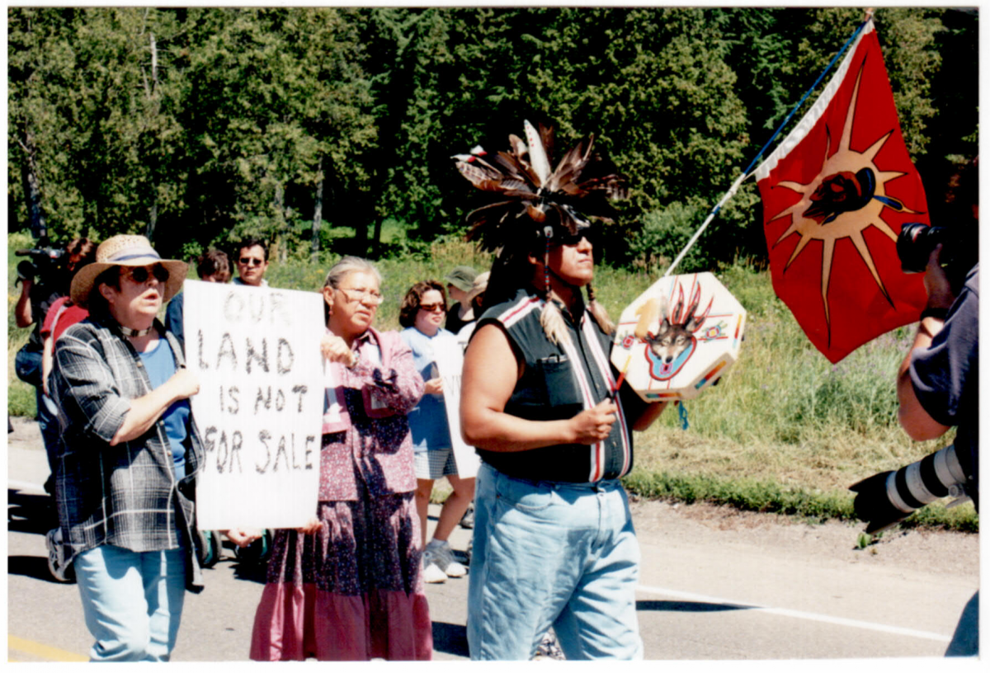
Hopes dashed
The formation of the 1991 Royal Commission on Aboriginal Peoples, also called the Erasmus-Dussault commission, raised hopes that the federal government had learned from the Oka crisis and was ready to substantive changes in its Aboriginal relations.Advertising, five years later, a report of 4,000 pages, containing over 400 recommendations, has also raised many hopes for the vast majority were bitterly disappointed. Not only the situation of Aboriginal people did she not really improved, but the government’s attitude has hardened since the coming to power of the Conservative Party of Stephen Harper.

The best example is the refusal by the Canadian government to ratify the UN Declaration on the Rights of Indigenous Peoples. In September 2007, Canada was one of four countries, with the United States, Australia and New Zealand, to oppose its adoption by the UN General Assembly. No less than 143 countries have yet supported. In his Speech from the Throne in March 2010, the Harper government announced its intention to finally ratify the Declaration, as has already been done more recently Australia and New Zealand, but “in full compliance with the Constitution and laws of Canada. In short, Canada is well prepared to adopt the Universal Declaration, provided that it forced him to any substantive change in its policies.
Same thing in Quebec where the Charest government was willing to adopt a motion asking the federal government to ratify the Declaration … but only to the conditions laid down in Ottawa!

Solidarity always necessary

On July 12, 1990, in the aftermath of the attack of the Surete du Quebec cons Kanehsatake a picket was held outside the headquarters of the SQ on Parthenais Montreal. It was the birth of Solidarity with the Coalition of Aboriginal people on a daily basis, has organized demonstrations throughout the summer of 1990.

This active solidarity, “the street” has helped thousands of people of all ages and all backgrounds, to oppose the actions of their own governments and to hear a speech-cons. Despite the chilly silence of the vast majority of intellectuals and artists from Quebec, many personalities have expressed their solidarity with the Mohawks at events organized by the Coalition. This is particularly the case of trade unionist Michel Chartrand, who died recently, trade union activists and feminists, Madeleine Parent and Roback, writer and activist, Pierre Vallieres, an anthropologist Rémi Savard, singer Richard Desjardins, filmmaker Arthur Lamothe and sculptor Armand Vaillancourt.

This solidarity has continued to occur, once the crisis is over. Closer links were forged not only with the Mohawks, but also with members of other indigenous nations. Demonstrations, pickets, occupations of offices, conferences have been organized in support of Mohawk struggling with police and judicial repression, but also many other causes, struggles against Cree and Innu hydro-electric projects Great Whale and SM-3; resistance Anishnabe Barriere Lake cons clearcuts on their territory, support for the Lubicon Cree Lake, Alberta, faced with the forestry giant Lubicon, etc..

Even if the Coalition Solidarity has ceased operations, some ten years, other groups have formed, other initiatives have been taken, other battles have been supported.
Because he believes that solidarity is still needed, a group of militants and activists of the Coalition of Solidarity with Aboriginal people has decided to revive, at least for the twentieth anniversary of the resistance of the Mohawks and especially for the peaceful march to be held in Kanehsatake and Oka, Sunday, July 11. We invite you to join this event to demand justice for the Mohawks and all indigenous peoples.

Twenty Years after the Oka Crisis, Injustice Continues
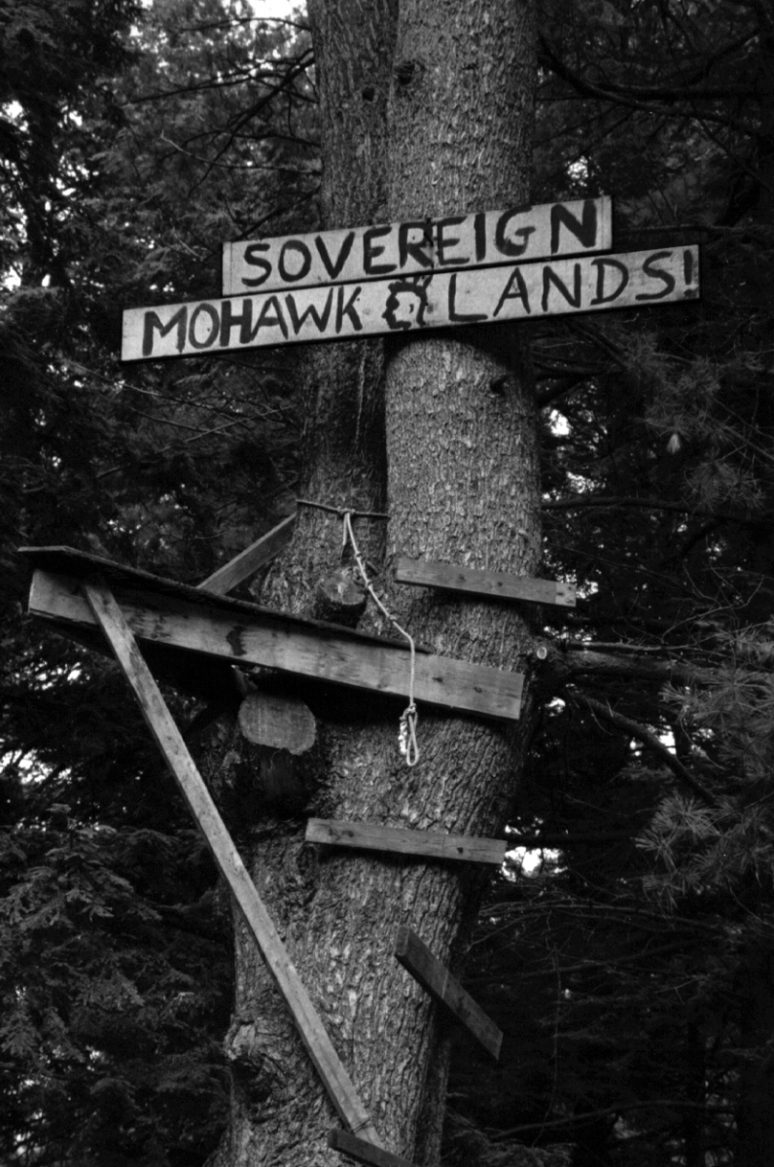On July 11, 1990, in response to year injunction obtenues by Oka mayor Jean Ouellette, the Surete du Quebec Invaded the small Mohawk community of Kanehsatake. Four months Earlier, the Mohawk HAD Begun peaceful vigil to protest Against Oka municipality’s plan to enlarge ITS golf course and build a parking lot on the community’s traditional territory. The project’s community Threatened the pine grove and ancestral burial ground. Tensions continued to rise HAD, Leading the Mohawk to close a secondary road-through the pine forest.

The SQ’s attack at 5 AM on the morning on the 11th Provoked the response of Armed Native people. A member of the SQ’s SWAT team, Marcel Lemay, Was mortally Wounded. Police officers retreated in disorder, and barricades Were Erected on Route 344. To Their show Solidarity, Kahnawake Mohawks blocked the Mercier bridge. This Was The Beginning of What Came to Be Known as the Oka crisis. It Lasted 78 days and not only Quebec Engagements, drank all of Canada.

Despite fine words from the Crisis Was Governments ounces over, nothing really changed for Native Has celebrities, and Things Have Changed Even less for the Mohawks of the causes of Kanehsatake WHERE are the Crisis Still Exactly What They Were.

A Threatened Constantly Territory

Recent news items Have Brought this home. In early June 2010 in Montreal developer, Norm Ducharme, Loved Announced intention of calling it the Surete du Quebec to enable Him to Realize a development project Along Highway 344, it was piece of land just across from Located the pine forest Kanehsatake. Last January, Mohawk HAD HAD to protest to Convince the developer to renounce Loved intention of clearing the land.

In the near future, the Quebec government APPROVe May Also Highly Controversial Another project was put forward by mining company Called Niocan. The company wants to exploit a deposit of niobium (an element with radioactive properties) in Oka, one of the territoire the Lordship of Two Mountains That Have Mohawks have viewed: Their over 290 years for. Niocan Has Never Been Able To Demonstrate That There Beyond Doubt No harmful effect would Be On The Surrounding Area, and in Particular, That It would not contaminer the ground and source of drinking water by a number of Used Mohawk.

Disappointed Hopes

When the federal government Established the Royal Commission on Aboriginal Peoples – Also Known as the Erasmus-Dussault Commission – in 1991, There Was Reason to Hope That It Had Learned the Lessons of the Oka Crisis and That It Was Ready to Make Some “fundamental exchange in ITS relations with Native peoples. Five years later “, the publication of a 4,000-page containing over 400 recommendations deferral Also Hopes Raised Which Have Led Many, in Almost Every box to bitter disappointment. Has Not only the situation of Native people not really Improved , drank the government’s attitude hardened Has Since the election of Stephen Harper’s Conservative Party.

The best illustration of this Is The Canadian government’s refusal granted to ratify the United Nations Declaration on the Rights of Indigenous Peoples. In September 2007, Canada Was one of Four countries – with the United States, Australia and New Zealand – to oppose ITS adoption by the UN General Assembly. The Declaration No. IS Supported by pronoun moins 143 Countries. STIs In March 2010 Speech from the Throne, the Harper government finally ITS Announced intention of endorsing the Declaration (as Australia and New Zealand Recently Have Already done), drank only ” In A Manner Fully consist with Canada’s Constitution and laws “. This Means That Canada Is Prepared to ratify the Universal Declaration as long as it Does not require” real “any change of policy.

La même Thing Is Happening in the Charest government Quebec WHERE Has Said It Was Willing to Adopt a Resolution Asking the federal government to ratify the Declaration … LUKAS purpose only to the conditions Stated by Ottawa!

Solidarity Is Still Needed

On July 12, 1990, the day after the Surete du Quebec’s attack on Kanehsatake a picket line Was Organized in front of SQ headquarters is Parthenais Street in Montreal. This Was the birth of the Coalition of Solidarity with Aboriginal Which Organized demonstrations on a Daily Basis THROUGHOUT the summer of 1990.

This Active Solidarity, in the street, made it possible for Thousands of people of all ages and to protest Against the origins actions you appropriately Their Own Government and Reasons to be an alternative discourse year. Despite the silence of the great fainthearted majorité Intellectuals and artists of Quebec, a number of Leading Their personalities showed Solidarity with the Mohawks at the Events Organized by Cluster. Among Them Were labor union activist Michel Chartrand (Recently deceased), labor activists and feminist Madeleine Parent and Roback, writer and activist Pierre Vallieres, anthropologist Rémi Savard, singer Richard Desjardins, filmmaker Arthur Lamothe and sculptor Armand Vaillancourt.

People continued to show Solidarity after the Crisis Was over. Were Closer ties created not only with the Mohawks, goal Also with members of Other indigenous nations. Demonstrations, picket lines and public talks Organized Were, and Were Occupied offices, to support Mohawk facings Punishment From The police and the judicial system, and to support causes as well Other: The Struggle of the Cree and Innu Nation Against the Great Whale and SM-3 hydro-electric projects, the strength of the Barrier Lake Anishnabe of clearcutting on Their Against territoire; the struggle of the Lubicon Cree of Lake, in Alberta, Lubicon Against the giant forestry company.

Although the reunification solidarity ITS activities ceased about ten years ago, sauf Have groups appeared, and Other Actions Have Been Taken in support of Other Struggles.
A group of activists from the Coalition of Solidarity with Native convinced That IS IS Solidarity Still needed today. As a result, They Have Decided To Bring The reunion back to life, at least To mark the Twentieth Anniversary of the Mohawks’ strength, and In Particular for the peaceful march to Be Held at Oka and Kanehsatake On Sunday, July 11. We Urge you to join the march and demand justice for the Mohawks and all Native peoples.

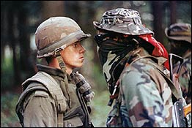

Oka Crisis
The Oka Crisis was a 78-day standoff (11 July–26 September 1990) between Mohawk protesters, police, and army. At the heart of the crisis was the proposed expansion of a golf course and development of condominiums on disputed land that included a Mohawk burial ground.

Oka Crisis
The Oka Crisis was a 78-day standoff (11 July–26 September 1990) between Mohawk protesters, police, and army. At the heart of the crisis was the proposed expansion of a golf course and development of condominiums on disputed land that included a Mohawk burial ground. Tensions were high, particularly after the death of Corporal Marcel Lemay, a police officer, and the situation was only resolved after the army was called in. While the golf course expansion was cancelled, and the land purchased by the federal government, it has not yet been transferred to the Kanesatake community.

Background
There was a long history behind the crisis at Oka; since the 18th century the Mohawk had been pressing the government to recognize their right to land in the area, but their requests had been largely ignored. In 1961, a nine-hole golf course was built on land that had been claimed by the Mohawk of the Kanesatake reserve as their Commons (known as the Pines); despite protests that the land included a burial ground, the Mohawk claim was rejected and the golf course was built. In 1989, the mayor of Oka, Jean Ouellette, announced that the golf course would be expanded to 18 holes. He also authorized the construction of 60 luxury condominiums in the Pines. Despite protests by the Mohawk of Kanesatake, and concerns expressed by the Québec Minister of the Environment and Minister of Native Affairs, construction was scheduled to begin.

Blockade and Police Raid
In order to halt further development of the Pines, Mohawk protesters constructed a barricade, blocking access to the area. Mohawk warriors from two other reserves—Kahnawake and Akwesasne—joined the protest, helping man the barricades. After two injunctions to remove the roadblock were ignored, the mayor of Oka asked the provincial police force, the Sûreté du Québec (SQ), to intervene. On the morning of 11 July 1990 the SQ attacked the barricade, using tear gas and concussion grenades to create confusion (although the gas blew back towards the police). During the brief gunfight that followed, SQ Corporal Marcel Lemay was killed and the SQ retreated.

Escalation
Resistance continued, with Aboriginal supporters from across the country joining the Mohawk at the barricades. The SQ constructed their own blockades on roads leading to Oka and the Kanesatake reserve. Mohawk from the nearby Kahnawake reserve blockaded the Mercier Bridge in support, effectively cutting off access between Montréal’s southern suburbs and the Island of Montréal. The resulting chaos angered local residents, and relations between Aboriginal and non-Aboriginal people in the area worsened. The SQ had to deal not only with the barricades, but also with frustrated and hostile civilians who often blamed them for the situation. At the same time, the demands of the protesters expanded to eventually include full sovereignty.

Federal Involvement and the End of the Crisis
As it became increasingly clear that the SQ could not resolve the crisis, the RCMP was brought in to assist them in mid-August. At the same time, Québec Premier Robert Bourassa requested the help of the Canadian armed forces and 2500 regular and reserve troops were put on standby. On August 20 about 800 members of the Royal 22e Regiment (the “Van Doos”) took over from the SQ at the Kahnawake and Kanesatake barricades, assuming a position only metres from the warriors. Facing increasing numbers of soldiers at the Pines and elsewhere in the Montréal area, as well as reconaissance aircraft above, the protesters were under heavy pressure. By 29 August negotiations had put an end to the blockade of the Mercier Bridge. Mohawk warriors at the Oka barricade continued their protest until 26 September 1990, when they dismantled their guns and surrendered to the army. Several were detained by the military and a number were later charged by the SQ. Five were convicted of crimes including assualt and theft, although only one served time in jail.

Public Response
There was substantial media coverage of the Oka Crisis across the nation, and public opinion varied widely. Many Quebeckers, especially those living in the immediate area, were angered by the blockades. In one incident, local residents stoned about 75 cars—containing mostly women, children, and the elderly—as they tried to leave the Kahnawake reserve (see Alanis Obomsawin's film Rocks at Whiskey Trench). However, others sympathized with the protesters, including John Ciaccia, the Québec Minister of Native Affairs at the time. Protests were held across the country in support of the Mohawk, with blockades in British Columbia and northern Ontario. Overall, the crisis made more Canadians aware of Aboriginal rights and land claims; it also illustrated the potential for future conflict if such claims were not resolved in a timely, transparent, and just manner.

Resolution?
During the crisis, the federal government agreed to purchase the Pines in order to prevent further development. The golf course expansion and condominium construction were cancelled. After the crisis had ended, the government purchased a number of additional plots of land for Kanesatake. However, these Crown lands have not yet been transferred to the Kanesatake Mohawk.
The Oka Crisis revealed a number of issues in terms of Aboriginal affairs, as well as government and police responses to protests and occupations. The crisis played an important role in the establishment of the Royal Commission on Aboriginal Peoples. Investigations held after the crisis revealed several problems in the SQ’s handling of the situation, including command failures and prejudice among SQ members. It has never been discovered who fired the shot that killed Corporal Marcel Lemay.

Standoff at Oka
A Mohawk standoff becomes a rallying cry for native anger and frustration
In 1988, George Erasmus, the leader of the Assembly of First Nations, delivered a dire warning about unsettled native land claims in Canada:
"We want to let you know that you are dealing with fire. We say, Canada, deal with us today because our militant leaders are already born. We cannot promise that you are going to like the kind of violent political action we can just about guarantee the next generation is going to bring to our reserves."
Two years later, his words proved prophetic when a land claim dispute turned violent and held the attention of the country.
In March 1990, Mohawks at Kanesatake, west of Montreal, set up a blockade to prevent bulldozers from breaking ground for a golf course that would be built on a native burial ground. The Mohawks disputed the land with the nearby municipality of Oka.
Among those buried in the cemetery the body of Kanawatiron, known as Joseph Gabriel, who had died in the 1930s.
In 1911, Kanawatiron was part of a native group that objected to the building of a railway through the reserve. Under the headline "Indians Threaten War Against Railroad Men," the Montreal Star reported the incident:
"Witnesses say there were at least forty braves armed with shotguns, revolvers and bludgeons, who with regular war cry accompaniment, informed the railroad labourers that they could proceed at their peril, as the property they were about to cross belonged to the Iroquois. The navvies [labourers] are said to have retired gracefully."
Seventy-nine years later, the events at Kanesatake would not end so gracefully.
On July 10, 1990, four months after the native roadblocks went up, the mayor of nearby Oka asked the provincial police, the Sûreté du Québec), to enforce an injunction from the Quebec superior court to have the blockade torn down.
The next day, 100 police officers armed with concussion grenades and tear gas, some with assault rifles, took up positions around the blockade.
Tensions ran high; eventually gunfire rang out from both sides.
Debbie Etienne, a social worker who lived in Kanesatake, remembered the ensuing chaos:
"People were screaming, asking if anyone got hit. I heard somebody was shot."
Someone was shot, and killed. It was Corporal Marcel Lemay of the Sûreté du Québec Police quickly surrounded Kanesatake.
Quebec's minister of Indian Affairs, John Ciaccia, reacted to the crisis with surprise:
"I never thought it would go so far," he said. "Nothing had prepared me for what would happen."
Throughout summer tensions increased. Natives at the nearby reserve of Kahnawake showed their support for the Warriors by erecting a blockade on the Mercier Bridge, effectively closing the road that carried commuters from the south shore of the St. Lawrence to Montreal. After a month of the blockade, tempers were flaring among commuters.
There were other incidents of violence, and pressure grew on the Quebec government to resolve the crisis, which had now become a rallying cry for natives frustrated with political marginalization.
Ellen Gabriel was with her people behind the Kahnawake barricades.
"I think aboriginal people really strongly identify with what was happening here, and they said, yeah, something like that has happened to us. Maybe not to that extreme but [they] recognize that pain."
On August 14, after a series of almost daily violent incidents, Premier Robert Bourassa called upon the army for support. Horrified Canadians watched as soldiers faced off with armed Mohawks from the militant Warrior society.
"The Warriors wanted the army," said Ciaccia, "because then they could say they were fighting nation against nation, the Mohawk army against the Canadian army ...They played it for all it was worth around the world."
On August 29, the Kahnawake Mohawks dismantled the barricades at the Mercier Bridge, defusing tension among commuters and leaving the Kanesatake Mohawks isolated.
On September 26, after a long and tense standoff, the Warriors surrendered, and most of the leaders were arrested.
"We didnt get our land," Debbie Etienne said. "But I think on the inside we gained a lot, because our kids saw the truth.... It proved what my grandparents [told me] and their grandparents told them ... We are not a violent people; they created the violence."
The only casualty was Marcel Lemay, whose wife was pregnant with their second child. No one was charged with the murder.
Some native leaders condemned the standoff at Oka, but others suggested it was a logical and inevitable outcome of five hundred years of inequality.

Maurice Richard's temper is as fiery as his nickname, and the Rocket is no stranger to the penalty box. The francophone star is frequently at odds with the man in charge of league discipline, NHL President Clarence Campbell, seen by many as a symbol of the anglophone elite. Richard has been given several fines and suspensions, but on March 13, 1955, he goes too far. During a scrap with the Boston Bruins, Richard deliberately injures an opponent and then punches a linesman.

Clarence Campbell responds by suspending Richard for the remainder of the season as well as the playoffs, a move that jeopardizes Richard's scoring record, the Canadiens' first place position, and their shot at winning the Stanley Cup. Worse, Campbell has the gall to attend the Canadiens' next home game. The provocative move is too much for Habs faithful, who are spoiling for a fight. They pelt the league president with food and then set off a tear gas bomb.

The Montreal Forum is evacuated, and violence spills out onto the streets of Montreal. Rioters smash windows, loot stores, and clash with police. The riot of St. Patrick's Day, March 17, 1955, is seen by many as a seminal moment in the evolution of Quebec's modern nationalist movement. Fifty years later, CBC Television looks back at the milestone "Richard Riot."

-------

The Richard Riot has taken on a significance greater than a mere sports riot in the fifty years since it happened. The sight of French Quebecers rioting in defence of a Québécois cultural icon like Richard led many commentators to believe it was a significant factor in Quebec's Quiet Revolution of the 1960s.^{[60][61]} Furthermore, the cause of the riot has been suggested to not be as a result of the severity of the suspension — instead, what mattered was that a Québécois player had been suspended by an anglophone president of an anglophone league. French Canadians saw themselves as inherently disadvantaged within Canada and North America as a whole.^{[62]} Richard was seen as a national hero by French Canadians, and almost a sort of a "revenge" against the anglophone establishment.^{[63]} The riot was a clear sign of rising ethnic tensions in Quebec.^{[64]}

In an article published four days after the riot, journalist André Laurendeau was the first to suggest the riot was a sign of growing nationalism in Quebec. Entitled "On a tué mon frère Richard" ("My brother Richard has been killed"), Laurendeau suggested the riot "betrayed what lay behind the apparent indifference and long-held passiveness of French Canadians".^{[63]}
On the other hand, Benoît Melançon argues persuasively that the riot has become part of the "Rocket Richard myth" and has taken on an importance that, in retrospect, is far greater than it actually had when it happened. For instance, he argues that: "Had there been no Riot, it is doubtful there would ever have been a Maurice Richard myth."^{[65]} The riot ended up taking on greater significance as time passed, but not for the reasons many non-academic commentators believe. Richard was in danger of being forgotten in the years immediately after his retirement, so he promoted himself, and his nascent myth, excessively:

There were Maurice Richard skates and jackets, but there were also Rocket ashtrays, Rocket transistor radios, and Rocket Richard Condensed Tomato Soup. Moreover, these products changed throughout history. "The principal impact of the trade in Richard ... has been the transformation of Maurice Richard into a product, then into a label, and ultimately into a myth."^{[66]}

He concludes by suggesting that the riot is now something it was not. To quote: "the riot has become the key event in turning Richard from a mere hockey player to a symbol of political resistance (even if Richard himself was publicly apolitical and, according to this book, definitely not for an independent Quebec)... According to this popular narrative, for the first time the people of Quebec stood up for themselves; especially English Canada delights in anachronistically announcing that this was the beginning of the 1960s Quiet Revolution."^{[67]} Perhaps the best way to explain how the interpretation of the riot changed is by looking at the change in the public perceptions of its antagonist: "it was necessary to overlook some of [Richard's] character traits and to rewrite several episodes of his career" in order to make him into a mythical figure.^{[68]}

(from 2009)

Hockey and Nationalism in Canada
In Canada, hockey is both inevitable and inescapable. Once the summer ends, professional and amateur seasons begin. As much as this correspondent loathes the sport, he is certainly a minority voice in Toronto, which fashions itself the hockey center of the universe. Roughly 65 kilometers west of the downtown is Hamilton, the city of shattered hockey dreams. Jim Balsillie, the co-owner of Blackberry-maker Research In Motion, attempted to relocate the bankrupt and unsuccessful Phoenix Coyotes to Hamilton. The Arizona bankruptcy judge, Redfield T. Baum, thwarted the Balsillie bid, rejecting it with prejudice. But the billionaire produced at least one result. He stirred a sense of national pride in Canadians who want a seventh National Hockey League team for the country, naming his campaign Make it Seven. Balsillie’s notice of surrender adroitly exploited the sentiments of Canadians.

From the beginning, my attempt to relocate the Coyotes to Hamilton has been about Canadian hockey fans and Canadian hockey. It was a chance to realize a dream. All I wanted was a fair chance to bring a seventh NHL team to Canada, to serve the best unserved hockey fans in the world. I believe I got that chance. I respect the court’s decision, and I will not be putting forward an appeal.

Nobody can deny that we are now a big step closer to having a seventh NHL team in Canada. It doesn’t matter who owns that team. When that day comes, I will be the first in line to buy a ticket to the home opener.

I want to take this opportunity to thank my family for all their love and support. I also want to thank the more than 200,000 fans who supported the bid online and the countless others who contacted me personally to show their support. This bid always was about the game we all love.

Yet the relocation of an American team to Canada is severely in doubt, according to Damien Cox.

On six occasions over the past 40 years, including Jim Balsillie’s unsuccessful attempt to buy the Phoenix Coyotes and move them to Hamilton, the American-dominated league has been faced with attempts to move teams from the U.S. to Canada, and five times the NHL has aggressively rejected and blocked those attempts….By contrast, the NHL has never blocked an effort by a Canadian-based team to move south to a U.S. market. It was allowed decades ago when Hamilton moved to New York and became the Americans and Ottawa shifted to St. Louis, and more recently when the Winnipeg Jets became the Coyotes and the Quebec Nordiques moved to Colorado. An interesting double standard, wouldn’t you say?
Fortunately, Cox answers the question by pointing out the curious strategy of NHL commissioner Gary Bettman.

…it’s a strange reality, this aggressive insistence of the NHL on trying and re-trying flimsy and flawed hockey markets and refusing to put teams where the game is most loved. Its reward in this case is control over the ongoing disaster in Phoenix, the option, according to the mega-lame prose of Judge Baum, to “take another shot at the sale net.” Good luck with that nightmare. Not a single Canadian will shed a sympathetic tear.

They are still lamenting what they see as a lost birthright to the game they love. The sale of Wayne Gretzky to the Los Angeles Kings by the Edmonton Oilers is not forgotten.

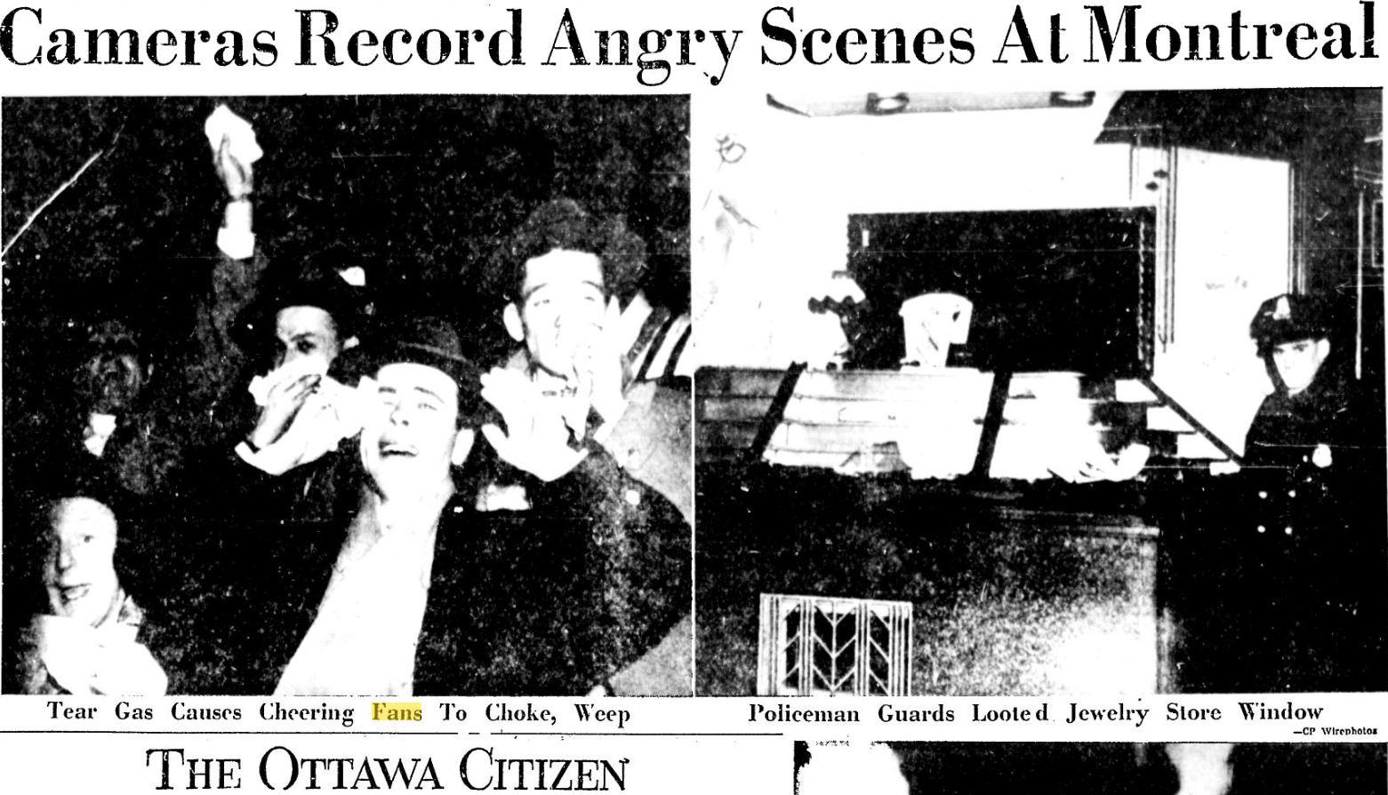
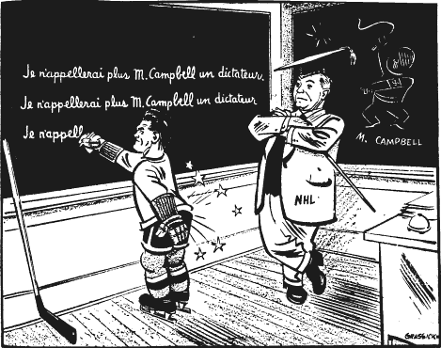
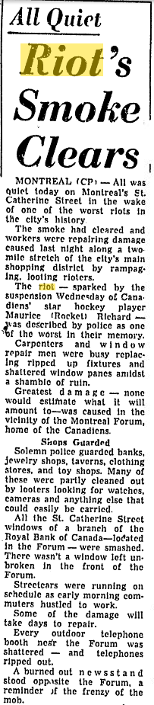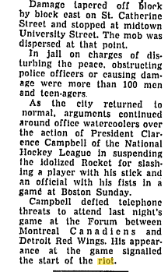

Don Macpherson: Olympic hockey brings Canadians together

By Don Macpherson, The Gazette February 25, 2014

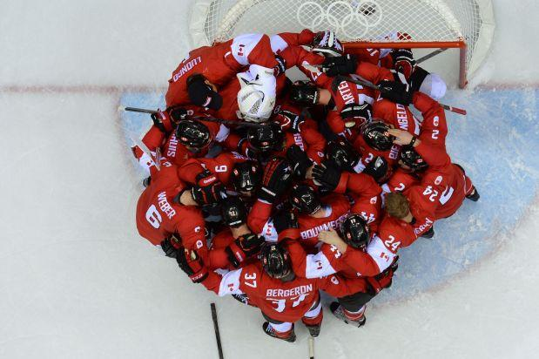

Canada’s players celebrate after winning the Men’s ice hockey final Sweden vs Canada at the Bolshoy Ice Dome during the Sochi Winter Olympics on February 23, 2014.

Photograph by: ALEXANDER NEMENOV , AFP/Getty Images
The Olympics really do bring Canadians together. It’s just that in Quebec, it takes a little longer.
During the 2010 Vancouver Winter Olympics, results of a poll by Ipsos Reid for the Historica Canada organization suggested that Quebecers were much less likely than other Canadians to say they would wear “Canada” or Olympic clothing, or fly or display the Canadian flag.
And Quebecers were more likely to say that there was too much Canadian nationalism on display.

But in a second poll a few days after those Games, Ipsos Reid found what it called a “major shift” in Quebec opinion in favour of Canada, compared to a poll a year earlier.
Among other findings, 63 per cent of Quebecers agreed they were “Canadian nationalists,” an increase of 15 percentage points.

And 76 per cent agreed that they had “a strong sense of belonging to Canada,” up eight points.

There may have been a similar “Olympic effect” in Quebec during the Sochi Games that concluded Sunday.

At first, when athletes from Quebec took an early lead in winning medals for Canada, some Parti Québécois ministers played sovereignist make-believe.
On Twitter, they relayed medal standings showing a non-existent Quebec national team well ahead of Canada.

Higher Education Minister Pierre Duchesne was taken in by a photo of the medallist Dufour-Lapointe sisters that had been doctored to replace the red-and-white “Canada” mitts they were wearing with blue-and-white “Quebec” ones.

But by the last day of the Games on Sunday, with Canada about to play in the men’s hockey final, even the nationalist Le Journal de Montréal had caught a mild case of Canadian patriotism.

“Go Canada!” it shouted on its cover — yes, in English — over a photo of two Russian fans with their faces painted like the Maple Leaf flag.

“All eyes on our hockey team,” it added in French — “our” team, with only four players from Quebec.

We’ve seen hockey unite the country before: in the 1972 “Summit Series,” the first time our best players faced off against the Soviet Union’s, and in the equally historic 2010 Vancouver Games, the first time they skated in the Olympics on home ice.

And as history has taught us, the warm feelings resulting from such victories don’t last long.
The morning after our gold medal on Sunday, Canadians awoke to the reality of a secessionist government still in power in Quebec.
There is, however, one way that hockey does help bring people in Canada together for good. And it was on display during Sunday’s game.

The CBC had cameras at several locations across the country where fans had gathered to watch the game.

Most were typical sports bars. But somebody had the inspired idea of placing a camera at a Muslim mosque in a Toronto suburb.

“Whoever wants to know the heart and mind of America had better learn baseball, the rules and reality of the game,” historian Jacques Barzun wrote.

In Canada, it’s hockey, our third national language, the one that gives the newly arrived and the native-born alike a conversational icebreaker with their neighbours, classmates, co-workers, even strangers.

In 2010, the Globe and Mail reported results of a poll by Environics Analytics and Research Now suggesting that in some ethnic communities, interest in watching professional hockey was “much higher than the average.

“The results suggest hockey acts as a kind of glue in the Canadian mosaic. Becoming a hockey fan, for a new immigrant, is a very public way of declaring an identification with Canadian culture.”

Who gets up before dawn on a Sunday morning in February to go watch a hockey game with other people that they could watch at home?

Canadians do.

‘Royal’ returns for Canada’s armed forces

Republish Reprint

Tristin Hopper | August 15, 2011 9:27 PM ET

After 43 years, the Canadian Forces are regaining their “royal” moniker.
Canada’s navy and air force are to be restored to their pre-1968 titles of Royal Canadian Navy and Royal Canadian Air Force.
Land Force Command will now be known simply as the Canadian Army.
Defence Minister Peter MacKay will announce the changes Tuesday morning at CFB Halifax. Similar ceremonies are expeced to take place at military bases across the country.
The name changes will not affect any of the military’s command structures.
The move — pushed by veteran groups loyal to the Crown — is being praised as a salute to the country’s history and decried as a throwback to colonial times.
“I think this is appalling … it’s abject colonialism,” said Jack Granatstein, military historian and author of Who Killed the Canadian Military?
During the 1956 Suez Crisis, when Canadian peacekeepers were sent to defuse tensions between Egyptian and British troops, the Canadians were criticized for showing up hoisting the Union Jack, wearing British-style uniforms and carrying regimental titles like the “Queen’s Own Rifles.” In response, said Mr. Granatstein, Pearson intentionally set about crafting not only a Canada-specific flag, but a Canada-specific military.
“I’m a historian, I think history matters, but we don’t have to be slavish in following it and restoring it,” said Mr. Granatstein.
In Quebec, the new designation has raised the ire of anti-monarchists. Mario Beaulieu, president of the sovereigntist Societe Saint-Jean-Baptiste de Montreal, called the move “rather insulting for Quebecers” and said it would do nothing to improve Conservative fortunes in Quebec. “The army deserves a better name than that,” he said.
Douglas Bland, chairman of Defence Management studies at Queen’s University, fears the name designation could be the beginning of a fissure that could become a headache for future governments. Future defence ministers could find themselves facing off against divided air force, navy and army leaders “trying to exert their influence on defence policy in the interest of their service.”
“It’s absolutely nostalgia by members of retired naval and air force establishments who pine for this kind of environment in which they lived,” he said. “I don’t think it’s something that deeply excites young soldiers and sailors.”
Up until 1968, Canada’s military consisted of the Royal Canadian Air Force, the Royal Canadian Navy and a number of units and regiments known collectively as the Canadian Army. To cut bureaucracy and eliminate competition between the branches, Paul Hellyer, the Defence Minister in the Pearson government, spearheaded a “unification” plan that joined the three together into the Canadian Forces. The navy and air force were known officially under the names of Maritime Command and Air Command.
“There was a conscious effort to make it an all-one-team Canadian Forces,” said Alan Okros, an association professor of military psychology at Royal Military College. “In doing so, there were some valuable symbols from the past that were lost.”

Designations were phased out, rank structures changed and names erased.
“For many years we weren’t even allowed to use the term ‘air force,’ you had to use the terms ‘air environment,’ ” said Angus Watt, a retired Lieutenant-General with Air Command.
Over the years, however, the commands have drifted back to their pre-1968 traditions. “There’s been a slow, gradual history of recognizing that some of the ‘clean-sweep’ approach to unification went a bit too far,” said Mr. Okros.
The three branches have regained unique ranks and the words “army,” “navy” and “air force” have even found their way back into recruiting materials.
“You’ve have a small-a air force and a small-n navy in Canada for probably a decade, but this confirms it,” said David Bercuson, Director of the Centre for Military and Strategic Studies at the University of Calgary.
The movement to restore the “royal” monikers was largely spearheaded by veterans organizations. Website Restore the Honour collected 6,000 signatures in favour of restoring the pre-1968 titles in time for Queen Elizabeth’s Diamond Jubilee in 2012.
“I recognize that service loyalties and affection still run deep and every Canadian Forces member is proud of his or her distinctive ‘service’ uniform and its traditions…. I expect that we will make a decision on this issue in the near future,” reads a May 31 email sent to Restore the Honour by Mr. MacKay.
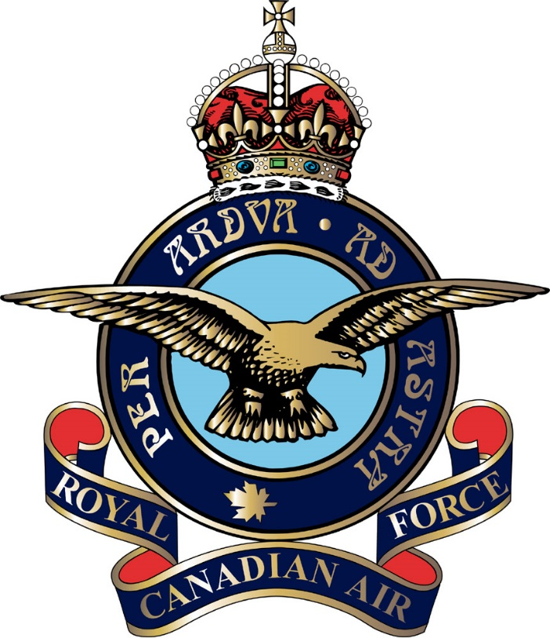

Finding of Franklin ship fuels Harper’s new nationalism

STEVEN CHASE
OTTAWA — The Globe and Mail
Published Tuesday, Sep. 09 2014, 10:09 PM EDT

A Parks Canada-led team has found a ship lost in the doomed Franklin expedition to unlock the Arctic nearly 170 years ago, the fruit of a search championed by Prime Minister Stephen Harper in his efforts to forge a Conservative brand of Canadian nationalism.
Searchers said they confirmed the authenticity of the antique British naval vessel, which is either HMS Terror or HMS Erebus, on Sunday. The sunken ship lies west of O’Reilly Island and in eastern Queen Maud Gulf in the waters of the Arctic archipelago.
Mr. Harper, whose government has promoted and funded the search for the Franklin wrecks, took it upon himself to personally announce the discovery Tuesday at a photo opportunity in Ottawa. The Prime Minister, who has styled his government a defender of Ottawa’s claim to the Arctic, described the expedition as having laid the foundation for Canadian sovereignty in the region.
He proclaimed the find of the Royal Navy ship a “historic moment for Canada,” noting public interest in the fate of vessels that were trying to traverse what is now Canada’s prized Northwest Passage has captivated generations.
“For more than a century this has been a great Canadian story, a mystery; it’s been the subject of scientists and historians, writers and singers,” Mr. Harper said.
Victorian England was enthralled by the story of Sir John Franklin’s expedition, which failed after vessels were frozen in ice and crews perished. Successive British recovery missions failed to find the ships but managed to chart significant portions of the Arctic – a legacy that benefited Canadians for years to come.
Since 2008, six searches led by Parks Canada have scoured hundreds of square kilometres of Arctic seabed, a hunt driven by what a senior Tory called Mr. Harper’s “genuine, nerdy interest” in the romantic story but also a desire to engage in conservative-minded myth-making that might capture the imagination of Canadians.
Arctic experts say they’re not sure they understand Mr. Harper’s claim that the Franklin expedition helped lay the basis for Canadian sovereignty in the region. These two British naval ships were lost decades before Confederation and the most relevant sovereignty question today – whether the Northwest Passage is an international waterway – doesn’t have much to do with this.
“This myth just had another chapter added,” Rob Huebert, associate director of the Centre for Military and Strategic Studies at the University of Calgary, said on Tuesday of the Franklin discovery.
Mr. Huebert said he’s happy the find will help raise Canadian interest in the Arctic, but he advises that every time the government uses the phrase “Canadian sovereignty,” listeners should substitute the word “nationalism” instead.
Like leaders before him, Mr. Harper is trying to put his own stamp on Canadian values – attempting to rework the national myth from one built on Liberal policies to one shaped by Conservatives. He’s long been bothered by the fact the rival Liberals owned the flag when it came to Canada’s political identity – a land of peacekeepers, generous social programs etc. – and is determined to change that. He’s also convinced a country that absorbs immigrants at such a fast rate needs a compelling series of narratives to stay united, sources say.
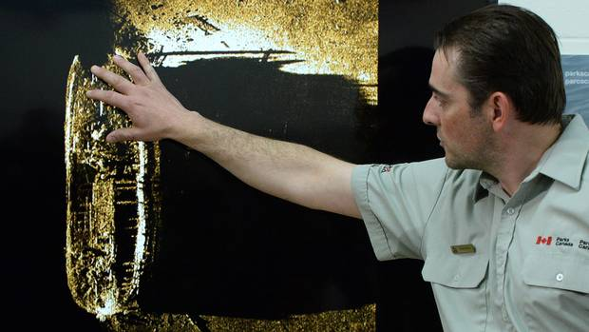
The Tory Leader’s effort to build a new national identity since 2006 has included a heavy emphasis on Canada’s military exploits, the bicentennial promotion of the War of 1812 as the “fight for Canada,” nine successive summer trips to the country’s North and talk of claiming the geographic North Pole for Ottawa.
The Franklin find is a clear victory for Mr. Harper, who’s had other notable pledges to champion the Arctic delayed or scaled back due to budget constraints, from Arctic patrol ships to a naval refuelling facility on Baffin Island.
Mr. Harper is not one for grand gestures, but he does like to walk tall in the Arctic for the TV cameras during annual northern tours. He has stood atop a submarine as jets roared overhead, sat in a fighter cockpit and fired a rifle as part of a military exercise.
On the Prime Minister’s 2014 trip, he toured the Arctic just shortly before the Franklin ship was discovered, missing by weeks a find that would have made his tour the most dramatic to date.
Those who know Mr. Harper say his fascination with Franklin is authentic. “Sure, it fits the northern narrative and his sense that Canada ought to nurture its myths and legends in order to build our sense of nationhood,” a source said. “However, a large part of it is the genuine interest of a student of history.”
According to a 1997 deal between Britain and Canada, Canada is granted custody and control of the Franklin wrecks and their contents and will be granted ownership of much of what is recovered. However any gold found must be shared equally with London aside from coins deemed to be privately owned or claimed by third parties. And Canada must offer to London any items of “outstanding significance to the Royal Navy.”

Stephen Harper calls for Canadian nationalism that’s not anti-American
NOVEMBER 19 - 2012
OTTAWA— On a Canada-U.S. business stage, Prime Minister Stephen Harper touted Canadians as more open to global trade than a “surprisingly” protectionist United States, and warned no one should doubt the seriousness of bigger long-term fiscal problems facing Washington.
Answering questions from moderator Maryscott Greenwood, a Democrat and former American embassy official in Ottawa, a relaxed Harper extolled the Canada-U.S. economic and political relationship as stronger than ever under his “extremely pro-American” government.
He painted Canada as a mature trading partner determined to build new ties to Asia while still nurturing vital links to the U.S. through projects such as a planned—and mostly Canadian-financed—new bridge from Windsor to Detroit.
Harper spoke frankly of his government’s deliberate effort to honour the north and the War of 1812 as part of a campaign to project a new brand of Canadian nationalism that celebrates the differences in Canadian policy and “character” as well as this country’s special relationship to its biggest and most powerful ally.
“We are strong Canadian nationalists who value what is distinctive and unique about this country and think in our own modest way that this is actually a better country,” said Harper. “What we’ve tried to do and tried to tell Canadians is there’s no need for true Canadian nationalism to have any sense of anti-Americanism.”
Yet for all his talk about shared values and interests, the prime minister drew sharp contrasts between the two countries.
He told the Canadian-American Business Council he sees “a surprising amount of protectionism in American political discourse on both sides of the political divide. In this country, it’s very different.”
The free trade debate nearly 25 years ago when Conservatives won the 1988 election over the trade deal with the U.S. was a “traumatic and cathartic exercise” in which, Harper said, critics of free trade took a “credibility hit.”
Dire warnings of disadvantages to the Canadian economy, assimilation, loss of sovereignty, and predictions of “the disappearance of Canada as a nation,” didn’t come to pass, said Harper. “I think that was a turning point.”
“The concept of being part of a trading global economy is not seriously challenged here the way it is surprisingly challenged in the U.S.”
Harper expressed confidence that U.S. political leaders would resolve the immediate “fiscal cliff” crisis by year’s end. That’s when a $600 billion package of automatic tax hikes and government spending cuts takes effect, which Harper said “could be a significant negative shock to the American and, therefore, the global economy.”
“Surely now that the election is over, reasonable people will come to those solutions and not wait for a crisis.”
But he cautioned there’s no such thing as a fiscal “bungee cord.”
“I think that kind of talk is foolish. If you go over a cliff, you can’t be sure what will happen next. We saw with the collapse of Lehman Brothers how a single major event can trigger a series of events that it’s very hard to pull back from.”
A separate and larger problem, said Harper, is the U.S. needs a “credible fiscal plan over the mid-term to deal with what I think is a pretty serious long-run fiscal situation.”
For its part, Canada will continue to pursue greater trade and energy ties with Asia, although the prime minister refused to tip his hand on whether his government will approve a controversial takeover of Nexen Inc by China’s state-owned CNOOC.
While he views TransCanada’s proposed north-south Keystone XL pipeline as a “great” energy and security project, Harper said U.S. President Barack Obama has indicated he has made no decision yet and “I accept him at his word on that.”
The prime minister did sound a frustrated note at the end, that for all the attention Canada pays to the U.S., it is not always reciprocated.
“My only complaint about the United States—and every Canadian will say this, but it’s just the way it is—we always like to have more attention in the United States. We certainly pay a lot of attention to you. You sometimes don’t pay enough of attention to us.”

Harper's tough talk on the Arctic less stern in private
CAMPBELL CLARK
OTTAWA
PUBLISHED MAY 12, 2011UPDATED MAY 12, 2011
Despite the military photo ops and defiant words aimed at the Russian Bear in the Far North, U.S. diplomatic cables indicate that Stephen Harper doesn't believe there's a threat of military conflict there: He told NATO it is not wanted in the Arctic because there's no likelihood of war.
The cables, released by website WikiLeaks, indicate that the U.S. embassy in Washington saw much of the Conservative government's aggressive public statements on the Arctic as a partisan strategy to win votes rather than substantive government policies. In private, the cables indicate, Mr. Harper was more "pragmatic."
The massive potential for oil and gas discoveries in the Arctic has countries scrambling for offshore turf, but those claims are largely being settled by United Nations legal arbitration. Nonetheless, Mr. Harper's government has often hinted at potential military encroachment by Russia and stressed the need for beefed-up military hardware to defend the Arctic.
One cable drafted by U.S. diplomats in Ottawa portrays Mr. Harper as dismissing the need for a military response to Russia over the Arctic. It includes an account from a Canadian official of a January, 2010, meeting between Mr. Harper and NATO Secretary-General Anders Fogh Rasmussen in which the PM said NATO has no role in the Arctic.
"According to PM Harper, Canada has a good working relationship with Russia with respect to the Arctic, and a NATO presence could backfire by exacerbating tensions," the cable states.
"He commented that there is no likelihood of Arctic states going to war, but that some non-Arctic members favoured a NATO role in the Arctic because it would afford them influence in an area where 'they don't belong.' "
That contradicts the Conservatives' frequent calls for more military tools to defend the Arctic, sometimes accompanied by bellicose rhetoric.
Last July, Defence Minister Peter MacKay claimed Canadian CF-18s repelled Cold War-era Russian bombers flying near Canadian airspace, and the Conservatives quickly sent their MPs "talking points" that said the incident showed Canada needs new F-35 stealth fighters. In February, 2009, Mr. Harper rebuked Russia publicly for "incursions." And a month later, then foreign affairs minister Lawrence Cannon responded to Russia's military operations in its own Arctic territory with a warning: "Canada will not be bullied."
Mr. Harper tours the Territories every summer, has a penchant for showing off the country's military equipment - such as visiting a frigate off Baffin Island with Mr. McKay in 2009 while fighter jets flew around overhead - and has frequently promised development of the sparsely populated region, pledging during the election campaign to build a highway to Tuktoyaktuk.
And there's a populist reason to take such stands: Although defence experts often dismiss the idea that Canada's Arctic is actually under foreign threat, many Canadians seem to think it is. A 2009 Environics survey found that 60 per cent of people living north of the 60th parallel (and 52 per cent of those south of it) believe there is a security or sovereignty threat to the northern border.
Tough talk on the Arctic also reinforces the Tories' embrace of drum-beating nationalism, which also includes celebrating the country's mission in Afghanistan.
Mr. Harper's communications director, Dimitri Soudas, said he would not comment on leaked U.S. cables.
"I don't think there has been any suggestion by our government or, quite frankly, any other country that is adjacent to the Arctic that there is a question of war. The question here is territorial sovereignty," he said. "It's being present."
NDP foreign affairs critic Paul Dewar said the Conservatives cannot claim they never raised the spectre of Arctic military conflict. "This was a pile of politics and not necessarily good policy being displayed," he said.
The release of the cables came as the Arctic Council - which includes Canada, the United States, Russia, Norway, Sweden, Finland, Denmark and Iceland - signed its first legally binding treaty to divide responsibilities for search-and-rescue activities in the Arctic. The deal sets aside the trickier questions of territorial claims to provide for legally entrenched functional co-operation.
Mr. Harper's government has viewed that body as the forum for Arctic co-operation. But his assertion that NATO allies don't belong in the Arctic underlines a point of policy on which Canada and Russia agree: that the region belongs to the countries that border it, and is not a shared territory like the Antarctic. "The question is whether it's a global commons. The Canadian government's answer is no," said Janice Stein, director of the Munk Centre for Global Affairs.
But the U.S. diplomatic cables express skepticism about whether Canadian Arctic policies live up to the Harper government's rhetoric.
A 2009 cable on Canada's defence policy describes the plan to build six Arctic Patrol ships for the navy as "an example of a requirement driven by political rather than military imperatives, since the navy did not request these patrol ships. The Conservatives have nonetheless long found domestic political capital in asserting Canada's 'Arctic Sovereignty.' "
Another 2010 cable described some of the Harper government's early "frosty rhetoric" aimed at the U.S. over the Arctic, but added "thus far, the government's ardour for the 'North' has translated only into a modest array of actions that have an impact on American and other foreign interests …" Mr. Harper's tone was less pointed in private, the memo says.
"That the PM's public stance on the Arctic may not reflect his private, perhaps more pragmatic, priorities, however, was evident in the fact that during several hours together with Ambassador Jacobson on January 7 and 8, which featured long and wide-ranging conversations, the PM did not once mention the Arctic," the cable states.
Doubting Harper
Stephen Harper liked to say early in his tenure that his government was bringing Canada back to the world stage with a more muscular military, using the slogan: "Canada is back."
U.S. diplomats have their doubts.
The U.S. embassy sent a skeptical assessment home to Washington in a 2010 cable entitled "Canada is back - or is it?"
The cable reports that Mr. Harper's big plans, first articulated in the 2006 campaign, for transforming the Canadian Forces to increase Canada's influence on world affairs are likely to fall short because of budget constraints, and that Canada's role in the world will likely be diminished because Ottawa will focus the Forces closer to home.
The Canada First Defence Strategy, released in 2008, led to some increases in military capability, the U.S. diplomats reported to Washington. But they said the Forces were "severely stretched," and the strategy, based on 20 years of increasing military budgets, was likely to be unsustainable.
"PM Harper has set an assertive course for Canadian foreign policy, declaring that 'Canada is back' on the world scene. However, his ambitions for Canada may exceed his grasp …" the cable said.
"The effect is likely to be that military resources will be redirected, defending 'sovereignty' in the Arctic and other Canadian interests, at the expense of future post-Afghanistan expeditionary missions," the embassy warned. "Senior Canadian military officials ... have already begun to express concern at a likely loss of Canada's influence with the U.S. and NATO after the end of Canada's Afghanistan mission, but so far this concern does not appear to be on the Prime Minister's or the Conservative Party's radar scope."

