Social 20 – Contending Loyalties – Region – 2014 (Updated 2020)

The Alberta Oil Sands

NAME: ________________________________________________________________________

DATE: _________________________________________________________________________

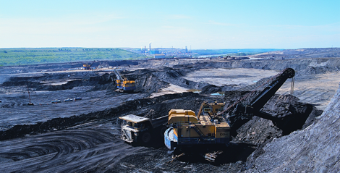
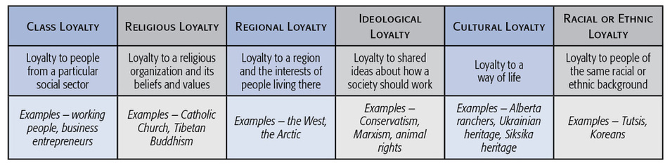
A region may be an area within a country (e.g. the West), an area with a province (e.g..
Northern Alberta), or even an area that crosses provincial and national boundaries (e.g.. the
Prairies). People often express their regional loyalty by actively promoting the interests of
their region. But this loyalty can sometimes clash with their national loyalties. This is what
happened in Alberta in the 1970s.

Step 1: As a class, discuss the following scenarios. Identify how nationalist and non-nationalist loyalties might conflict:
- You have just received a “prosperity cheque” from the Alberta government, which is distributing the cheques so Alberta citizens can share in the revenues generated by the oil industry.
- Your best friend gets a summer job delivering pizza in Fort McMurray and wants you to join the team. He says it’s “easy money”.

Step 2: Read the following scenario and respond to it in a half page response.
“For as many years as you can remember, your family has worked for oil companies. Both your mother and grandfather have worked and supported the development of the oil sands. Your mother has been a geologist, and your grandfather was the CEO of a major western Canadian oil firm. You share their beliefs on the development of the oil sands, but you are concerned with environmental stewardship.
You recently joined Greenpeace.
In a heated discussion around the supper table last night, your mother and grandfather try to talk some “sense” into you.”
Your task is to identify your loyalties to both Greenpeace and the development of the oil sands and to explain how these loyalties might be in conflict. Can these loyalties be reconciled? How?
Step 2: Complete the following chart to enhance your understanding of when regional and national loyalties compete.
Oil, Gas, & Regional Loyalty | The Oil Sands & Loyalty | The Oil Sands & Ideological Loyalty | The Oil Sands & Cultural Loyalty

Step 3: Examine the following political cartoons (from Graeme MacKay) and the accompanying text from the Toronto Star and excerpt from the Calgary Herald and answer the questions below.

Liberals face flood of outrage in B.C. after approval of Trans Mountain pipeline
The federal cabinet’s decision to approve Kinder Morgan Canada’s Trans Mountain pipeline expansion has prompted a flood of outrage and promises of protests, court challenges and civil disobedience in British Columbia.
Vancouver Mayor Gregor Robertson said he was “profoundly disappointed,” calling the decision a “big step backwards” for Canada’s environment and economy.
“I — along with the tens of thousands of residents, local First Nations, and other Metro Vancouver cities who told the federal government a resounding ‘no’ to this project — will keep speaking out against this pipeline expansion that doesn’t make sense for our economic or environmental future.”
The $6.8-billion project would triple the capacity of the Trans Mountain pipeline, from 300,000 to 890,000 barrels a day, and would add 980 kilometres of new pipe along the route from near Edmonton to Burnaby, B.C.
It would also increase the number of tankers leaving Vancouver-area waters seven-fold, from five to 34 per month, prompting fierce opposition from local mayors and First Nations who say any risk of a diluted-bitumen spill is unacceptable.
Prime Minister Justin Trudeau announced the project would be approved with 157 conditions at a news conference Tuesday. He said he expects the decision to be “bitterly disputed” by a number of people across the country, but said the project is in Canada’s best interests. (Source: Toronto Star)

Trudeau green-lights Trans Mountain expansion, Enbridge Line 3, but rejects Northern Gateway – Calgary Herald – Nov 30, 2016

Prime Minister Justin Trudeau has given the green light to two out of three major pipelines that will ship oil out of Alberta, crediting the provincial government’s climate change plan for paving the way for projects that are in the national interest.
The decision is a monumental development in Alberta’s multi-year quest to open new markets for its oilsands crude, although the two approved projects — especially Kinder Morgan’s Trans Mountain expansion — still face major opposition and regulatory hurdles.
In Ottawa, Trudeau announced the Liberal cabinet had formally approved the Trans Mountain development, which transports oil from the Edmonton area to Burnaby, B.C.
As well, he gave the go-ahead to Enbridge’s Line 3 project, which replaces existing pipe running from Alberta into the United States.
But the prime minister also confirmed Enbridge’s Northern Gateway project — long opposed by the Liberals — has been rejected. The federal government will also keep its campaign promise to ban oil tanker traffic along the northern coast of British Columbia.
Trudeau said the government is trying to strike a balance between economic and environmental concerns.
“Let me say this definitively, we could not have approved this project without the leadership of Premier (Rachel) Notley and Alberta’s climate leadership plan,” said Trudeau, who met with the premier following his news conference.
“Alberta’s climate plan is a vital contributor to our national strategy. It has been rightly celebrated as a major step forward, both by industry and the environmental community.”
…
Environmental groups vowed to fight the pipeline both through legal means and civil disobedience, while Vancouver Mayor Gregor Robertson issued a statement saying he was “profoundly disappointed.”
“Vancouver’s economy is the strongest and greenest in Canada and our marine-based industries play a big role in our success … it doesn’t make sense to jeopardize that success with the risk that comes with an expanded Kinder Morgan heavy oil pipeline,” he said.
The B.C. government has also set out five conditions for the approval of new oilsands pipelines in the province, not all of which have been met yet. Trudeau and B.C. Premier Christy Clark spoke by phone Tuesday night.
The $6.8-billion Trans Mountain project will expand an existing 1,150-kilometre pipeline, almost tripling the capacity to 890,000 barrels per day and providing an export outlet for Canadian oil to reach Asian markets.

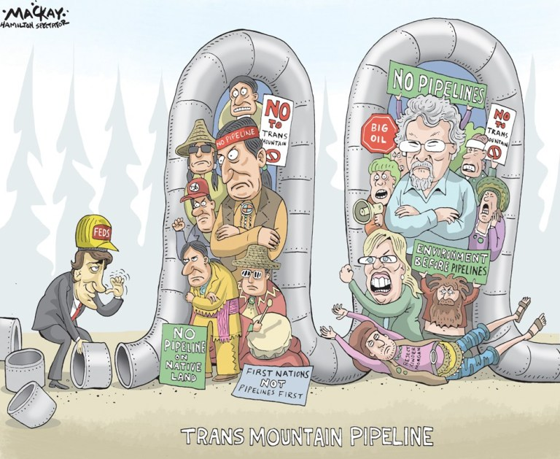

Questions:
What contending loyalties are evident in the articles?

What loyalties are the then mayor of Vancouver appealing to? Why?

Who is the cartoonist critical of…pipeline supporters or their opponents? Defend your answer.

Research developments on this—and other pipelines—since 2016. What has happened since then? Are we any closer to having increased pipeline capacity? Have the supporters/opponents stayed the same or changed?

