OUTCOME:
1.8 Analyze how the development of nationalism is shaped by historical, geographic, political, economic and social factors

In 2014 Scotland held a referendum to decide whether Scotland should become an independent country from the United Kingdom. Voter turnout was an astounding 86.6%, the highest that it has ever been in any referendum or election since the introduction of universal suffrage.

The two campaign groups included Yes Scotland (Yes Supporters) and Better Together (No Supporters. In reading the summary about this issue, provide four factors based on at least two different factors of the following five factors that shapes nationalism.

Historical Factors - Geographical Factors - Political Factors - Economic Factors - Social Factors
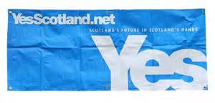
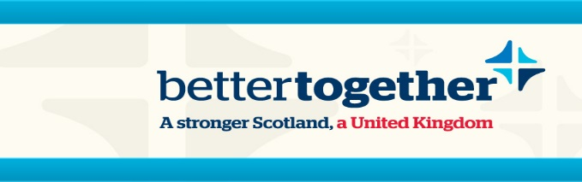

Factor:

Support/Explanation:
Factor:

Support/Explanation:
Factor:

Support/Explanation:
Factor:

Support/Explanation:

Outcome 1.8: 4 marks each factor
/16

Scotland's vote on independence: What you need to know
By Laura Smith-Spark, CNN
updated 11:58 PM EDT, Thu September 18, 2014

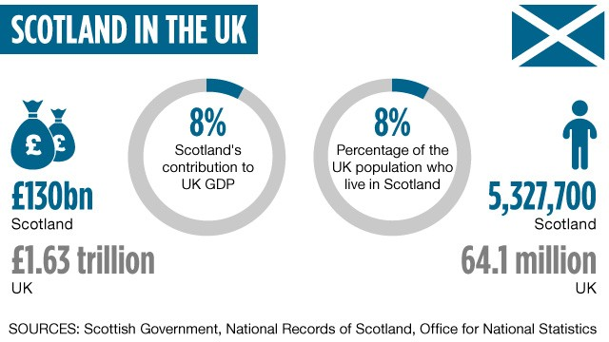

What are the Scottish voting on, and why?
Voters will be presented with a simple yes/no question: Should Scotland be an independent country?

The Scottish government, led by the Scottish National Party, says this is a "once in a generation opportunity" for Scotland's people to take control of the decisions that affect them most. A "yes" vote means that "Scotland's future will be in Scotland's hands," it says, and that life will be better and fairer for its people.

British Prime Minister David Cameron wants Scotland to remain part of an undivided United Kingdom of Great Britain and Northern Ireland. He says that it is a decision solely for the Scottish people -- but that remaining part of the United Kingdom will give them security and strength. "There will be no going back," he warns.

Because the United Kingdom has no written constitution, there's no established law to govern the process. So these are truly uncharted waters.

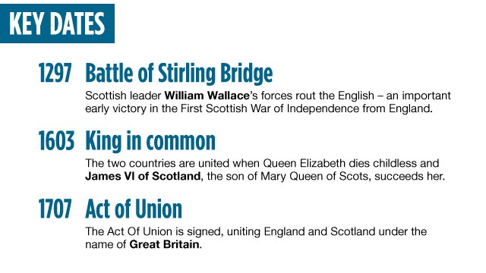

Why is this significant to the rest of the world?
The question mark over Scotland's future is already having an impact on domestic and international business. Some worry that the breakup of the United Kingdom could undermine London's standing as an international financial capital.

Last month, 130 business leaders published an open letter in which they warned of the impact of uncertainty over issues including currency, regulation, tax, pensions, EU membership and support for Scottish exports. A day later, more than 200 other business leaders signed an open letter backing an independent Scotland.

The British pound sank Monday after the first poll that showed the "yes" vote in the lead, with CNN Money reporting that it reflected uncertainty over the outcome of the referendum and an increased risk of a "messy divorce."

The UK's defense capability could be affected. The Scottish government says it wants to remove nuclear weapons from Scotland as soon as possible -- namely, the UK Trident nuclear submarine fleet based at Faslane. The Scottish government says, "It is our firm position that an independent Scotland should not host nuclear weapons and we would only join NATO on that basis."

Scotland would have to renegotiate its entry to both NATO and the European Union if it votes for independence. EU leaders have signaled they would take a hard line and make Scotland apply to join like any other independent nation. However, the "yes" campaign says it could easily be done through amendments to existing treaties.

If Scotland chooses to split from Britain, it could give other people ideas.
The debate is being closely watched by independence movements in Spain's Catalonia province, Canada's Quebec province and France's Mediterranean island of Corsica.
If Scotland votes to leave, the British Prime Minister will likely come under pressure to resign -- although he has told UK media "emphatically" he will not do so. The major Westminster parties have promised to devolve more powers to Scotland if it chooses to stay in the union.

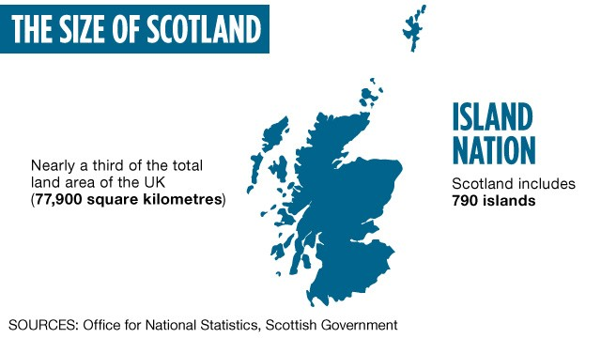

What's the history behind the vote?
Scotland has long had a testy relationship with its more populous neighbor. The Act of Union in 1707 joined the kingdom of Scotland with England and Wales, but many Scots were unhappy at being yoked to their longtime rival south of the border.

Since 1999, Scotland has had a devolved government, meaning many, but not all, decisions are made at the Scottish Parliament in Holyrood, Edinburgh. In May 2011 the nationalist Scottish National Party, which had campaigned on a promise to hold an independence referendum, surprised many by winning an outright majority in the Scottish Parliament.
In October 2012, the UK and Scottish governments agreed that the referendum would be held, and the question to be put to voters was agreed on early last year.

Dauvit Broun, a professor of Scottish history at the University of Glasgow, said one driving force for the vote was the widening gulf between the policies pursued by the coalition UK government in Westminster, led by the Conservative Party under Cameron since 2010, and what the Scottish people want.

Many Scots are strongly opposed to the current Westminster government's attempts to reform -- or in their eyes dismantle -- the welfare state and say it was not elected by them. Illustrating that sentiment, there's only one Conservative MP in Scotland at present, leading humorists to point out that even giant pandas are better represented (Edinburgh Zoo has two.)
"Since the period of Margaret Thatcher, there has been a growing divide, and a sense that what Scotland feels consensus about ... has become more and more different to England," Broun said.

Looking further back, Scotland and England have been growing apart since the demise of the British Empire, Broun says. The decline of the Presbyterian church in Scotland, which provided a sense of self-government and Scottish identity, has also played a part in fueling the desire for independence, he said.

What are the key issues?
Questions over the economy have dominated the debate.

The Scottish government argues the country would be better off after independence, largely based on its taking control of revenues from North Sea oil and gas found in Scottish waters. It says it would manage the energy industry better, invest to boost production, and create a wealth fund, similar to Norway's oil fund, to benefit future generations.

But not everyone agrees with the Scottish government's rosy assessment. A report by the Institute for Fiscal Studies in March said the latest figures showed Scotland's budget deficit had worsened relative to the rest of the United Kingdom, thanks to falling North Sea revenues and higher public spending north of the border. It also warned of the dangers of relying too heavily on a volatile and ultimately finite income source.

The Scottish government says the economy is diverse, with other key elements including food and drink, tourism, creative industries, universities, financial services and manufacturing.

Another big issue is what currency an independent Scotland would have.
Scottish First Minister Alex Salmond has said he wants Scotland to continue to use the pound in a currency union with the rest of the United Kingdom, and that it has the right to do so.

But the three main parties in Westminster -- David Cameron's Conservatives, their coalition partners the Liberal Democrats, and Labour -- have all said this won't be an option. The Scottish government responded that this was "bullying" from Westminster.

It's unclear what would happen to Scotland's share of UK debt if it's not part of a currency union.

