Social Studies 20-1– Unit 1 WRA I Practice Source Interpretation

ASSIGNMENT:
You will complete the attached chart using the provided sources and complete the following tasks.

- Examine each source.

- Interpret each source to demonstrate your understanding of how each source links to nationalism.

- Explain one or more of the relationships that exist among all three sources.

Source I

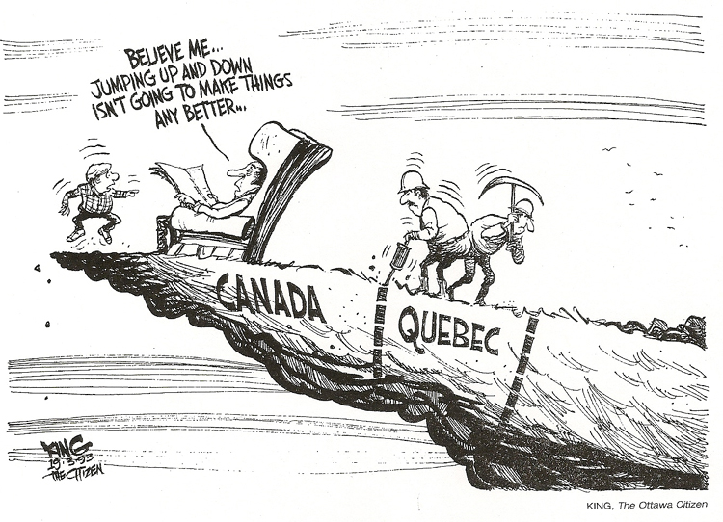
Source II
In the psychological sense, there is no Canadian nation as there is an American or French nation. There is a legal and geographical entity, but the nation does not exist. For there are no objects that all Canadians share as objects of national feeling.

-Charles Hanley in Nationalism in Canada, 1966.

Source III
Modern nationalism in the vast majority of cases points to a deep, almost spiritual connection between land and people… Territory is the physical aspect of the life of the community and therefore reflects and conditions the identity of that community.

—Malcolm Shaw, Title to Territory in Africa- International Legal Issues
(Oxford: Clarendon Press, 1986)

Marking Rubric:
 | Excellent  5 | Proficient  4 | Satisfactory  3 | Limited  2 | Poor  1 | TOTAL
Interpretation of Sources  X 3 | Interpretation of the sources is sophisticated, insightful, and precise, demonstrating a perceptive understanding of links to the course. | Interpretation of the sources is logical, specific, and adept, demonstrating a sound understanding of the links to the course. | Interpretation of the sources is adequate, straightforward, and conventional, demonstrating a generalized understanding of the links to the course. | Interpretation of the sources is incomplete, vague, and simplistic, demonstrating a confused understanding of the links to the course. | Interpretation of the sources is scant, inaccurate, and irrelevant, demonstrating little or no understanding of the links to the course. | /15
Relationship Between the Sources | The explanation of the relationships is perceptive and thorough. | The explanation of the relationships is capable and purposeful. | The explanation of the relationships is adequate and straightforward. | The explanation of the relationships is superficial, incomplete, redundant and of questionable accuracy. | The explanation of the relationships is scant, illogical and tangential. | /5
 |  |  |  |  |  | / 20 Marks

Social Studies 20-1 Unit 1 WRA I Source Interpretation Chart

Meaning / Perspective / Links to Nationalism
Source I
Source II
Meaning / Perspective / Links to Nationalism
Source III
Relationships

