Social 10-1

The International organizations: WTO & G8

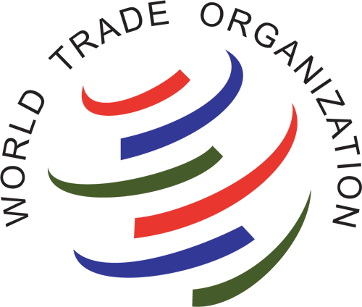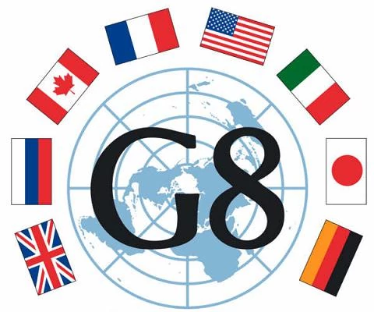

The World Trade Organization (WTO)
- Came to be in 1995, it is the successor to GATT (General Agreements on Tariffs and Trade) which was created post WWII
- 160 members accounting for 95% of the world’s trade
- It is the only international organization dealing with the global rules of trade between nations. Its main function is to ensure that trade flows as smoothly, predictably and freely as possible
- Decisions in the WTO are typically taken by consensus among all member countries and they are ratified by members’ parliaments.
- The goal is to improve the welfare of the peoples of the member countries

Advantages of the WTO | Disadvantages of the WTO
- Lower prices for consumers. Removing tariffs enables us to buy cheaper imports  - Free trade encourages greater competitiveness. Firms face a higher incentive to cut costs. For example, a domestic monopoly may now face competition from foreign firms.  - Law of comparative advantage states that free trade will enable an increase in economic welfare. This is because countries can specialise in producing goods where they have a lower opportunity cost.  - Economies of scale. By encouraging free trade, firms can specialise and produce a higher quantity. This enables more economies of scale, this is important for industries with high fixed costs, such as car and aeroplane manufacture.  - Free trade can help increase global economic growth.  - The system helps promote peace  - Disputes are handled constructively  - Rules make life easier for all  - Freer trade cuts the costs of living  - It provides more choice of products and qualities  - Trade raises incomes  - Trade stimulates economic growth  - The basic principles make life more efficient  - Governments are shielded from lobbying  - The system encourages good government  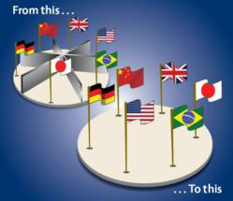 | - However, the WTO has often been criticised for ignoring the plight of the developing world.  - It is argued the benefits of free trade accrue mostly to the developed world.  - Free trade may prevent developing economies develop their infant industries. For example, if a developing economy was trying to diversify their economy to develop a new manufacturing industry, they may be unable to do it without some tariff protection.  - Fundamentally undemocratic- rules are written for corporations  - WTO tramples on Human Rights- rights of corporations over rights of humans,  - Believes in privatizing essential services  - Destroys the environment in hopes of profit  - Creates increasing inequality in the world  - 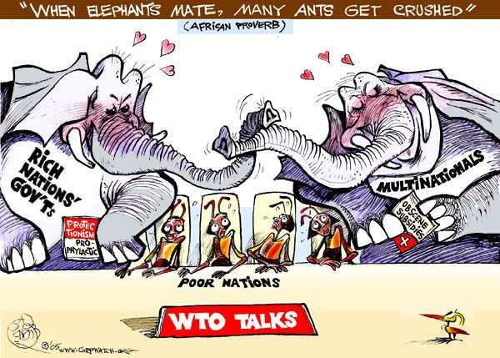

G8 (Group of Eight) Currently known as the G7 (see point 2)
- Group of 8 highly industrialized countries (France, Germany, Italy, Canada, UK, Japan, USA and Russia) whose GDP’s make up over 50% of the world’s economy
- Russia has been banned from the G8 as a result of invading Ukraine, status will be reinstated if Russia withdraws - now referred to as G7
- Formed in 1975, it was intended to provide major industrial powers of the noncommunist world a venue in which to address economic concerns, which at the time included inflation and the recession sparked by the oil crisis of the 1970s. Cold War politics invariably entered the group's agenda.
- It is not a formal institution, and there is no charter or secretariat. The presidency, a position responsible for planning ministerial meetings and the annual summit, rotates among the member states.

Advantages of the G8 | Disadvantages of the G8
- Smaller group creates an ability to focus on world issues  - Meet annually  - Able to influence global insitutions (they contain 50% of the vote in the WB & IMF)  - Have created many substantial gains in the world including combating disease and debt-relief plans | - Countries fail to deliver on ambitious commitments  - Anti-global protests often occur due to the group’s pro-trade liberalization beliefs  - Many members are the same as those in the IMF and WTO  - Represents only elite countries

** note** as a result of the G8, the G20 was formed to create an even wider dialogue of world issues. In the G20 countries from Africa and Asia are also represented.

