Causes of the

FRENCH REVOLUTION

Your task:
- Create a concept map that visually outlines the key causes of the French Revolution and the most important details explaining each cause

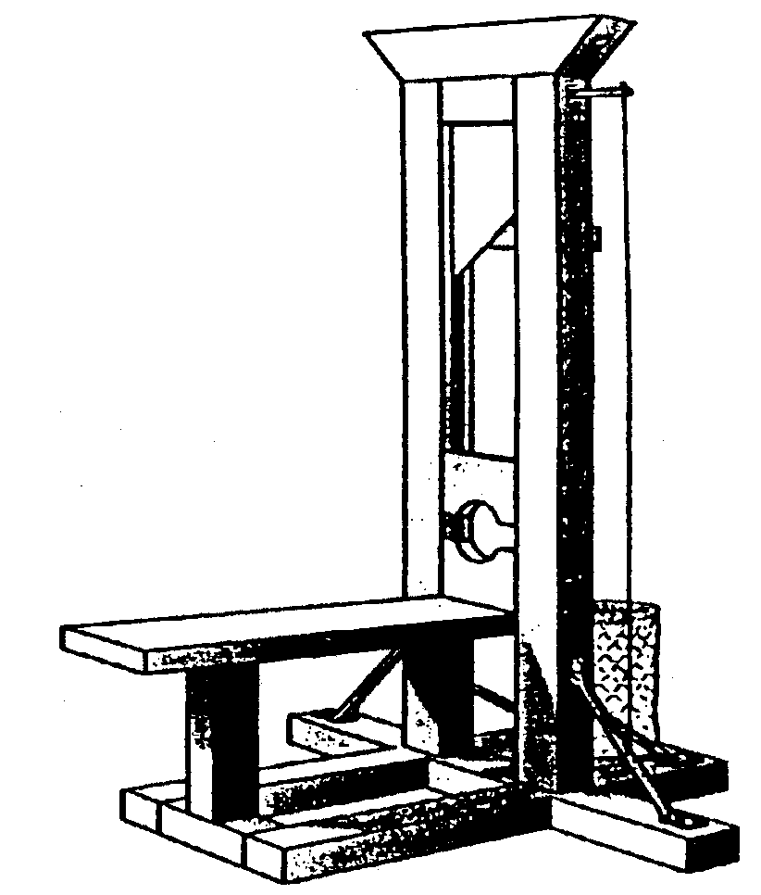
Step One:
- Place the title “Causes of the French Revolution” in the center of your page
- Choose the Top 4 Causes of the French Revolution
- For each of the 4 causes explain AT LEAST 3 details that explain it more fully
  - One detail from your notes (lecture)
  - One detail from your textbook (across various chapters)

***After each point put a N for notes, or T for textbook so I know your source for each of your detailed pieces of information

Keys to success:
- Present your ideas neatly and orderly
- Brainstorm your ideas on a scrap sheet of paper before you begin your good copy
- Consider all the causes of the French Revolution before you decide on your top 4
- Whenever possible, include more than three details for each of your causes
Cause 1
Detailed information – T
Detailed information – N
Detailed information - N

Causes of the French Revolution

Step Two:
- Using the information from your concept map answer the following question in paragraph format on a separate sheet of paper:

“In your opinion, which of the causes of the French Revolution was the most significant? What makes the cause you chose more significant than some of the other causes? Support your answer with specific details”

