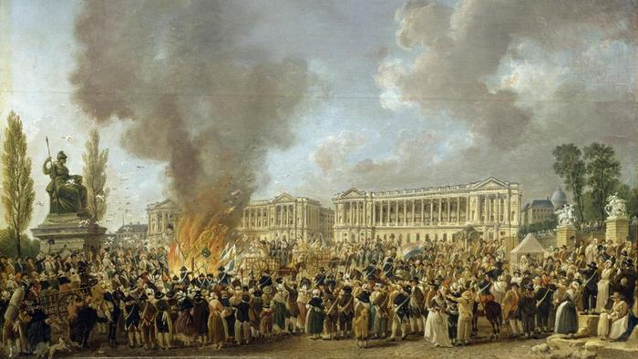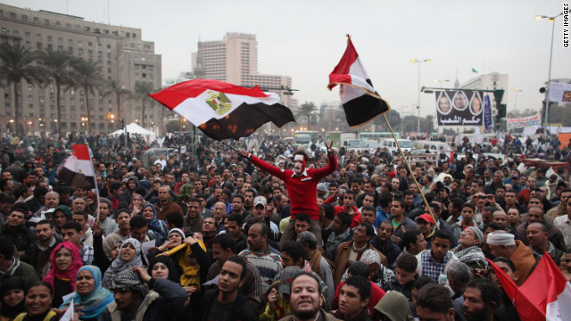
FRENCH
EGYPT
REVOLUTIONS

***NOTE*** You may replace any or all of the 3-6 sentences with a presentation during class time or verbal discussion during a FOCUS block***
TASK 1
Using the internet, identify at least five causes of the Egyptian revolution of 2011. Explain them in your own words (3-6 sentences EACH)

TASK 2
Compare these causes with the causes we’ve identified in the French Revolution. Overall would you say that these revolutions were caused by similar or different factors? Why? (3-6 sentences)

TASK 3
Using the internet, explain (in your own words) why there were still protests and a coup in 2013 in Egypt? Shouldn’t the revolution be over since it overthrew the government in 2011? (3-6 sentences)

TASK 4
Compare the aftermath of the French Revolution with the events in Egypt in 2013. Why do you think there is usually violence following revolution? (3-6 sentences)

TASK 5
Overall would you say that you are optimistic or pessimistic about the future of democracy in Egypt? Why or why not? Link your prediction to the French Revolution. (3-6 sentences)

RUBRIC

 | Requirements for 3-6 sentences
4 | Response is factually correct. Explores the question in depth and provides a response that is thoughtful and informed by research.
3 | Response is factually correct. Explores the question in depth and provides a response that is informed by research.
2 | Response is factually correct. Explores the question in adequately and provides a response that makes it obvious some research has been completed.
1 | Response is mostly factually correct. Answers the question superficially and without obviously using research OR Response is not factually correct. Does not explores the question and little to no research is obvious.

Response # | Mark
1
2
3
4
5
6
7
8

