Oka Crisis, 1990
by WarriorPublications.wordpress.com
(Selected excerpts)
INTRODUCTION
The Oka Crisis of 1990 involved the Mohawk territories of Kanehsatake/Oka & Kahnawake, both located near Montreal, Quebec. The standoff began with an armed police assault on a blockade at Kanehsatake on July 11, 1990, which saw one police officer shot dead in a brief exchange of gunfire. Following this, 2,000 police were mobilized, later replaced by 4,500 soldiers with tanks & APC’s, along with naval & air support.
All through the summer of 1990, Oka was the top story in Canadian TV & print media. The armed warriors at both Kanehsatake & Kahnawake inspired widespread support & solidarity from Indigenous people throughout the country. Protests, occupations, blockades, & sabotage actions were carried out, an indication of the great potential for rebellion amongst Indigenous peoples.
This manifestation of unity & solidarity served to limit the use of lethal force by the government in ending the standoff. Overall, Oka had a profound effect on Indigenous peoples and was the single most important factor in re-inspiring our warrior spirit. The 77-day standoff also served as an example of Indigenous sovereignty, and the necessity of armed force to defend territory & people against violent aggression by external forces.
Psychological Warfare
“The warriors covered empty shoe boxes in black, strapped them to their backs, and clambered over the Mercier Bridge to make the SQ think they were planting explosives on the bridge. They used welding torches on old scrap iron, behind a blind, to make it seem as if they were cutting the anchor bolts of the bridge to weaken it. And they wandered around an empty field, looking at a map, to pretend they were picking their way through a minefield. It was all part of a deliberate strategy to keep their enemies off guard and confused. “It was like a chess game,” said Little Marine. “They didn’t know who we were, they didn’t know what to expect,” added Michael Thomas, another warrior leader” (People of the Pines, p. 245).
August 20
On August 20, the military moved in to take over SQ positions. Many Mohawks were glad to see the hated SQ [Quebec police] leave.
One Canadian Forces soldier interviewed by the media stated his views on the Mohawks:
“The people are convinced that they’re right. They have a certain patriotism. Unfortunately, they are tossing aside the rules of our white governments. They’re in a vicious circle. As long as we don’t recognize them as a nation with their own protective force, we can’t accept that they can bear military arms. But as long as they don’t possess military arms, they will not be able to affirm their rights as a nation” (People of the Pines, p. 314).
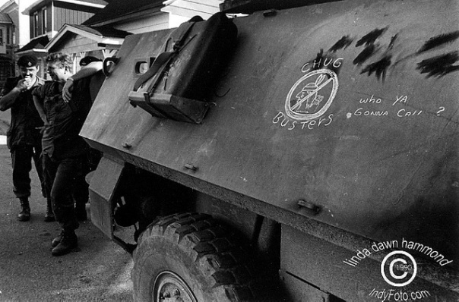
Kahnawake- Raid on Longhouse (Sept 3)
While the military was advancing into Kanehsatake, warriors in Kahnawake attempted to retake the Mercier Bridge. In the morning of September 3, a group of fifteen warriors moved onto the bridge and pulled out weapons, including a .50-calibre rifle. Repair crews fled. The military immediately responded with APC’s and dozens of troops. The warriors retreat in a van, which they drive back into Kahnawake and to the Longhouse. Here they allegedly attempt to conceal their weapons, unaware they are under surveillance by a military helicopter.
A few hours later, a convoy of APC’s rolls into Kahanwake and over 100 soldiers & SQ raid the Longhouse. According to military commanders, the presence of weapons had violated agreements with the warrior not to enter Kahnawake.
At the Longhouse, the soldiers are confronted by Mohawk women who fight to stop them. The soldiers force their way in and find numerous weapons inside. Several women & soldiers are injured. After the raid, the military keeps its APC’s stationed at the entrance to the village, now controlling half of Kahnawake territory
Sept 18
On September 18, soldiers & police land on Tekakwitha Island, a deserted island on the edge of the territory, connected by a short bridge. Dozens of troops & SQ land on the western side of the island, by boat & helicopter. As they advance towards bridge, hundreds of Mohawks rush to confront them.
Some 30 soldiers move to block the bridge & begin to set up razor wire. Mohawks dismantle this & begin throwing rocks and assaulting soldiers. Soldiers use rifle butts to defend themselves & begin firing volleys of tear gas.
Mohawks disperse & then regroup. In a second attack, one soldier is beaten semi-conscious and others are wounded. Soldiers fire warning shots into the air & pull back into a defensive position. Reinforcements arrive, and now there are 140 soldiers.
After a 7 hour standoff, eight military Chinook helicopters are used to airlift the soldiers out. 20 are injured.
For the Mohawks, there are 75 injured, including cuts, bruises, fractures and tear gas. These include children as young as five, and one elder 72 years old. The military claims to seize 47 weapons from the island, most are hunting rifles and shotguns.
End of Siege
On September 26, more SQ began to arrive. Some warriors feel that if military custody is an option, it must be taken now. At 4 PM, the decision is made to disengage ASAP. Only Lasagna & Noriega disagree, and accuse others of “selling out.” Media are told to leave. A large fire is built at the rear of the TC. Internal documents and weapons are burned. Ammunition & handguns are thrown into a septic tank.
At 5:34 PM the Warrior flag is lowered. Everyone wears camouflage “to symbolize their belief that the warriors were an army of defense for the Mohawks & their land” (People of the Pines, p. 395). By this time, even Lasagna & Noriega have accepted the decision to disengage.
At 6:50 PM the group – 13 men, 16 women, & six children—began to walk down the laneway towards the military lines. Halfway down, they veered into the woods, heading for forest in the north-eastern corner. Trip flares are set off.
As they reach a row of razor wire, those carrying stretcher boards throw them over. People run across these, through the woods, & up onto the highway. Only a few soldiers are at this location, and they’re caught by surprise.
There is chaos, yelling, pushing, & shoving. Major Tremblay is knocked to the ground. In the confusion, 4 Mohawks escape and reach the town (where they are mobbed by supporters). SQ try to arrest them but are fought off by the crowd. Later, Noriega is arrested in town, walking around in his cammies. Loran Thompson, dressed in civvies, disappears into a crowd.
By 7:10 PM, Mohawks still on the highway are encircled & under control. They are forced on their knees and their hands are bound with plasticuffs. Some are broken by the stronger men, and soldiers put multiple sets on these ones. Lasagna, Noriega, and 3 minors are immediately turned over the SQ, while the rest are loaded onto two military buses and sent to CFB Farnham. Some are assaulted & abused.

