Social Studies 20-1– Unit 1 WRA I Practice Source Interpretation

ASSIGNMENT:
You will complete the attached chart using the provided sources and complete the following tasks.

- Examine each source.

- Interpret each source to demonstrate your understanding of how each source links to nationalism.

- Explain one or more of the relationships that exist among all three sources.

Source I

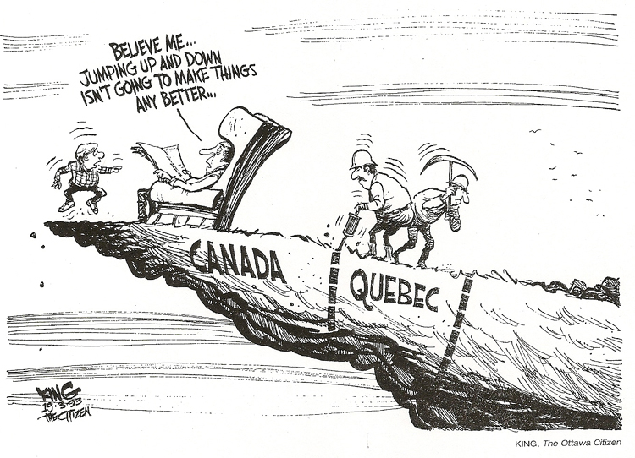
Source II
In the psychological sense, there is no Canadian nation as there is an American or French nation. There is a legal and geographical entity, but the nation does not exist. For there are no objects that all Canadians share as objects of national feeling.

-Charles Hanley in Nationalism in Canada, 1966.

Source III

Marking Rubric:
 | Excellent  5 | Proficient  4 | Satisfactory  3 | Limited  2 | Poor  1 | TOTAL
Interpretation of Sources  X 3 | Interpretation of the sources is sophisticated, insightful, and precise, demonstrating a perceptive understanding of links to the course. | Interpretation of the sources is logical, specific, and adept, demonstrating a sound understanding of the links to the course. | Interpretation of the sources is adequate, straightforward, and conventional, demonstrating a generalized understanding of the links to the course. | Interpretation of the sources is incomplete, vague, and simplistic, demonstrating a confused understanding of the links to the course. | Interpretation of the sources is scant, inaccurate, and irrelevant, demonstrating little or no understanding of the links to the course. | /15
Relationship Between the Sources | The explanation of the relationships is perceptive and thorough. | The explanation of the relationships is capable and purposeful. | The explanation of the relationships is adequate and straightforward. | The explanation of the relationships is superficial, incomplete, redundant and of questionable accuracy. | The explanation of the relationships is scant, illogical and tangential. | /5
 |  |  |  |  |  | / 20 Marks

Social Studies 20-1 Unit 1 WRA I Source Interpretation Chart

Meaning / Perspective / Links to Nationalism
Source I
Source II
Meaning / Perspective / Links to Nationalism
Source III
Relationships

